THE DIOCESE OF SHEFFIELD ACADEMIES TRUST

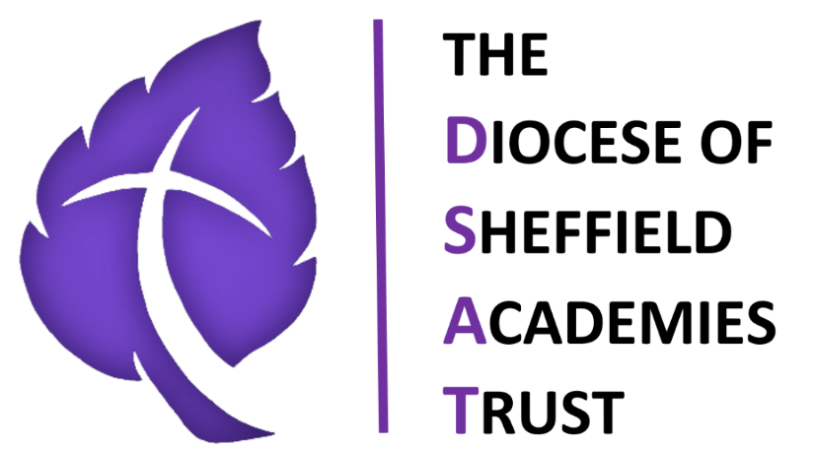

FOOD & DRINK/SAFE EATING POLICY
2025-26
Approved by:
Last reviewed on: | Summer 2025
Next review due by: | Summer 2026

Food & Drink / Safe Eating Policy

1. Purpose of this Policy
This policy outlines the procedures and standards for providing safe, healthy, and appropriate food and drink to children in our school-based early years provision. It ensures compliance with the EYFS Statutory Framework and promotes children’s health, wellbeing, and safety during mealtimes and snack times.

2. Aims
- To provide nutritious food and drink that meet children’s dietary and developmental needs.
- To ensure safe eating practices that minimise the risk of choking.
- To create a calm, positive, and inclusive eating environment.
- To meet individual dietary, medical, and cultural requirements.
- To ensure staff follow consistent hygiene and supervision procedures.

3. Legal and Statutory Requirements
This policy is informed by: - The Early Years Foundation Stage (EYFS) Statutory Framework - School Food Standards - Health and Safety at Work legislation - Allergy and medical needs guidance

4. Roles and Responsibilities

Senior Leadership Team (SLT)
- Ensure compliance with statutory requirements.
- Provide staff training on safe eating, allergies, and food hygiene.

Early Years Staff
- Follow all procedures in this policy.
- Supervise children closely during all eating and drinking times.
- Record and communicate dietary or allergy needs.

Parents/Carers
- Provide accurate, up-to-date information on allergies, dietary requirements, and cultural preferences.
- Supply food that meets school guidelines (where applicable).

5. Food Provision and Nutrition
- Meals, snacks, and drinks provided by the school must follow nutritional standards.
- Drinking water is accessible to children at all times.
- Sugary drinks and sweets are not permitted.
- Fruit, vegetables, and healthy snacks are promoted.
- Foods known as high choking risks are modified, removed, or prepared safely.

Choking-Risk Food List
- Whole grapes, cherry tomatoes, berries – cut into quarters
- Raw carrot sticks – cut into thin strips or cooked until soft
- Nuts, seeds, popcorn, marshmallows – avoided
- Hard or sticky sweets – avoided
- Large pieces of meat or cheese – cut into small, manageable pieces
- Sausages – sliced lengthwise
- Apples and pears – sliced thinly or cooked

6. Safe Eating Procedures

Supervision
- Children must be actively supervised during all eating times.
- Staff must sit with children to model positive eating habits.

Choking Prevention
- Children must be seated while eating.
- No running, walking, playing, or talking with food in the mouth.
- Staff trained in paediatric first aid must be available.
- Foods from the choking-risk list must be prepared appropriately.

Mealtime Conduct
- Promote calm, unhurried eating.
- Encourage independence (e.g., pouring drinks, using utensils) while maintaining safety.
- Educate children about healthy choices.

7. Allergy and Dietary Management
- The school maintains an allergy register accessible to all staff.
- Individual Healthcare Plans (IHPs) are in place for children with medical conditions.
- Allergen-free zones implemented where required.
- Food sharing is not permitted.
- Staff must be trained in recognising allergic reactions and responding appropriately.

8. Hygiene and Food Safety
- Staff must wash hands before preparing, serving, or assisting with food.
- Children wash hands before and after eating.
- Surfaces are cleaned and sanitised before use.
- Any food brought from home should be stored safely.
- Food temperatures and storage follow safety guidelines.

9. Drinks
- Only water is offered throughout the day.
- Milk may be offered during snack times.
- No juice, fizzy drinks, energy drinks, or squash are permitted.

10. Cultural and Religious Considerations
- Staff respect and accommodate religious dietary rules (e.g., Halal, vegetarian, no pork).
- Celebrations involving food must adhere to known allergies and cultural practices.

11. Staff Training
- All staff receive training on:
  - Choking prevention
  - Food hygiene
  - Allergy management
  - EYFS requirements regarding food and drink

12. Monitoring and Review
- SLT monitors implementation through observation and feedback.
- Policy reviewed annually or sooner if statutory guidance changes.

