Barnsley Bikeability
Cycle Training
The Ellis Primary School

Dear Parent / Guardian,

Bikeability is the national award for cycling and is delivered by Active Barnsley on behalf on Barnsley Council, aiming to help give children and young people the skills to confidently ride a bike safely.

Bikeability cycle training will be delivered in your school, week commencing Monday 22nd September 2025.

Bikeability sessions will be delivered on the playground and quiet, safe residential roads close to school, all within school time.

- Full training is delivered by experienced and qualified instructors.
- Free bike safety check for your child’s bike.
- If you haven’t got a bike, we can loan a bike and helmets where needed, just indicate on the consent form.
- Children undertaking the course will receive a badge and certificate

Please note, both levels of this course are for children who can already ride a bike and they should be able to balance unaided as a minimum. Children that are considered to be riding competently after Level 1 will progress to Level 2.

Bikeability Level 1 - Developing your child’s basic riding skills and understanding of riding their bike.

Bikeability Level 2 – Developing your child’s confidence and understanding of local routes.
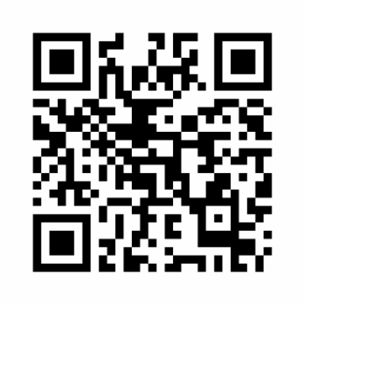
To book a FREE place for your child, please use the QR Code or link here.

https://consent.bikeability.org.uk/matt-cap-arena

If you are unable to access the internet, please speak to the school about using an alternative booking method.
Yours Faithfully,
Adam Robinson
Bikeability Co-ordinator BMBC / Active Barnsley

