History Topic Overview
Early Years Topic Overview
All the holistic topics include some historical concepts in the ‘past and present’ strand of Understanding the World

 | Autumn 1 | Autumn 2 | Spring 1 | Spring 2 | Summer 1 | Summer 2
Cycle 1 | Me & My Family  Learn about themselves & family similarities & differences | Seasons  Introduce the Four Seasons, focusing on seasonal change form Autumn to Winter | Food  Family traditions and customs – what people eat now and what they ate in the past | Growing  Sequence events – begin to understand growing and changing over time | Mini-beasts  The passing of time – begin to understand the key events  in a given life-cycle | Traditional Tales  What can we learn from  stories set in the past?
Cycle 2 | Rhyme Time  Familiar rhymes from the past and present | Light & Dark  Sequence of daily events –  night and day | Toys  Toys old and new -  past and present | Homes  Homes now and in the past | Where we live!  What is old and what is new in the area that we live? | Journeys  Recall events from their own past

National Curriculum Topic Overview Key Stage 1 & Key Stage 2
(Kapow History Scheme)
 | Autumn Term | Spring Term | Summer Term
Year 1 | How am I making history? | How have toys changed? | How have explorers changed the world?
Year 2 | How was school different in the past? | How did we learn to fly? | What is a monarch?
Year 3 | British History 1:  Would you prefer to live in the Stone Age, Iron Age or Bronze Age? | British History 2:  Why did Romans settle in Britain? | What did the ancient Egyptians believe?
Year 4 | How have children’s lives changed? | British History 3:  How hard was it to invade and settle in Britain? | British History 4:  Were the Vikings raiders, traders or settlers?
Year 5 | British History 5:  What was life like in Tudor England? | What did the Greeks ever do for us? | How did the Maya civilisation compare to the Anglo Saxons?
Year 6 | What does the census tell us about our local area? | British History 6:  What was the impact of World War II on the people of Britain? | Unheard histories: Who should go on the banknote?
How does Kapow Primary help our school to meet the statutory guidance for History?
Our scheme of work fulfils the statutory requirements for History outlined in The National curriculum (2014) and was created
based on the principles outlined in the Ofsted Research review series: history
https://www.gov.uk/government/publications/research-review-series-history/research-review-series-history

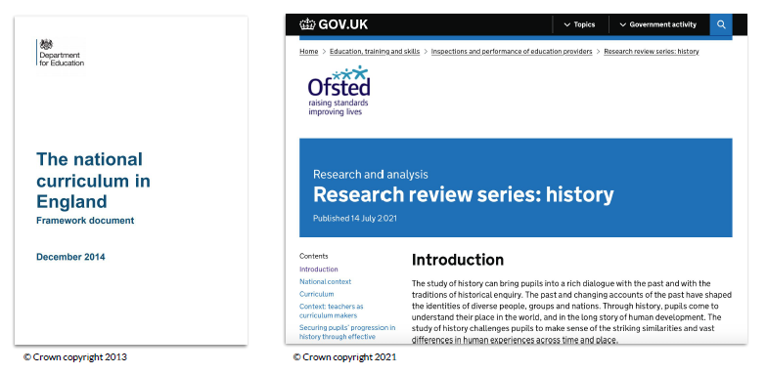

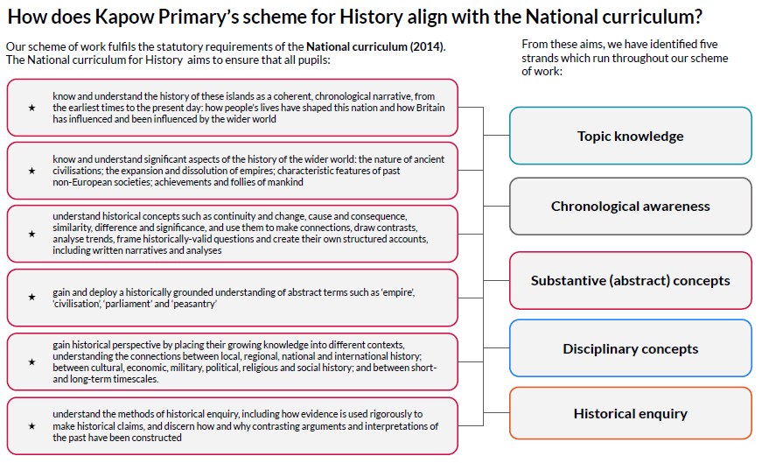

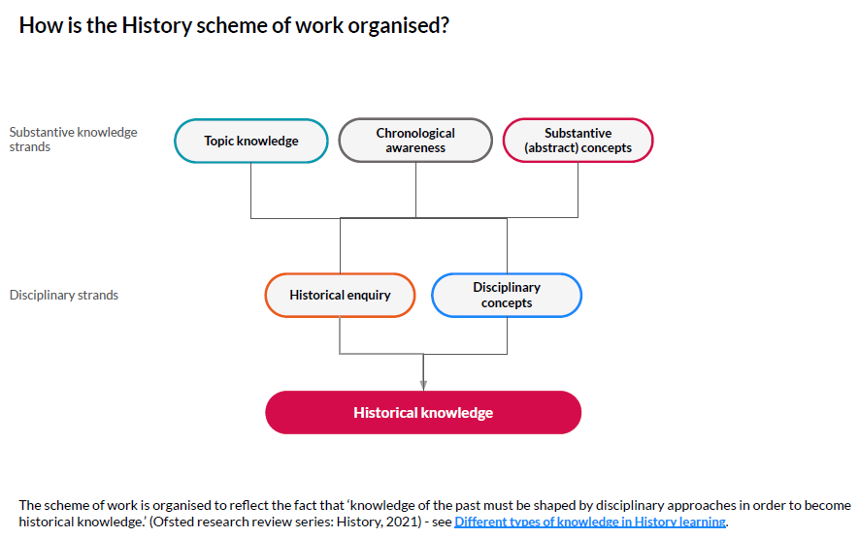

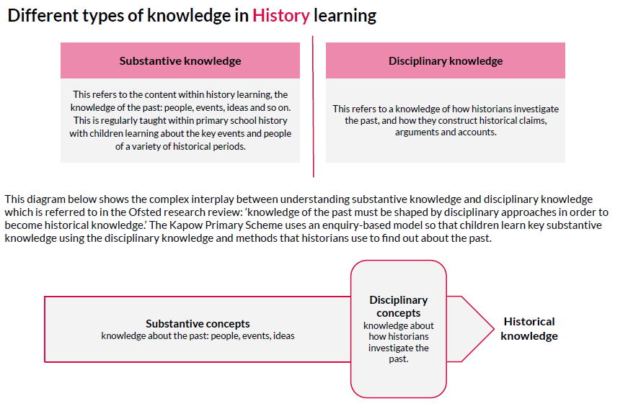
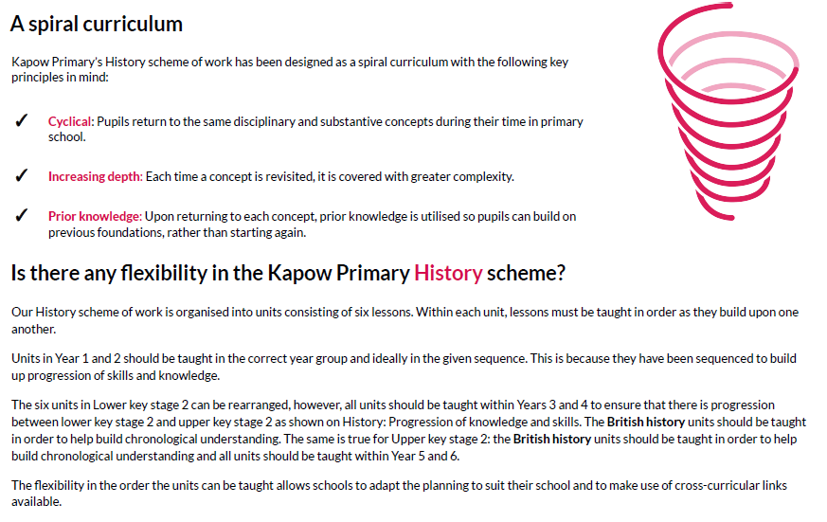

Why are the units sequenced this way?

History in the Early Years – Understanding the World (Past and Present)
Planned adult led activities and enhanced provision help children to reflect on memories and experiences from their own past and extend only to situations that will still be very familiar to their everyday lives. Children will learn through exploring artefacts and photographs in continuous provision and adults play a key role in introducing a particular concept or topic through whole class and small group carpet sessions using stories, artefacts and interactive board resources such as videos, PowerPoints or Smart Notebook presentations. The two year cycle of topics taught throughout the Early Years have been carefully selected to support skills and knowledge development, which will lay the foundations for pupils’ history learning in Key Stages 1 and 2. The curriculum is designed to foster a curiosity about history, prompting children to start asking questions about the past while referring to their own experiences. Children begin to develop a basic understanding that when we refer to the ‘past,’ we are referring to events that have already happened and become familiar with some of the vocabulary we use to talk about the past (e.g. last year, last week, yesterday).

National Curriculum History
As already stated, there is some flexibility in the order the History units can be taught, particularly in Lower key stage 2 and Upper key stage 2 where similar skills and knowledge are covered in different historical contexts. The order of units on this long-term plan is our suggested order for teaching the units, if possible, and we provide the justification for this sequencing below.

Key Stage 1
In Key stage 1, we have sequenced the learning to specifically develop pupils’ conceptual understanding of the ‘past’ by first making it relevant to their own lives, then by looking at how life has changed over time in familiar contexts and finally by studying contexts which are likely to be new to them.
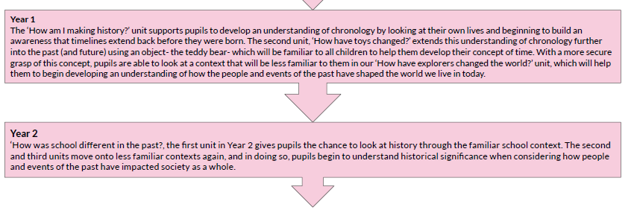

Key stage 2
The National curriculum states that pupils should 'know and understand the history of these islands as a coherent, chronological narrative, from the earliest times to the present day', and so our British History units across Key stage 2 are sequenced chronologically to allow pupils to understand this narrative. For world history, The Historical Association states that 'You don't have to teach topics in chronological order but need to relate the topics you teach to their chronological context', and our Kapow Primary timeline allows the teacher to place all units in their chronological context, and in relation to pupils' prior learning in History.
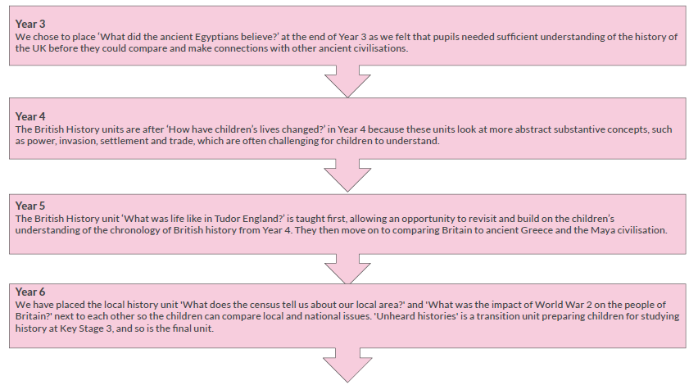

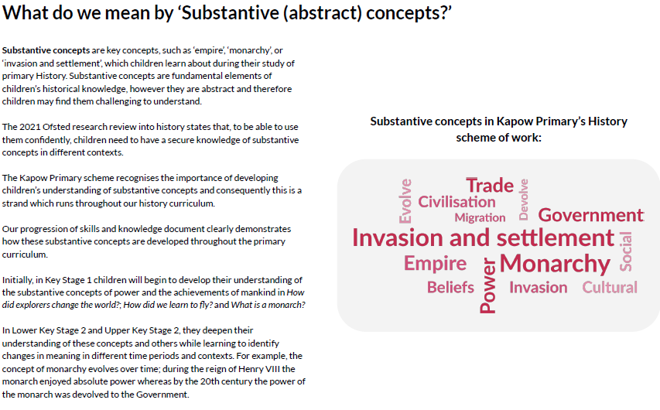

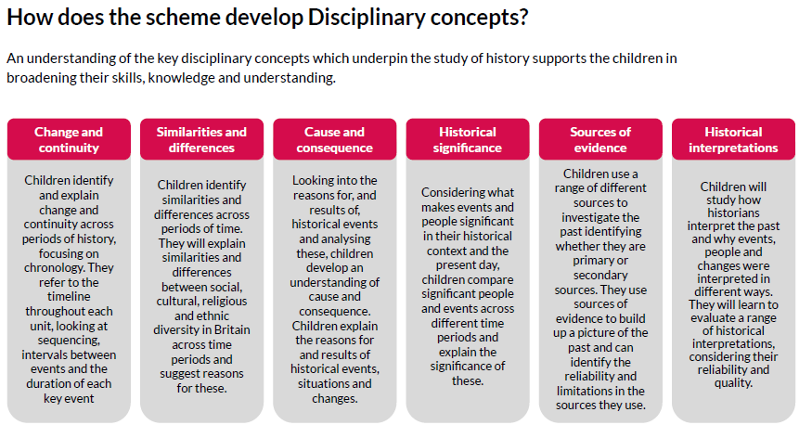

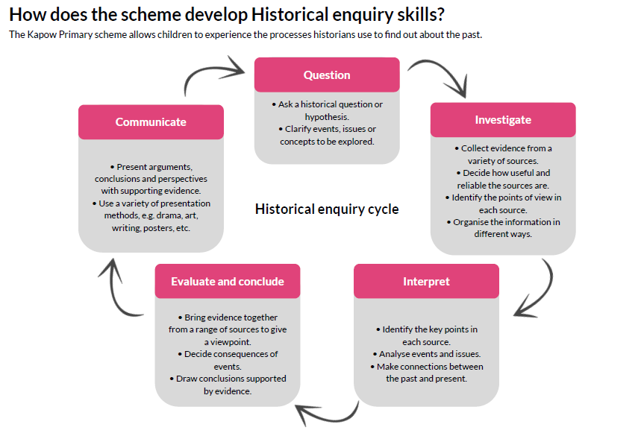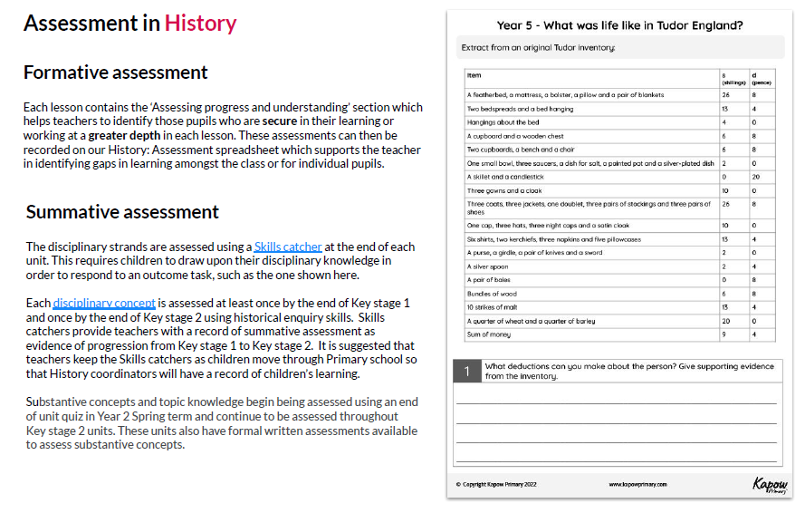
History Long Term Planning
Early Years: Understanding the World – Past and Present

All the holistic topics include some historical concepts in the ‘past and present’ strand of Understanding the World. During their time in Early Years, children will have opportunities to reflect on memories and experiences from their own past and comment on images of familiar situations in the past. Children will look for similarities and differences between photos, images and objects from the past and present day. Children to compare and contrast characters from various stories set in the past, including historical figures. Children will identify similarities and differences between characters, enhancing their understanding of the past.

 | Autumn 1 | Autumn 2 | Spring 1 | Spring 2 | Summer 1 | Summer 2
These are the key concepts about the past and present that children will learn about during their time in the Early Years | F1:  Children will begin to talk about themselves. | F1:  Children will begin to say who is in their family and become familiar with the words used to label different age groups. | F1:  Children will begin to talk about different life events (e.g. birthdays, holidays etc) | F1:  Children will begin to listen when others talk about themselves and their families | F1:  Children will begin to recognise the sequence of time relating to ‘age’ – baby- toddler- child- teenager- adult etc | F1:  Children will begin to recognise similarities and differences between themselves, their family members and those of their friends
 | F2:  Children will know about their own life story and how they have changed. | F2:  Children will talk about the lives of people around them and begin to acknowledge different age groups. | F2:  Children will know about some similarities and differences between things in the past and now. | F2:  Children will talk about past and present events in their lives and what has been read to them. | F2:  Children will know about the past through settings and characters. | F2:  Children will know about the past through settings, characters and events.

History Long Term Planning Key Stage 1
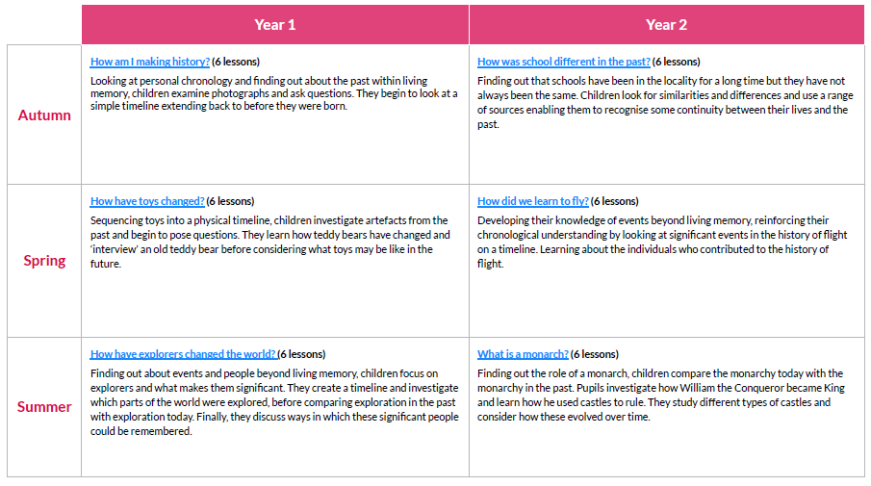

History Long Term Planning Lower Key Stage 2
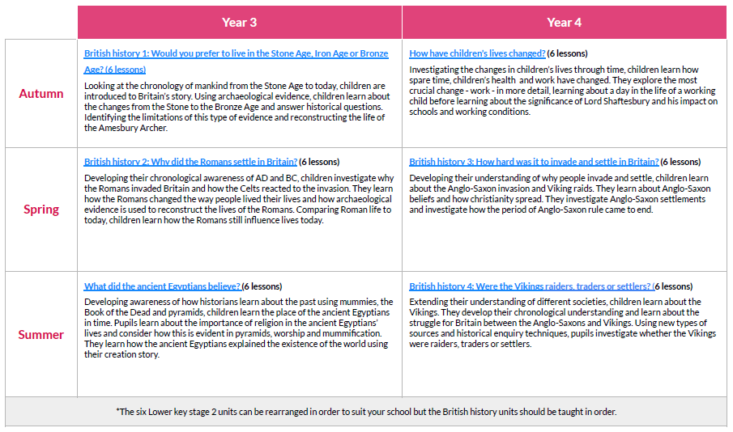
History Long Term Planning Upper Key Stage 2
