You tube – restricted mode
To set restrictions on you tube – follow instructions on the links below.
https://www.youtube.com/intl/en_be/howyoutubeworks/user-settings/parental-controls/#supervised-experience-on-youtube
https://support.google.com/youtube/answer/7354993?hl=en-GB
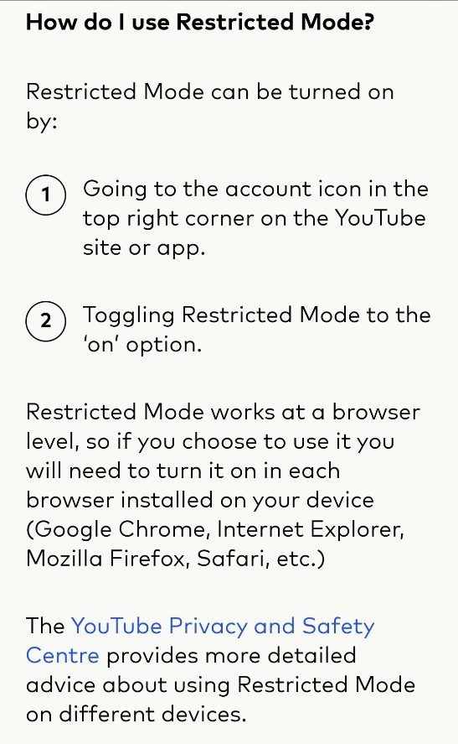

There is also a video from Internet Matters.com – you can follow the instructions here;
https://www.internetmatters.org/parental-controls/entertainment-search-engines/youtube-restricted-mode/

