Sport Newsletter 2022-23
I can’t believe it is nearly the end of another academic year and what a year it has been for sport at The Ellis! I thought it would be nice to share some of the achievements we have had over the year.
During the year we attended 38 events, with a few more still to fit in before the end of term. Some weeks we have had up to 4 trips happening with sport!
Nearly all children across Key Stage 1 and 2 have competed in an event, either in or away from school, and those who haven’t, have all experienced some form of sport additional to PE, through our enrichment activities.
Autumn Term
- KS2 Cross Country – Winners of both the boy and girl events in Y5 and Y6
- Y5/6 Tag Rugby event – Winners and progressed to the South Yorkshire Finals
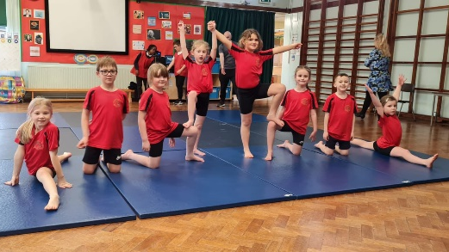
- Y3 Kick Rounders event - 2nd place
- Skipping Festival
- Gymnastics have a go session – KS2
- Gymnastics have a go session – KS1
- KS1 Football
- Y3/4 Football
- Y5/6 Football - Winners
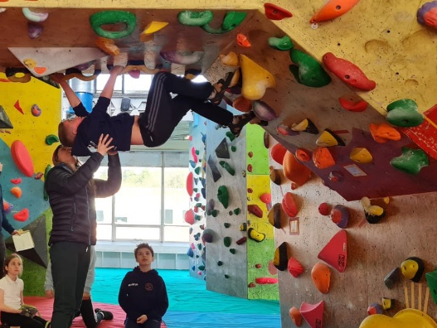
- Y5/6 Netball – Winners
- Y6 Transition Netball

Spring Term
- Aqua Fest
- Inclusive Boccia
- Football Finals Boys
- Bouldering- 6 children through to the county finals
- Bouldering County Finals – one child finished 2nd out of 700 children
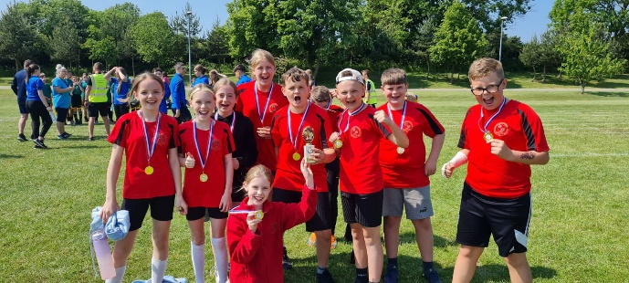
- Handball
- KS1 Gymnastics – Joint Winners
- Dodgeball
- Y3/4 Orienteering
- Y5/6 Sportshall Athletics
- Y5/6 Handball
- Y5/6 Teambuilding
Summer Term
- Y5/6 Cricket Boys – Winners
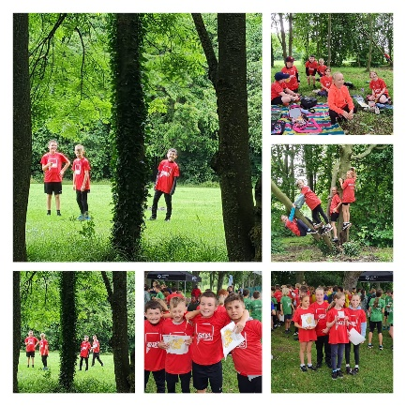
- Y5/6 Cricket Girls - Winners
- School Games Orienteering KS2 – Y5/6 Boys Winners, Y5/6 Girls Winners, Y3/4 Girls 2nd, Y3/4 Boys 3rd
- Orienteering County Finals – Y3/4 2nd out of the whole of Yorkshire
- Cricket County Finals Girls
- Cricket County Finals Boys
- Inclusive Glow Disco
- Y5/6 Rounders – Winners
- Inclusive Athletics
- Y3/4 Cricket – Attended event and advanced through to the county finals
- Y3/4 Handball
- Y5 Cross Country
Events still to come:
- Tri Golf competition
- Sports Day
- Swimming Gala
- Y6 Bike and Scooter Experience

As you can see, we have had some amazing success stories throughout the past year. To progress through to so many county finals events, in many different sports, shows what amazing and talented children we have at The Ellis. I am so lucky to work with a fantastic team who see the value sport has in school, and who have been very amenable whilst having children and staff taken from their lessons. Special thanks go to Mrs Fiddes for helping with the logistics to ensure events go ahead and for being so versatile when I announce we have a last minute event we need to attend! Also to Mrs Connelly, for making sure all the kits are washed and for attending the events with the children, often exceeding their levels of enthusiasm and passion for the sport!

Additional to these events the children in Key Stage 1 and 2 have also participated in enrichment days in Taekwondo, bike and scooter experiences, Bikeability, tennis and cricket, to name just a few. If anyone knows of any different experiences we may enjoy as enrichment for the children, please don’t hesitate to get in touch.
Individually, we have some exceptional students who participate at a high level outside of school. We have children who compete for their clubs at swimming and netball, footballers who have been signed by Sheffield Wednesday FC, a boy in Y3 who had the experience of playing at the Stade de France during May Half Term and their team won the Europa Cup. I love hearing about all your children’s achievements from out of school. Please feel free to tweet @theellissport to keep me updated of things you are doing outside of school.
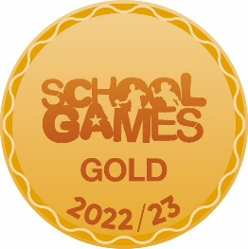
One final achievement for the school is being awarded the School Games Gold Mark for 2022-23. Things we have done to achieve this are: attendance at many cluster and School Games events, encouraging 60 active minutes additional to PE sessions for children and developing a challenging and progressive curriculum.
As you may be buying new uniform for the next school year soon, please may I remind you that our PE kit is plain black shorts and a plain white t-shirt (with or without a school logo). Children may require jogging bottoms when doing PE outside. Trainers should be worn for all outdoor PE.
I wish you all a lovely summer and look forward to many events in the coming year.
Thank you for your continued support.
Miss Cook

