How to access ‘family friendly’ settings on TikTok.
- Go to your child’s profile page and select the 3 horizontal lines in the top right-hand corner.

- Select ‘settings and privacy’

- Select ‘family pairing’
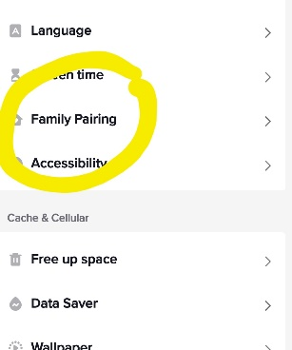

- Follow instructions to set safe controls on your child profile.
