**Reading in the Early Years**

Sharing a book with your child is such a basic, enjoyable activity that parents can do to help their children but it is also crucial to a child’s literacy development. It is important to note that every child is different and develops reading skills at a different pace. You will also find certain books and illustrations may engage them more than others as this will be strongly linked to their interests and experiences.

Why is reading so important?

Reading has a direct impact on the children’s access to the curriculum – much of the curriculum relies on children being able to read and make sense of the environment around them.

Reading helps children to understand Standard English.

Through listening to and reading stories, children will begin to understand grammar.

Children develop their writing skills through reading books. They see what writing is for. It can also initiate opportunities for mark making such as drawing pictures from the story or having a go at writing such as writing letters to characters (e.g. to Jack to thank him for the bean seeds).

Reading books develops children’s vocabulary e.g. such as the descriptive language in the stories *We’re going on a Bear Hunt and The Rainbow Fish etc.*

Reading is an enjoyable experience in itself and that is something we must try to develop in children.

Reading book help children make sense of their experiences and those of others e.g. relating it to their own familiar experiences/situations.

Reading and Language Development

During the early stages of reading development, children need to recognise letters, be aware of and able to manipulate sounds within words, and use conventions about the relationship between letters and their pronunciation. For this reason, children need good speaking and listening skills and therefore need exposure to a language rich environment from the start. Our main aim in the EYFS is to develop and extend the children’s speaking and listening through providing them with regular story-times each day, talking to the children during play, providing them with access to high quality provision to extend their vocabulary. For children who need additional support to develop their communication and language skills we provide targeted interventions such as Speech & Language Therapy or access to the WellComm Language Programme or Nuffield Early Language Intervention Programme (in Reception).

**How do we teach reading at The Ellis?**

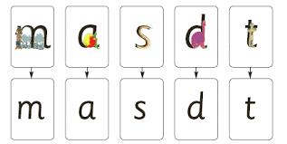One of the main ways that we teach reading is through phonics. We begin in FS1 teaching the children to hear and distinguish sounds around them. This includes listening to and distinguishing between environmental and instrumental sounds, hearing rhythm and rhyme, alliteration and sounds in words. Once children have mastered this skill, we use the Read Write Inc. scheme to teach children how to link letters to sounds. In Set 1, the children learn to hear initial sounds in words and match these to the written letter (grapheme). Each sound has a picture prompt to help them remember the letter and understand how to write them.

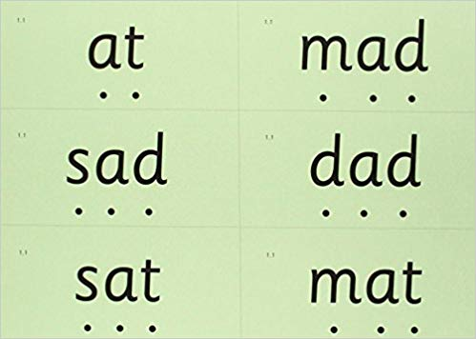The Read Write Inc. phonics scheme helps young children to link sounds to letters. When the children recognise enough letter sounds they are taught to use their segment and blend the sounds the sounds in words. We call this ‘***Fred Talk***’.

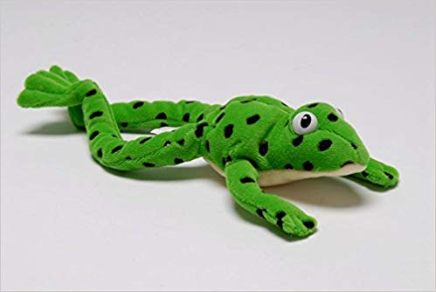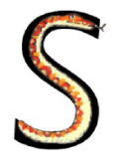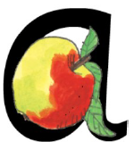

This is Fred Frog who

loves to talk in sounds

e.g. c-a-t, d-o-g, h-e-n.

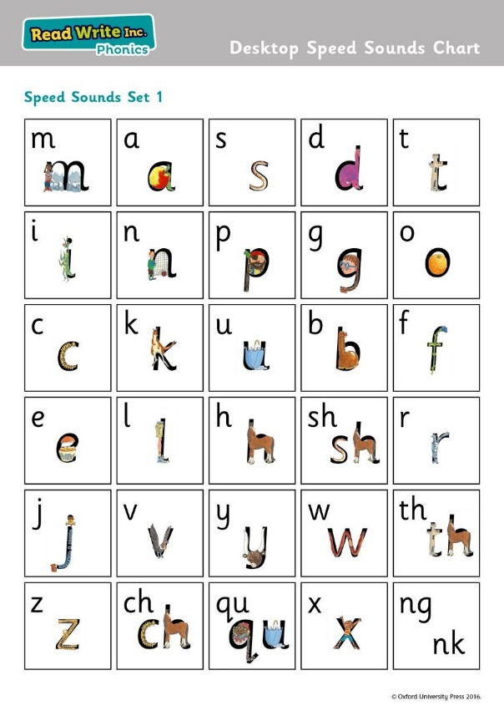**Set 1 Sounds**are taught in the following order together with rhymes to help children form the letters correctly and instantly recognise sounds ready for blending. Children will also use pictures for each sound to help recognise the sound and then form the shape of the sound.

Set 1 sounds and rhymes

|  |  |  |  |  |
| --- | --- | --- | --- | --- |
| **m** Maisie Mountain Mountain  Down Maisie then over the two mountains. | **a** back around the apple, up and down the leaf | **s** slide around the snake | **d** back around the dinosaur’s back, up his neck and down to his feet | **t** down the tower across the tower |
| **i** down the insect’s body, dot the head | **n** down Nobby and over the net | **p** down the plait up and over the pirate’s head | **g** round the girls face, down her hair and give her a curl | **o** back around the orange |
| **c** curl back around the caterpillar | **k** down the kangaroo’s body tail and leg | **u** down and under the umbrella, up to the top and down to the puddle | **b** down the laces, bounce it up and over the toe and touch the heel | **f** down the stem and draw the leaves |
| **e** slice into the egg, go over the top, then under the egg | **l** down the long leg | **h** down the horse's head to the hooves and over his back | **sh** shsh said the snake to the horse | **r** down the robot's back, then up and curl |
| **j** down his body, curl and dot | **v** down a wing, up a wing | **y** down a horn, up a horn and under the yak's head | **w** down, up, down, up the worm | **th** thank you said the princess in the tall tower to the horse |
| z zig-zag-zig, down  the zip | **ch** the caterpillar made the horse sneeze | **qu** round the queen’s head, up to her crown, down her hair and curl | **x** cross down the arm and leg and cross the other way | **ng**  thing on a string  **nk** I think I stink |

The children are then taught **Set 2 Sounds**- the vowel sounds. In Read Write Inc. the two or three letters join together as ***special friends*** to make one sound.

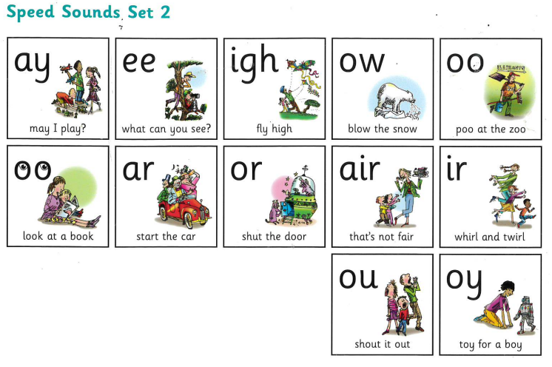

Red and Green words:

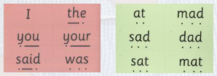The children are taught tricky ‘red’ words (most of these words have to be learned by sight) and practise decoding ‘green words’ using the sounds that they have learnt so far.

Alongside learning to decode the words on the page, children also learn comprehension skills. This helps them to make sense of what the words say and what the text means. Together, these skills help children on their way to becoming keen and confident readers.

In addition to Read Write Inc., we also teach children the following reading conventions:

* How to hold books the correct way up and turn the pages correctly.
* Know that print carries meaning and is read from left to right and top to

bottom.

* Point to each word as we read them.

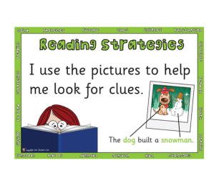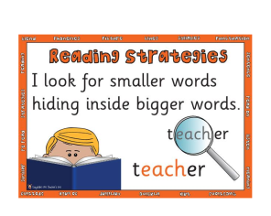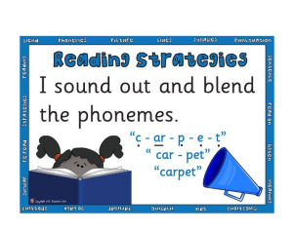We teach the following reading strategies:-

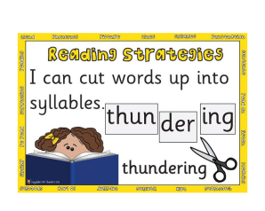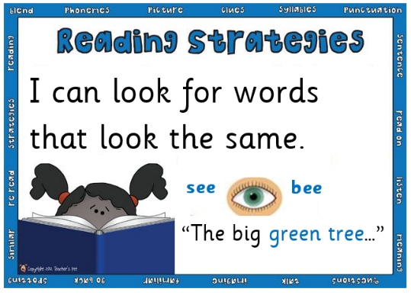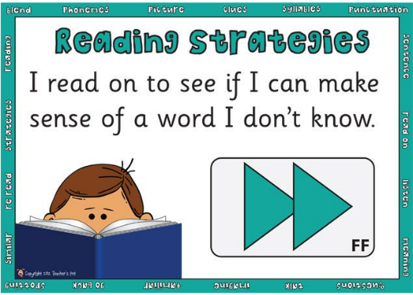

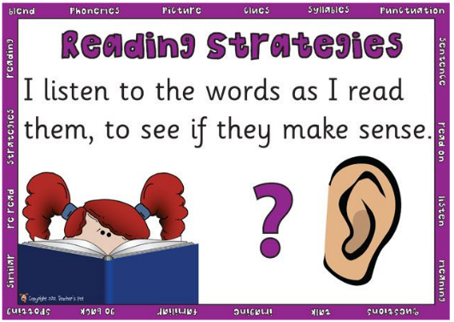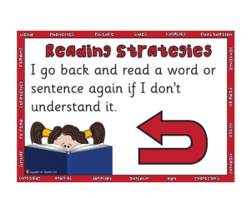

Below is an overview of how we teach reading at The Ellis:

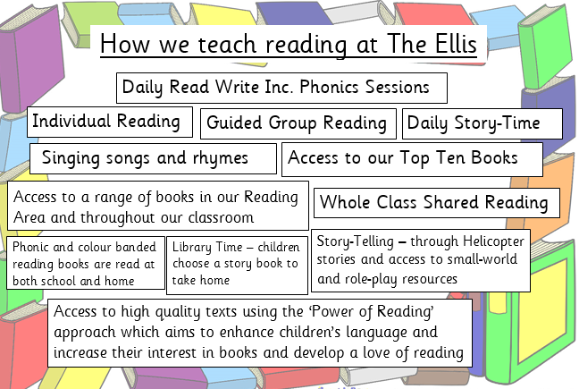

## How to help at your child read at home

There are lots of ways you can help your child with reading in Reception. Here are some good ideas.

### 1. Play rhyming games

Say ‘into the pot goes’ while pretending to place objects that rhyme into a pot (for example, a bat, a hat, a cat, a mat). Do this with your child and then see if they can do it independently.

You can turn this into a game by throwing in words that don’t rhyme, and asking your child to catch these ones out. For example, a cat, a hat, a bird – this last word shouldn’t go in the pot!

### 2. Play phonics word games

Play simple phonics word games based on the sounds your child is learning and has learned at school. Start off using just the speech sounds and then immediately say the word. For example, you could say, ‘At the shop I will buy a /m/ /a/ /p/ – map, a /b/ /e/ /d/ – bed, a /d/ /u/ /ck/ – duck.’ Then, trying just saying the sounds and asking your child to work out and say the whole word.

### 3. Say the sounds right

In all games and activities, make sure you pronounce speech sounds clearly. Try to make them as short as possible – for example, the letter m has a short /m/ sound, not a continuous /mmmmmmm/ sound. Try not to add an extra sound onto the speech sound either (for example, the sound is /m/ and not /m-uh/).

### 4. Listen to your child read

In Reception, your child will bring home books to read. Try to find time to hear them read every day. It could be snuggled up on the sofa, at bedtime, or before school. Be sure to be patient and don’t forget to be impressed! If your child gets stuck on a word, remind them to say the letter sounds individually and then blend them together quickly to hear the word. If your child still can’t work out the word, then tell them what it is and move on.

### 5. Read to your child

Learning to read can be hard work for many children, so it’s important to keep enjoying books together. Your child will also benefit from listening to books and stories that they can’t read themselves yet. This might include non-fiction books about things they are interested in or longer stories with more adventurous vocabulary.

Further support:

Please watch the videos below to find out more information about how to support your child’s early reading development.

What is Read Write Inc. phonics?

<https://www.youtube.com/watch?v=sjlPILhk7bQ>

How to pronounce pure sounds

<https://www.oxfordowl.co.uk/for-home/reading-owl/find-a-book/read-write-inc-phonics--1/phonics-pure-sounds-video>

What is blending?

<https://www.oxfordowl.co.uk/for-home/reading-owl/find-a-book/read-write-inc-phonics--1/sound-blending-phonics-video>

Why read to your child?

<https://www.youtube.com/watch?v=kjHqJQ8sxs4>

10 things to think about when reading with your child

<https://www.youtube.com/watch?v=iHMl70ZmxIQ>

There is more information about reading and phonics on the following websites:

<https://home.oxfordowl.co.uk/reading/reading-schemes-oxford-levels/read-write-inc-phonics-guide/>

<https://www.ruthmiskin.com>