Dear Parent/Carer,

We have been busy making Easter gifts in class.

If you would like to buy your child’s gifts please see the description and price below.

Please send money into class in an envelope with your child’s name on stating which gift(s) you would like.

All money raised from these gifts will be used to buy equipment for the indoor and outdoor environment.

Many thanks and kind regards,

Mr Grayhurst and Mrs Beevers

Hand-decorated egg cup £2.00

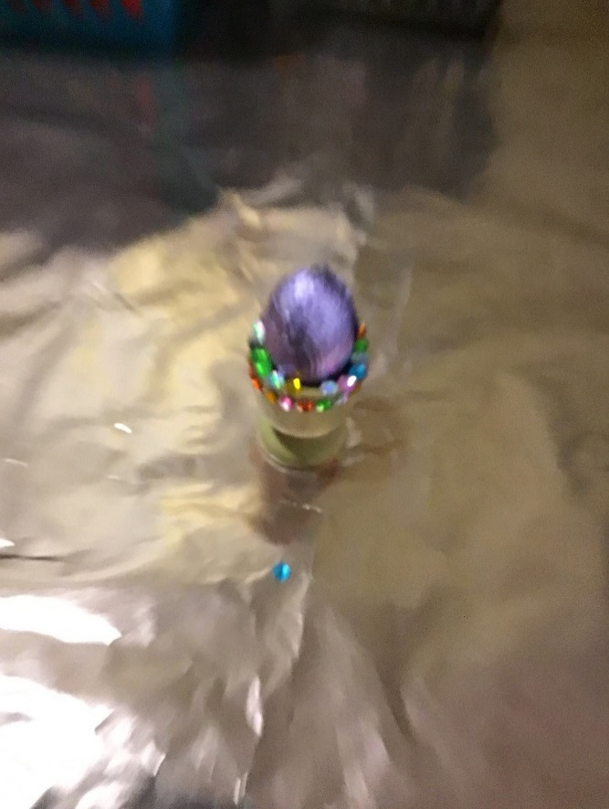

Hand decorated plant pot with flowering plant and an Easter surprise ☺ £1.50

