Dear Parents/ Carers,
We have been busy making Easter gifts in Nursery.
If you would like to buy your child’s gifts please see the description and price below.
Please send all money into Nursery in an envelope with your child’s name on stating which gift(s) you would like.
All money raised from these gifts will be used to buy equipment for the indoor and outdoor environment.
Thank you
Mrs. T. Pollard

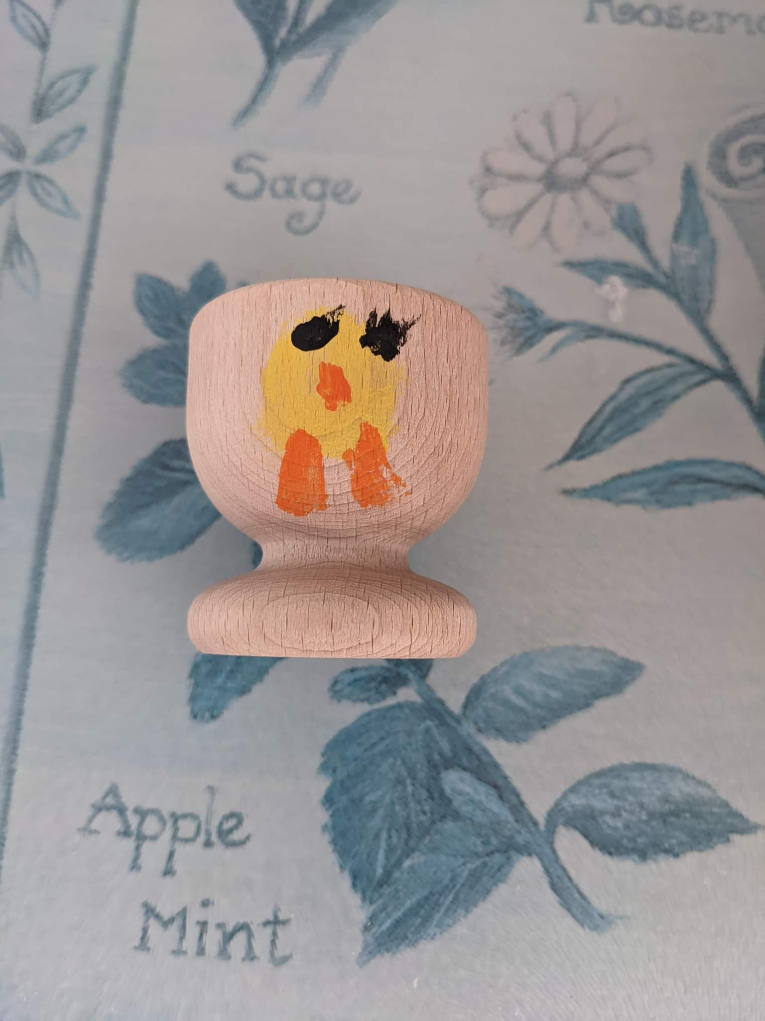Hand-decorated egg cup £2.00

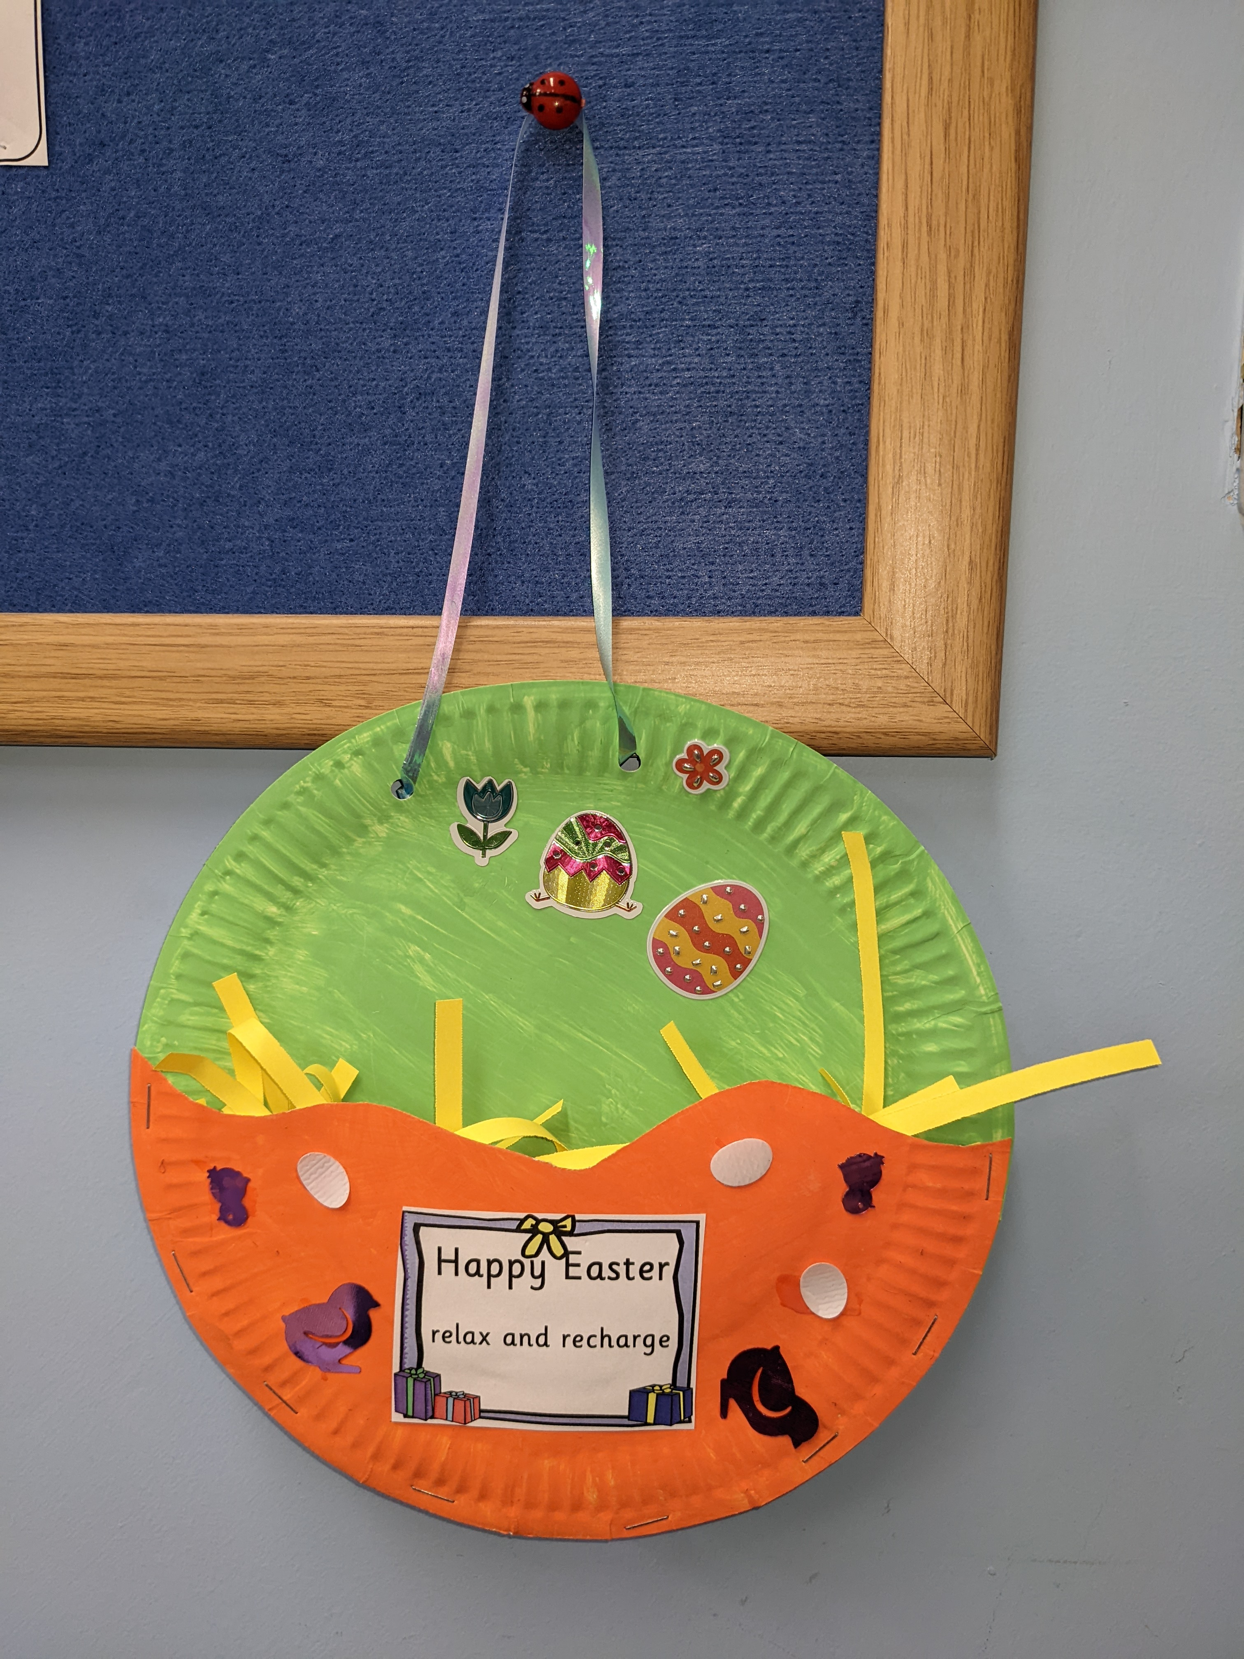Paper plate hanger (including surprise gifts inside) £2.00

Thank you
Mrs. Pollard & Mrs. Kelly

