The Ellis Calculation Policy
This calculation policy has been created to meet the expectations of the new national curriculum but most importantly the learning needs of our children at The Ellis. The methods have been chosen to match the national curriculum but have also been specifically selected after consideration of our children’s learning styles.
Age Expectations
The policy has been organised by year group, considering the national curriculum 2014 expectations. The new curriculum focuses on skills and mastery and is not about moving children on to the next method as soon as they can do the one before. Working on more complex and richer problems rather than new methods will support this ‘mastering’ of maths. However, some children will be working at levels well above their age and will require the introduction of new methods. Some children will not yet be ready to work on methods identified for their year group and maths learning needs to be adapted and personalised for these children.
Mental Methods
The concrete resources, visual models and written methods in this document are important but they by no means meant as a replacement of mental methods. As children become more mature and confident with their calculation, they need to start following these 4 steps when approaching problems:
- Can I solve this using a mental method in my head?
- Do I need some jottings to help me?
- Do I need to use a written method to solve this problem?
- Do I need to use apparatus (including a calculator) to solve this problem?

Mental maths and regular practice of mental methods for quick calculations is a key part of learning. The use of arithmetic practice and tools such as Times Table Rockstar, Big Maths, Hit the button, IXL maths, Operation maths ad Maths Rocks are important as part of the process to develop fluent mathematicians.

Addition
Foundation Stage
Key vocabulary
Games and songs can be a useful way to begin using the vocabulary involved in addition. add, more, plus, makes, total, altogether, score, double, one more, two more, ten more how many more to make…? how many more is … than …?
Key skills
- Select the correct numeral to represent 1 to 5, then 1 to 10 objects.
- Count an irregular arrangement of up to ten objects.
- Estimate how many objects they can see and check by counting them.
- Use the language of ‘more’ and ‘fewer’ to compare two sets of objects.
- Find the total number of items in two groups by counting all of them.
- Say the number that is one more than a given number.
- Find one more from a group of up to five objects, then ten objects.
- In practical activities and discussion, begin to use the vocabulary involved in addition.
- Record, using marks that they can interpret and explain. (Note: children should start learning how to form numerals 0-9 correctly during FS)
- Begin to identify own mathematical problems based on own interests and fascinations.
Key models and manipulatives
- Fingers
- Counters
- Range of objects (cubes, compare bears, cards, etc.)
- Numicon
- Number blocks (cbeebies)
- Tens frames
- Part whole model
- Number tracks
- Number cards
- Rekenreks
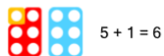
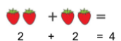
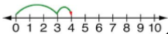
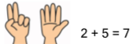

Addition
Year 1
Focus
Adding with numbers up to 20.
Key vocabulary
sum, total, parts and wholes, plus, add, altogether, more than, and, make, altogether, total, equal to, equals, the same as, double, most, count on, number line
Key skills
- Reading and writing numbers to 100 in numerals.
- Writing numbers to 20 in words including correct spelling.
- Counting to and across 100 in ones.
- Counting in multiples of 2, 5 and 10.
- Solving simple one step addition problems: using objects, number lines and images to support.
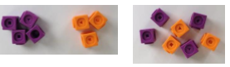
Methods
Using manipulatives to add
Drawing more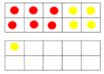
Adding on a number line
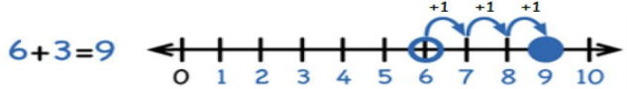
Key models and manipulatives
- Part whole models
- Bead strings
- Numicon
- Number lines
- Double sided counters
- Tens frames
- Number tracks
- Number cards
- Place value counters
- Tens and ones sticks
- Rekenreks

Addition
Year 2
Focus
Adding with 2 digit numbers.
Key vocabulary
sum, total, parts and wholes, plus, add, altogether, more than, and, make, altogether, total, equal to, equals, the same as, double, most, count on, number line, tens, ones, columns, count on, partitioning, tens, ones
Key skills
- Add a 2-digit number and ones and a 2-digit number and 10s.
- Add pairs of 2-digit numbers.
- Add three single digit number.
- Know and show that adding can be done in any order (the commutative law).
- Recall bonds to 20 and multiple of 10 bonds to 100.
- Count in steps of 2,3 and 5 and count in 10s from any number.
- Understand the place value of 2 –digit numbers (tens and ones).
- Compare and order numbers to 100 using < > and = signs.
- Read and write numbers to at least 100 in numerals and words.
- Solve contextual addition problems.
Methods
Adding on a blank number line.
Pictorial representation of tens and ones- the children drawing the images
Partitioning and adding (not crossing tens)
Partitioning and adding (crossing tens)
Partitioned column addition
Key models and manipulatives
- Part whole models
- Bar models
- Bead strings
- Numicon
- Number lines
- Double sided counters
- Tens frames
- Number tracks
- Arrow cards
- Place value counters
- Tens and ones sticks (base ten)
- Place value grids
- Rekenreks

Addition
Year 3
Focus
Adding with numbers up to 3 digits.
Key vocabulary
Add, more, plus, and, make, altogether, total, equal to, equals, the same as, double, most, count on, number line, sum, tens, ones, partition, addition, column, tens boundary, hundreds boundary, increase, vertical, carry
Key skills
- Read and write numbers to 1000 in numerals and words.
- Add 2 digit number mentally including those that bridge 100.
- Add a 3 digit number and ones, a 3 digit number and 10s and a 3 digit number and 100s mentally.
- Estimate answers to calculations, using the inverse operation to check.
- Solve problems, including missing number problems using number facts and place value.
- Recognise the place value of each digit in a 3 digit number (hundreds, tens and units).
- Continue to practice many different mental addition strategies including adding to the nearest multiple of 10, 100, 1000 and adjusting, using number bonds, using near doubles, partitioning and recombining etc.
Methods
Addition on a blank number line
Column addition
Efficient mental calculation
Key models and manipulatives
- Bar model
- Part whole model
- Number lines
- Place value counters
- Hundreds, tens and one sticks (base ten)
- Place value grids
- Place value arrow cards

Addition
Year 4
Focus
Adding with numbers up to 4 digits.
Key vocabulary
Add, more, plus, and, make, altogether, total, equal to, equals, the same as, double, most, count on, number line, sum, tens, ones, partition, addition, column, tens boundary, hundreds boundary, increase, vertical, carry, expanded, compact, thousands, hundreds, digits, inverse.
Key skills
- Select most appropriate method: mental, jottings or written and explain why.
- Recognise the place value of every digit in a 4 digit number.
- Round any number to the nearest 10, 100 or 1000.
- Estimate and use inverse operations to check answers.
- Solve 2 step problems in different contexts, picking the correct operation to use.
- Find 100 more or less than a number.
- Continue to use a wide range of mental addition methods.
- Add numbers with up to 4 digits using column addition.
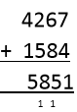
Methods
Column method

Efficient mental calculation
Key models and manipulatives
- Bar model
- Part whole model
- Number lines
- Place value counters
- Hundreds, tens and one sticks (base ten)
- Place value grids
- Place value arrow cards

Addition
Year 5
Focus
Adding with more than 4 digits (including introduction of decimals)
Key vocabulary
Add, more, plus, and, make, altogether, total, equal to, equals, the same as, double, most, count on, number line, sum, tens, ones, partition, addition, column, tens boundary, hundreds boundary, increase, vertical, carry, exchange, expanded, compact, thousands, hundreds, digits, inverse, decimal place, decimal point, tenths, hundredths, thousandths.
Key skills
- Add increasingly large numbers mentally using an expanding range of strategies.
- Use rounding to check answers and make estimates.
- Understand the place value of tenths and hundredths.
- Solve multi step problems in different contexts, deciding which operations and methods to use and explaining why.
- Read, write, order and compare number to 1 million.
- Round any number to 1 million to the nearest 10, 100, 1000, 10 000 or 100 000.
- Add numbers with more than 4 digits using column addition.
Methods
Column addition (including decimals)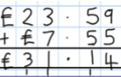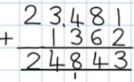
Efficient mental calculation
Key models and manipulatives
- Bar model
- Part whole model
- Place value counters
- Place value grids
- Place value arrow cards

Addition
Year 6
Focus
Adding several numbers with increasing levels of complexity.
Key vocabulary
Add, more, plus, and, make, altogether, total, equal to, equals, the same as, double, most, count on, number line, sum, tens, ones, partition, addition, column, tens boundary, hundreds boundary, increase, vertical, carry, exchange, expanded, compact, thousands, hundreds, digits, inverse, decimal place, decimal point, tenths, hundredths, thousandths, integer
Key skills
- Solve problems mentally, including those with mixed operations and large numbers, using all the mental strategies learnt in previous years.
- Solve multi step problems in context, deciding which operations and methods to use.
- Use estimation to check answers to a calculation.
- Read, write order and compare numbers to 10 million and understand the value of each digit.
- Round any whole number to the nearest 10, 100, 1000, 10 000, 100 000, 1 000 000 or 10 000 000
- Round decimal numbers to the nearest whole number.
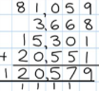
Methods
Column addition
Efficient mental calculation
Key models and manipulatives
- Bar model
- Place value counters
- Place value grids
- Place value arrow cards

Subtraction
Foundation Stage
Key Vocabulary
Games and songs can be a useful way to begin using the vocabulary involved in subtraction: e.g. Five Little Men in a Flying Saucer, Ten Green Bottles, Five Currant Buns.
Take, take away, leave, subtract, minus, equals, number sentence, count back, one less, two less, ten less how many are left / left over? how many have gone? how many fewer is … than …?
Key skills
- Select the correct numeral to represent 1 to 5, then 1 to 10 objects.
- Count an irregular arrangement of up to ten objects.
- Estimate how many objects they can see and check by counting them.
- Use the language of ‘more’ and ‘fewer’ to compare two sets of objects.
- Say the number that is one less than a given number.
- Find one less from a group of up to five objects, then ten objects.
- In practical activities and discussion, begin to use the vocabulary involved in subtraction
- Record, using marks that they can interpret and explain. (Note: children should start learning how to form numerals 0-9 correctly during FS)
- Begin to identify own mathematical problems based on own interests and fascinations.
Key model and manipulatives
- Fingers
- Counters
- Range of objects (cubes, compare bears, cards, etc.)
- Numicon
- Number blocks (cbeebies)
- Tens frames
- Part whole model
- Number tracks
- Number cards
- Rekenreks
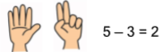
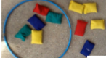
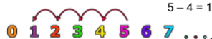
Subtraction
Year 1
Focus
Subtracting numbers within 20
Key vocabulary
Equal to, take, take away, less, minus, subtract, leaves, distance between, difference between, how many more, how many fewer/less than, most, least, count back, how many left, how much less is_?, part, whole
Key skills
- Given a number, say one more or one less.
- Count to and over 100, forward and back from any number in 1s.
- Represent and use subtraction facts to 20 and within 20.
- Subtract with one digit and 2 digit numbers to 20, including zero.
- Solve one step problems that involve subtraction using objects, pictures and numbered lines.
- Read and write numbers to 100 in numerals.
- Write numbers in words to 20s, including correct spelling.
Methods
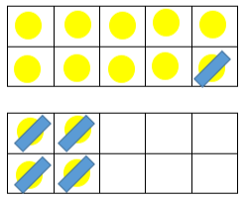
Taking away on a number line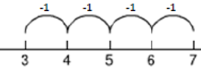
Taking away by crossing out.

Key models and manipulatives
- Part whole models
- Bead strings
- Numicon
- Number lines
- Double sided counters
- Tens frames
- Number tracks
- Number cards
- Place value counters
- Tens and ones sticks
- Rekenreks

Subtraction
Year 2
Focus
Subtracting with 2 digit numbers
Key vocabulary
Equal to, take, take away, less, minus, subtract, leaves, distance between, difference between, how many more, how many fewer/less than, most, least, count back, how many left, how much less is_?, count on, strategy, partition, tens, one, part, whole, exchange
Key skills
- Recognise the place value of each digit in a 2 digit number.
- Recall and use subtraction facts to 20 fluently, use to derive related facts to 100.
- Subtract using objects, images, 100 squares and mentally including a two digit number and ones, a two digit number and 10s and two 2 digit numbers.
- Understand and show that subtraction calculations cannot be done in any order.
- Use the inverse relationship between + and – to check calculations and solve missing number problems.
- Solve simple subtraction problems in context using written and mental methods.
- Read and write numbers to at least 100 in numerals and words.
Methods
Counting back on a blank number line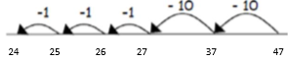
Pictorial representation- drawing tens and ones
Partition column method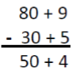
Key models and manipulatives
- Part whole models
- Bar model
- Bead strings
- Numicon
- Number lines
- Double sided counters
- Tens frames
- Number tracks
- Number cards
- Place value counters
- Tens and ones sticks
- Place value grids
- Rekenreks

Subtraction
Year 3
Focus
Subtracting with 2 and 3 digit numbers
Key vocabulary
equal to, take, take away, less, minus, subtract, leaves, distance between, difference between, how many more, how many fewer/less than, most, least, count back, how many left, how much less is_?, count on, strategy, partition, tens, ones, exchange, decrease, hundreds, value, digit
Key skills
- Subtract mentally: a 3 digit number and 1s, a 3 digit number and 10s and a 3 digit number and 100s.
- Estimate answers and use the inverse to check.
- Solve problems in different contexts, including missing number problems.
- Find 10 or 100 more or less than a given number.
- Recognise the place value in a 3 digit number, 100s, 10s and 1s.
- Solving finding the difference problems using counting on.
- Reading and writing numbers up to 1000 in numerals and words.
Practise and develop mental strategies including subtracting near multiples of 10 and adjusting, Methods
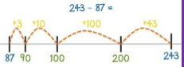
Counting back on blank number lines
Counting on on blank number lines
Column method
- counting on etc.
Key models and manipulatives
- Part whole models
- Bar model
- Bead strings
- Number lines
- Double sided counters
- Tens frames
- Number tracks
- Number cards
- Place value counters
- Tens and ones sticks
- Place value grids

Subtraction
Year 4
Focus
Subtracting with numbers up to 4 digits.
Key vocabulary
Equal to, take, take away, less, minus, subtract, leaves, distance between, difference between, how many more, how many fewer/less than, most, least, count back, how many left, how much less is_?, count on, strategy, partition, tens, ones, exchange, decrease, hundreds, thousands, value, digit, inverse
Key skills
- Subtract by counting on where numbers are close together or they are near to multiples of 10, 100 etc.
- Children select a mental, written or jotting method depending on what the problem requires.
- Children estimate and use the inverse operation to check a problem.
- Children solve 2 step problems involving + and -, picking the correct operation and method.
- Children solve simple money and measure problems with fractions and decimals.
- Find 1000 more or 1000 less than a given number.
- Count backwards through zero including negative numbers.
- Recognise the place value of each digit in a 4 digit number.
- Round any number to the nearest 10, 100 or 1000.
- Solve number and practical problems that involve increasingly large positive integers.
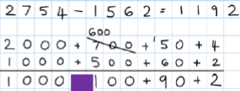
Methods
Partition column method (consolidation)
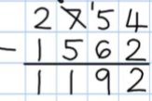
Column method

Key models and manipulatives
- Bar model
- Part whole model
- Number lines
- Place value counters
- Hundreds, tens and one sticks (base ten)
- Place value grids

Subtraction
Year 5
Focus
Subtracting with numbers beyond 4 digits including decimals
Key vocabulary
Equal to, take, take away, less, minus, subtract, leaves, distance between, difference between, how many more, how many fewer/less than, most, least, count back, how many left, how much less is_?, count on, strategy, partition, tens, ones, exchange, decrease, hundreds, value, digit, inverse, tenths, hundredths, decimal place, decimal
Key skills
- Subtract mentally with increasingly large numbers.
- Use rounding and estimation to check answers to calculations.
- Solve addition and subtraction multi step problems, deciding which operations to use and why.
- Read, write, order and compare numbers to at least 1 million and understand the value of each digit.
- Count forwards or backwards in steps of powers of 10 up to 1 million.
- Understand negative numbers in context and count forwards and backwards through 0.
- Round any number up to 1 million to the nearest 10, 100, 1000, 10 000 and 100 000.
Methods
Column subtraction (with exchange) including decimals
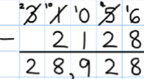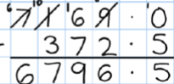
Key models and manipulatives
- Bar model
- Part whole model
- Place value counters
- Place value grids

Subtraction
Year 6
Focus
Subtracting increasingly complex numbers including decimals
Key vocabulary
Equal to, take, take away, less, minus, subtract, leaves, distance between, difference between, how many more, how many fewer/less than, most, least, count back, how many left, how much less is_?, count on, strategy, partition, tens, ones, exchange, decrease, hundreds, value, digit, inverse, tenths, hundredths, decimal place, decimal
Key skills
- Solve addition and subtraction multi step problems in context, deciding which operations to use and why.
- Read, write, order and compare numbers to at least 10 million and understand the value of each digit.
- Round any whole number up to 10 million to the nearest 10, 100, 1000, 10 000, 100 000, or 1 million.
- Use negative numbers in context and calculate intervals across zero.
- Look at a calculation and decide whether you need to use a mental method, a jotting, a written method or a calculator to solve.
Methods
Column subtraction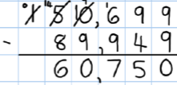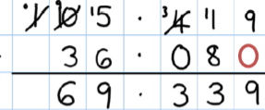
Key models and manipulatives
- Bar model
- Place value counters
- Place value grids

Multiplication
Foundation stage
Key vocabulary
Lots of, groups of, times, repeated addition, double, combine, twos, fives, tens
Key skills
- Select the correct numeral to represent 1 to 5, then 1 to 10 objects.
- Count an irregular arrangement of up to ten objects.
- Estimate how many objects they can see and check by counting them.
- Find the total number of items in two groups by counting all of them.
- Record, using marks that they can interpret and explain. . (Note: children should start learning how to form numerals 0-9 correctly during FS)
- Begin to identify own mathematical problems based on own interests and fascinations.
Key models and manipulatives
- Fingers
- Counters
- Range of objects (cubes, compare bears, cards, etc.)
- Numicon
- Number blocks (cbeebies)
- Tens frames
- Part whole model
- Number tracks
- Number cards
- Counting hoops
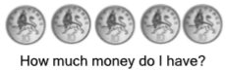
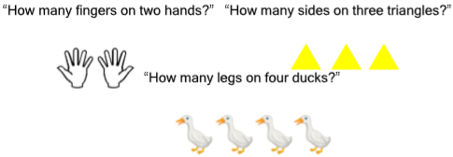

Multiplication
Year 1
Focus
Repeated addition with objects, arrays and pictorial representations
Counting in steps of 2, 5, 10
Key vocabulary
Groups of, lots of, times, array, altogether, multiply, count
Key skills
- Count in multiples of 2,5 and 10.
- Solve 1 step problems involving multiplication using objects, arrays or pictures with support.
- Make connections between arrays and counting in 2s, 5s and 10s.
- Begin to understand doubling using objects and pictorial representations.
- Solve practical problem solving activities counting equal sets or groups.
- Have lots of practice counting and bundling groups of objects into 2s, 5s and 10s.
Methods
Repeated addition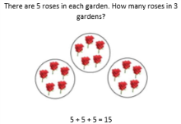
Arrays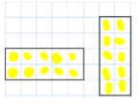
Key models and manipulatives
- Objects
- Counters
- Tens frames
- Bar model
- Arrays
- Bead strings

Multiplication
Year 2
Focus
Multiplying using arrays and repeated addition-
2 ,5, 10 x table facts
Counting in steps of 3 and 4
Key vocabulary
Groups of, lots of, times, array, altogether, multiply, count, multiplied by, repeated addition, column, row, commutative, sets of, equal groups, times as big as, once, twice, three times
Key skills
- Count in steps of 2,3 and 5 from zero and in 10s from any number.
- Recall and use multiplication facts for the 2,5 and 10 times tables.
- Recognise odd and even numbers.
- Write and calculate number statements using the x and = signs.
- Show that multiplication can be done in any order (the commutative law).
- Solve a range of multiplication problems using objects, arrays, repeated addition, mental methods and multiplication facts.
- Use and become familiar with all of the above multiplication language.
Methods
Arrays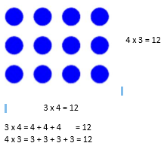
Repeated addition on a number line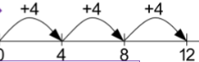
Key models and manipultives
- Counters
- Bar model
- Arrays
- Bead strings
- Number lines

Multiplication
Year 3
Focus
Multiplying 2 digit numbers by 1 digit numbers
3, 4, 6, 8 x table facts
Key vocabulary
Groups of, lots of, times, array, altogether, multiply, count, multiplied by, repeated addition, column, row, commutative, sets of, equal groups, times as big as, once, twice, three times, partition, grid method, multiple, product, tens, ones, value
Key skills
- Recall and use multiplication facts for the 2,3,4,5,6 and 10 multiplication tables and multiply multiples of 10.
- Write and calculate number sentences using known x tables.
- Answer 2 digit x 1 digit problems using mental and written methods.
- Solve multiplication problems in context including missing number problems.
- Develop mental strategies using commutativity (e.g. 4x12x5=4x5x12=20x12=240) and for missing number problems.
Methods
Grid method using arrays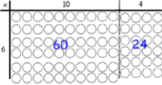
Grid method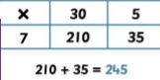
Short multiplication
Key models and manipulatives
- Counters
- Bar model
- Arrays
- Number lines
- Grids

Multiplication
Year 4
Focus
Multiplying 2 and 3-digit numbers but 1-digit numbers
6, 7, 8, 9, 11, 12 x table facts.
Key vocabulary
Groups of, lots of, times, array, altogether, multiply, count, multiplied by, repeated addition, column, row, commutative, sets of, equal groups, times as big as, once, twice, three times, partition, grid method, multiple, product, tens, ones, value, inverse
Key skills
- Count in multiples of 6,7,8,9,25 and 1000.
- Recall multiplication facts for all multiplication tables up to 12 x 12.
- Recognise place value of digits in up to 4 digit numbers.
- Multiply large numbers and multiple values mentally using place value, known facts and derived facts.
- Use commutativity mentally to solve problems.
- Solve problems in a range of contexts that are increasingly complex.
Methods
Grid method using arrays
Grid method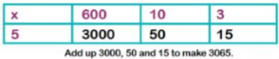
Short multiplication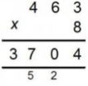
Key models and manipulatives
- Counters
- Bar model
- Arrays
- Number lines
- Grids

Multiplication
Year 5
Focus
Multiplying up to 4 digits by 1 or 2 digit numbers
Recalling times table facts up to 12 x 12
Key vocabulary
Groups of, lots of, times, array, altogether, multiply, count, multiplied by, repeated addition, column, row, commutative, sets of, equal groups, times as big as, once, twice, three times, partition, grid method, multiple, product, tens, ones, value, inverse, square, factor, integer, decimal, short/long multiplication, exchange.
Key skills
- Identify multiples and factors, using secure x table facts to 12 x 12.
- Solve problems where larger numbers are decomposed into their factors.
- Multiply and divide integers and decimals by 10,100 and 1000.
- Recognise and use square and cube numbers and their notation.
- Solve problems that have different combinations of operations, picking the most useful methods.
Methods
Short multiplication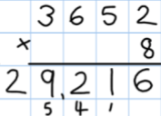

Long multiplication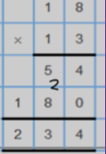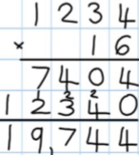
Key models and manipulatives
- Counters
- Bar model
- Arrays
- Grids
- Place value counters

Multiplication
Year 6
Focus
Consolidating long and short multiplication
Multiplying decimals
Recalling times table facts up to 12 x 12
Key vocabulary
Groups of, lots of, times, array, altogether, multiply, count, multiplied by, repeated addition, column, row, commutative, sets of, equal groups, times as big as, once, twice, three times, partition, grid method, multiple, product, tens, ones, value, inverse, square, factor, integer, decimal, short/long multiplication, carry, tenths, hundredths, decimals
Key skills
- Multiply up to 4 digits by 2 digits using long multiplication.
- Solve mixed operation and large number problems using mental methods.
- Solve multi step problems involving a range of operations.
- Estimate and approximate answers of problems to improve accuracy.
- Round any integer to the determined level of accuracy.
Methods
Short multiplication
Long multiplication
Key models and manipulatives
- Counters
- Bar model
- Arrays
- Number lines
- Grids
- Place value counters

Division
Foundation Stage
Key vocabulary
halve, share, share equally, one each, two each, three each, group in pairs / threes / tens, equal groups of, in equal parts, left, left over
Key skills
- Select the correct numeral to represent 1 to 5, then 1 to 10 objects.
- Count an irregular arrangement of up to ten objects.
- Estimate how many objects they can see and check by counting them.
- Record, using marks that they can interpret and explain. (Note: children should start learning how to form numerals 0-9 correctly during FS)
- Begin to identify own mathematical problems based on own interests and fascinations.
Key models and manipulatives
- Sharing plates
- Fingers
- Range of objects (cubes, compare bears, cards, etc.)
- Numicon
- Number blocks (cbeebies)
- Tens frames
- Part whole model
- Number tracks
- Number cards
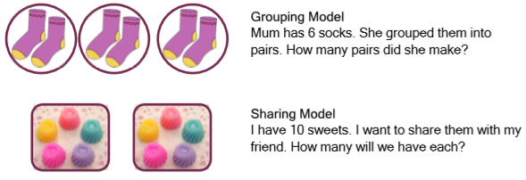

Division
Year 1
Focus
Grouping and sharing small quantities
Key vocabulary
Share, share equally, one each, two each…, group, groups of, lots of
Key skills
- Solve one step problems involving multiplication and division using concrete objects with support from adults.
- Children use grouping and sharing to understand division and to begin to understand finding simple fractions.
- Children make connections between arrays and counting in 2s, 5s and 10s.
- Children use halving and understand that this is the same as sharing into 2 equal groups.
Methods
Grouping and sharing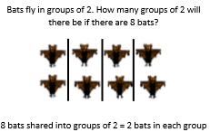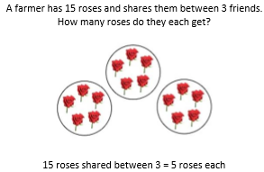
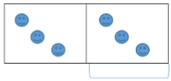
Key models and manipulatives
- Counters
- Bar model
- Sharing
- Bead strings

Division
Year 2
Focus
Grouping and sharing larger quantities
Key vocabulary
Share, share equally, one each, two each…, group, groups of, lots of, array, divide, divided by, divided into, division, grouping, number line, left, left over
Key skills
- Count in steps of 2,3 and 5 from 0.
- Recall and use x and ÷ facts for the 2,5 and 10 times tables.
- Solve division problems and write division number sentences for problems.
- Understand that division is not commutative unlike multiplication.
- Solve increasingly challenging division problems using concrete objects, arrays, and simple written methods such as grouping on a number line.
Methods
Grouping and sharing
Arrays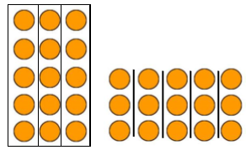
Grouping on a number line
Key models and manipulatives
- Counters
- Bar model
- Sharing
- Bead strings
- Number lines
- Arrays
- Tens and ones (base ten)

Division
Year 3
Focus
Dividing 2 digit numbers by 1 digit numbers
Key vocabulary
Share, share equally, one each, two each…, group, groups of, lots of, array, divide, divided by, divided into, division, grouping, number line, left, left over, inverse, short division, carry, remainder, multiple
Key skills
- Recall and use and ÷ facts for the 2,3,4,5,6,8 and 10 x tables (using doubling to connect the 2,4 and 8 x tables)
- Solving division problems where a 2 digit number is divided by a 1 digit number using mental and written.
- Solve problems in a variety of contexts including missing number problems.
- Pupils begin to derive related facts e.g. 9 ÷ 3 = 3 means 90 ÷ 3 = 30 or 90 ÷ 30 = 3.
- Pupils develop confidence in written methods, moving from number lines to short division.
Methods
Sharing and grouping
Grouping on a number line or in a bar model
Short division (bus stop)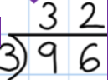
Key models and manipulatives
- Counters
- Bar model
- sharing
- Bead strings
- Number lines
- Tens and ones (base ten)
- Arrays

Division
Year 4
Focus
Consolidating and extending short division
Key vocabulary
Share, share equally, one each, two each…, group, groups of, lots of, array, divide, divided by, divided into, division, grouping, number line, left, left over, inverse, short division, carry, remainder, multiple, divisible by, factor
Key skills
- Recall multiplication and division facts for all numbers to 12 x 12.
- Use place value and known facts to derive facts mentally- including multiplying and dividing by 100, 10 and 1.
- Practise mental methods and extend this to three digit numbers using derived facts- e.g. 100 ÷ 5 = 20 so 20 x 5 = 100.
- Solve two step problems with increasingly harder numbers in a range of contexts, using language to identify the correct operation.
- Correspondence problems should be introduced such as 3 cakes are shared equally between 10 children, 1 man has 6 cats so how many cats do 3 men have etc.
Methods
Grouping and sharing
Number lines
Short division (bus stop)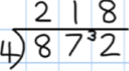
Key models and manipulatives
- Counters
- Bar model
- sharing
- Bead strings
- Number lines
- Tens and ones (base ten)
- Arrays
- Place value counters
- Place value grids

Division
Year 5
Focus
Extending use of short division to 4 digits and remainders
Key vocabulary
Share, share equally, one each, two each…, group, groups of, lots of, array, divide, divided by, divided into, division, grouping, number line, left, left over, inverse, short division, carry, exchange, remainder, multiple, divisible by, factor, quotient, prime number, prime factors, composite number (non-prime)
Key skills
- Multiply and divide numbers mentally, using known facts.
- Identify multiples and factors, including all factor pairs of a number and common factors between 2 numbers.
- Solve x and ÷ problems where larger numbers are decomposed into their factors.
- Multiply and divide whole numbers and decimals by 10, 100 and 1000.
- Use vocabulary of prime numbers, prime factors and composite numbers.
- Work out whether a number up to 100 is prime and know all prime numbers to 30.
- Use and understand multiplication and division as inverses.
- Present division with remainders answers differently, showing the remainder as a fraction, decimal or whole number by rounding.
- Solve problems with a combination of all four operations including fraction scaling problems and problems involving simple rates.
Methods
Short division (bus stop)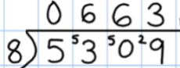
Division including remainders
Key models and manipulatives
- Counters
- Bar model
- sharing
- Bead strings
- Number lines
- Tens and ones (base ten)
- Arrays
- Place value counters
- Place value grids

Division
Year 6
Focus
Using short division to divide 4 digit numbers and express remainders as decimals and fractions
Key vocabulary
Share, share equally, one each, two each…, group, groups of, lots of, array, divide, divided by, divided into, division, grouping, number line, left, left over, inverse, short division, carry, exchange remainder, multiple, divisible by, factor, quotient, prime number, prime factors, composite number (non-prime), common factor, dividend, divisor
Key skills
- Use multiplication and division facts up to 12 x 12 to solve more complex problems.
- Decide when to use short or long division and interpret remainders in a way that is appropriate to the problem.
- Perform mental calculations for problems involving large numbers and mixed calculations.
- Identify common factors, common multiples and prime numbers.
- Use estimation to check answers to calculations and determine accuracy.
- Use written methods of division to solve decimal problems up to 2 decimal places.
- Solve problems which require rounding to 10, 100, 1000 and beyond.
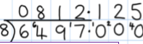
Methods
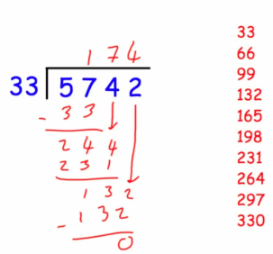
Short division (bus stop)
Long division

(Expressing remainders as decimals and fractions)
Key models and manipulatives
- Counters
- Bar model
- sharing
- Number lines
- Tens and ones (base ten)
- Arrays
- Place value counters
- Place value grids

