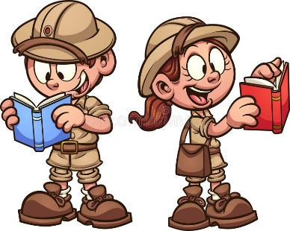
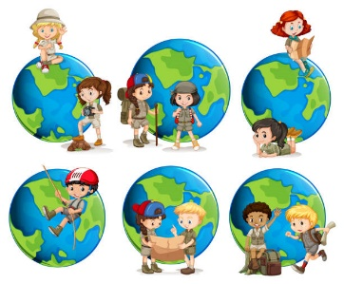
Adventurers and Explorers
Home learning ideas.

Here are some learning activities that you can do with your children at home to support their learning in school.
- Explore the routes that famous adventurers took on their expeditions.
- Look at a pirate ship and label the different parts and the jobs on board.
- Research different pirates.
- Draw and label a picture of an explorer and think about what you would need to take on an expedition
- Find out about the daily life of a pirate.
- Write a list of 10 questions you would like to ask a famous explorer
- Make a pirate ship or a meal.
- Plan an expedition
- Write an adventure story where you are the explorer and maybe you find a new land!
You can choose which of these activities you would like to do. You do not need to do all of them! We also know that you and your children have lots of original, creative ideas of your own. We love to see these too!
Please encourage your child to bring their learning into school to share.

