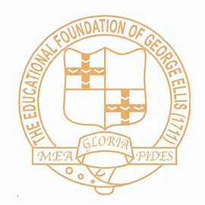
100 books to read at The Ellis
With thousands of new children’s titles published every year we’re absolutely spoilt for choice! Teachers at The Ellis have come together to compile a list of ‘100 books to read before you leave The Ellis’. We wanted to share this with you as we are often asked by parents/guardians to recommend books that can be shared at home. We are challenging our amazing children at The Ellis to read as many of these books as possible. Children will have the opportunity to access these texts in school and teachers will use these in class to inspire our learning. Please note that this list is by no means exhaustive, reading can be personal and we encourage children to independently select books.

The beginning of the reading journey… FS1

The Very Hungry Caterpillar – Eric Carle
The Gruffalo –Julia Donaldson
Elmer – David McKee
Rainbow Fish – Marcus Pfister
Owl babies – Martin Wadell
We're going on a Bear Hunt – Michael Rosen
The Smartest Giant in Town – Julia Donaldson
Room on a broom - Julia Donaldson
Each Peach Pear Plum - Janet and Allan Ahlberg
A squash and a Squeeze- Julia Donaldson
What the Ladybird Heard/ heard next- Julia Donaldson
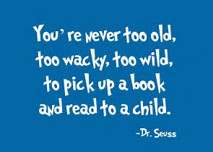
Zog - Julia Donaldson

FS2

The Tiger who came to Tea – Judith Kerr
Sharing a Shell – Julia Donaldson
Spinderella –Julia Donaldson
Shark in the park – Nick Sharratt
Handa’s Surprise – Eileen Brown
The Jolly Postman - Janet and Allan Ahlberg
Superworm – Julia Donaldson
Barry the fish with fingers – Sue Hendra
Supertato –Sue Hendra
Rumble in the jungle – Giles Andreae
Mr Wolf’s Pancakes – Jan Fearnley
How to catch a star – Oliver Jeffers
Norman the Slug with a silly shell – Sue Hendra

KS1

Charlie and the chocolate factory – Roald Dahl
The Twits – Roald Dahl
Lighthouse keeper’s lunch – Ronda and David Armitage
The man on the moon –Simon Bartram
The day the crayons quit – Drew Daywalk, Oliver Jeffers
Lost and found – Oliver Jeffers
The way back home – Oliver Jeffers
Stuck – Oliver Jeffers
A bear called Paddington – Michael Bond
Funnybones- Allan Ahlberg, Janet Ahlberg
The gigantic turnip –Irene Yates
Aliens love underpants –Claire Freedman
The true story of the Three Little Pigs - Jon Scieszka
Peace at last – Jill Murphy
Whatever next – Jill Murphy
Farmer duck - Martin Waddell · Michael Rosen · Helen Oxenbury
The owl who was afraid of the dark –Jill Tomlinson
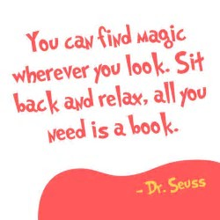
Not now Bernard – David McKee
Mr Grumpy’s outing – John Burningham
The paper bag princess - Robert Munsch, Michael Martchenko
Cake girl – David Lucas
This is the bear – Sarah Hayes
Where the wild things are – Maurice Sendak
Through the magic mirror – Anthony Browne
Get off our train – John Burningham

LKS2 (Y3 & Y4)

The Butterfly Lion – Michael Morpurgo
UG – Raymond Briggs
James and the Giant Peach – Roald Dahl
Gangsta Granny – David Walliams
The Faraway Tree – Enid Blighton
Horrid Henry Series – Francesca Simon
The Story of Tracey Beaker – Jacqueline Wilson
Please Mrs Butler – Allan Ahlberg
Animal Ark Series – Lucy Daniels
Fantastic Mr Fox – Roald Dahl
Stone Age Boy – Satoshi Kitamura
Toms Midnight Garden – Phillipa Pearce
The Secret Garden – Frances Hodgson Burnett
Oliver Twist – Charles Dickens
The Railway Children – Edith Nesbit
Stig of the Dump – Clive King
Black Beauty – Anna Sewell
Watership Down – Richard Adams
The Chronicles of Narnia – C.S.Lewis
Charlotte's Web – E.B.White
The Worst Witch – Jill Murphy
The Borrowers – Mary Norton
Swallows and Amazons – Arthur Ransome

UKS2

Goodnight Mr Tom – Michelle Magorian
Holes – Louis Sachar
Who let the Gods out? – Maz Evans
Street Child – Berlie Doherty
Matilda – Roald Dahl
The Diary of Anne Frank
Wonder – R J Palacio
Alice’s adventures in wonderland – Lewis Carroll
Sad book - Michael Rosen
When Hitler stole pink rabbit – Judith Kerr
Once – Morris Gleitzman
Skellig – David Almond
My name is Mina (prequel to Skellig) –David Almond
Private Peaceful – Michael Morpurgo
Time Travelling With a Hamster – Ross Welford
Cloud Busting – Malorie Blackman
The Arrival – Shaun Tan
Flour Babies – Anne Fine
Beetle Boy – M.G.Leonard
Harry Potter and the Philosopher’s Stone – JK Rowling
A Monster Calls – Patrick Ness
The Fantastic Flying Books of Mr Morris Lessmore – W.E.Joyce
The Invention of Hugo Cabret – Brian Selznick
Tuesday – David Weisner
Letters from the Lighthouse – Emma Carroll
The Lost Thing – Shaun Tan
Sector 7 – David Weisner
