Good afternoon,

My name is Richard Wilkinson and I work for the Yorkshire Cricket Board as a Head of Region. In a voluntary capacity I am also the Junior Coordinator for Wombwell Main Cricket Club.

Our Winter training for 2022 is starting on the 2nd February at Kirk Balk school, 6-7pm which is open to all boys and girls aged 5-12 years.

Kind regards,

Richard Wilkinson

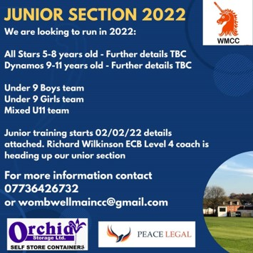

|  |
| --- |
| cid:image001.jpg@01D803CA.0207EAA0 |

