Dear Parents,

Over the holiday period, there has been a local increase in the number of reported cases of the Omicron variant of COVID and some new rules regarding testing and isolation. Although cases have risen all reports are that Omicron is a milder variant. We are aware though that this is still an anxious time for all.

The headlines are schools stay open, which is great news, as you know we have always done everything we can to remain open, however staffing may impact on this, if we have staff off with the virus.

We will operate school, as we did before the holidays if there are increased cases within a class, we will inform you and keep that class in their pod as much as possible. As a school we were already wearing masks in communal areas before Christmas, this is now mandatory.

**ISOLATION HAS CHANGED**

One of the most common misunderstandings is around counting days of isolation. The day that you test positive or first have symptoms is classed as Day 0 (see the chart below). Day 1 of counted isolation begins the following day. On Day 10, isolation finishes at 11.59pm on that day, regardless of the time of day you tested positive.

However, it is now possible to end self-isolation **early** after 7 days, **following 2 negative LFD** tests **taken 24 hours apart.** **The first LFD test should not be taken before the sixth day**. This guidance applies to all who have tested positive, vaccinated and unvaccinated adults and children.

**For example: I**f you test positive on a Saturday, you can take an LFD the following Friday (Day 6). If you take this test at 8am, then you must leave 24 hours before taking a second test, so 8am on Saturday morning (Day 7).

|  |  |  |  |
| --- | --- | --- | --- |
| **Day PCR test taken / symptoms began = Day 0** | **Day 6** |  | **Day 7** |
| Saturday | Friday | **You must leave 24 hours between each test** | Saturday |
| Sunday | Saturday | Sunday |
| Monday | Sunday | Monday |
| Tuesday | Monday | Tuesday |
| Wednesday | Tuesday | Wednesday |
| Thursday | Wednesday | Thursday |
| Friday | Thursday | Friday |

  If you have 2 negative LFD tests, one on Day 6 and one on Day 7, and **no longer have a high temperature**, you can come out of isolation straight after the second test on Day 7. If not, then you must continue to isolate as you are still shedding the virus.

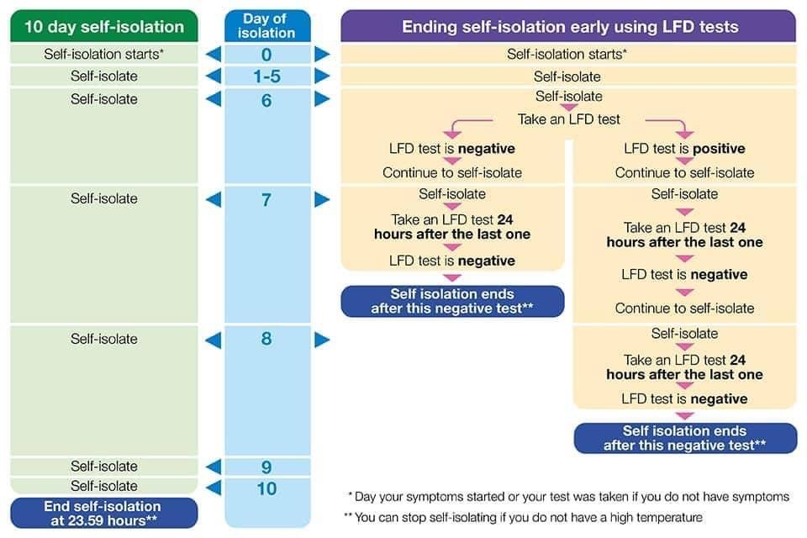

**It is still the case that children should not attend school if they have:**

* a new, continuous cough
* a high temperature
* a loss of, or change in their normal sense of taste of smell (anosmia)

**Where children have any of these symptoms, parents should not rely on an LFD (lateral flow test), but go to a testing centre for a PCR.**

**Isolating as a Contact**

If you **are fully vaccinated\*** or aged under 18 years and 6 months, and you live in the same household as someone with COVID-19, you are not legally required to self-isolate. However, you are strongly advised to take an LFD test every day for 7 days, and to self-isolate if any of these test results are positive

If you are aged 18 years 6 months or over and you are **not fully vaccinated**\*and you live in the same household as someone with COVID-19, you are legally required to stay at home and self-isolate

***\*You are fully vaccinated 14 days after having received 2 doses of an approved vaccine (such as Pfizer/BioNTech, AstraZeneca or Moderna/Spikevax) or one dose of the single-dose Janssen vaccine.***

Children and young people aged under 18 years 6 months who usually attend an education or childcare setting and who have been identified as a close contact should continue to attend the setting as normal, but should take daily LFD tests at home.

**Children under the age of 5**

Regular LFD tests are not recommended for children aged under 5. If they live with someone who has COVID-19 they are not legally required to self-isolate but you should limit their contact with anyone who is at higher risk of severe illness if infected with COVID-19 and arrange for them to take a PCR test as soon as possible.

As ever we will continue to keep you informed of any changes

Thank you for your continued support

Mrs Hurding