Dear Parents and Carers,

The Fantastic Foxes have settled into life in Year Four brilliantly and we are proud of each and every one of them for all that they have achieved during the first half term. We cannot wait for the busy half term ahead of us.

Below is information which we hope will be helpful to you:

PE
Please note that our PE days have changed and are now Tuesdays and Thursdays.
This half term children will be covering gymnastics and yoga. Please ensure that your child has their PE kit in school on those days.

Forest School
We are all really excited as it is time for Year Four to take part in Forest School sessions with Miss Batley this half term! Forest School sessions will be every Tuesday, please can you ensure that your child has suitable footwear (preferably wellies) and a coat on those days. The class will be split into two smaller teams and will take part in Forest School sessions every alternate week.

Outdoor learning
There is no such thing as bad weather, only inappropriate clothing! At The Ellis we are working hard to develop the outdoor environment and opportunities to learn outside and in Y4 we will be using our outdoor classroom and wider school environment as much as possible. This means that your child will need appropriate footwear and coats every day. Indoor pumps will be needed in school to protect our classrooms from the inevitable mud!

Transition/Staffing Changes
I will be starting maternity leave at the end of November. Mrs Kaskiewicz (who the children know very well) will be covering my maternity leave. Mrs Kaskiewicz will be in school over the next couple of weeks so that vital information can be handed over, she will also be in class to support the children’s learning. I will be sad to say goodbye to Y4 but I have no doubts that Y4 will amaze Mrs Kaskiewicz as much as they have me during the autumn term.

Reading Books
Your child may have already brought home a reading book to share with you at home, or they may have a book that they are reading at home. Please record in their reading diary when they have read to an adult or maybe an older sibling. We ask that reading diaries are in your child’s book bag every day so that we can fill them in when they have taken part in reading in school. If reading diaries are filled then we will send home a second diary free of charge, however if it is lost then we ask that a new one is bought from the office at the cost of £1. Your child is welcome to change their book any day of the week when they have completed it but it is their responsibility to ensure books are changed regularly. Children should aim to read at home at least 3 times per week and dojos will be awarded for reading.

Spelling books
The children are once again receiving spelling books. They will write in their new spellings on a Thursday and bring their book home to practise. Please support your child in learning their spellings. They will be regularly assessed in their spellings on a Friday. Their spelling books need to be in school every Friday.

Home Learning
Each half term, children are expected to complete a home learning project linked to our topic. We are always intrigued to see what our superstars have been up to! Once they have completed their project or projects (as some children prefer to do a few shorter projects, whilst others like to complete one long one), please send them into school so we can share their learning with the class. (Photos or PowerPoints can be emailed to Mrs Fiddes and will be passed onto Year 4 staff to share). Please encourage your child to take pride in their home learning and aim for a quality piece that may have taken a few sessions to complete.

Here are some learning activities that you can do with your children at home to support their learning in school.
- Explore the differences in clothing. Design a new outfit.
- Research Indian landmarks and make models.
- Look at the map of India and label key landmarks and cities.
- Draw a picture of an Indian God or Goddess and find out information about them.
- Find out about traditional Indian food and cook a meal for your family.
- Write a list of 10 questions you would like to ask a person living in India and research the answers.
- Find out about an Indian celebration and present.
- Create your own rangoli or mehndi pattern.
- Write an Indian travel guide or brochure.
- You can choose which of these activities you would like to do. You do not need to do all of them! We also know that you and your children have lots of original, creative ideas of your own. We love to see these too!
- Please encourage your child to bring their learning into school to share.

Online learning
Children are encouraged to be regularly practising spellings, time tables and areas of the curriculum online. As a school we have subscribed to websites to support the children with their learning. The children will be given their individual logins for TT Rockstars and Spelling Shed. Please support your child with their learning on these platforms. If logins have been misplaced I can issue new ones.

Topmarks maths is also a fantastic website for the children to be practising all areas of the maths curriculum using interactive games.

Our new topic is Incredible India and below is an overview of the learning we will be doing this half term.

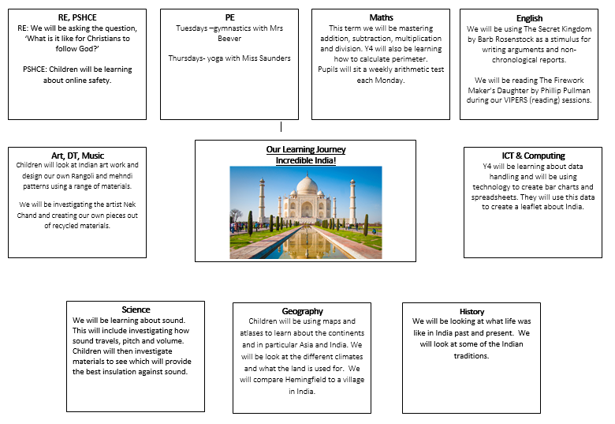

If you have any questions, queries or worries then please get in touch via the phone or email.
Thank you for your continued support.

Best wishes,
The Y4 Team
(Miss Saunders, Mrs Kaskiewicz, Miss Turton and Mr Webster)

