Our Through the Decades topic continues this half term.
Below is an overview of the learning we will be doing until Christmas.
Maths  We will be completing our learning about the four operations, before moving on to developing our understanding of fractions. We will end the half term learning about position and direction. | English  We will be finishing reading The Haunting of Aveline Jones by Phil Hickes during our VIPERS sessions. We will be developing our comprehension skills through answering questions about this novel. We will also complete past SATs paper at some point during the half term.  Our writing lessons will centre around The Mysteries of Harris Burdick. We will be developing our narrative skills and creating mystery stories which include a range of literary devices.  We will also look a writing recounts including letter writing. | History  Our history will continue to focus on our ‘Through the Decades’ topic. We we will be looking at a range of sources of evidence and discussing which are the most reliable. | PSHE  For our PSHE this half term we will be visiting Crucial Crew where we will learn a range of information about keeping ourselves safe.
Music  Our music this half term will be following the Charanga Scheme and will tie into our Through the Decades topic as we listen to music from different decades. We will use a range of percussion and tuned instruments to create our own compositions. |  | Geography  Our Geography will be based on our topic and we will be looking at significant World Wide events for example: The Space Race and Live Aid. | DT  Our DT this half term will involve looking at components and assembling them to create a wonderful surprise (or 2) for Christmas. 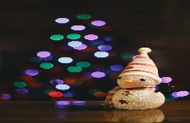
French  Mr Hamilton will be teaching Y6 French every Wednesday. | Through the Decades  Our through the decades topic will focus on how life has changed since 1948. We will look at significant events and key individuals in each decade. We will use a variety of sources to explore and evaluate the past.  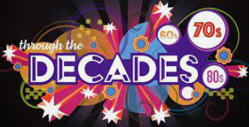 |  | RE  Our RE this half term will focus on Christmas and discuss how significant it is that Mary was Jesus’ mother.
PE
We will have an outdoor PE lesson each Thursday. Please send appropriate clothing as we will go out in most weathers. We will also have an indoor session on a Friday.
Science  Our science this half term is focusing on the Human Body. We will be making blood and looking at various organs and what they do. |  |  | Art  Our Art this term will be integrated into our DT project.

