Dear Parents/ Carers,
We have been busy making our Autumn gifts in Nursery.
If you would like to buy your child’s gifts please see the description and price below.
Send all money into Nursery in an envelope with your child’s name on stating which gift(s) you would like.
All money raised from these gifts will be used to buy equipment for the outdoor environment.
Thank you
Mrs. T. Pollard and Mrs. Kelly

Autumn candle jar £2.00

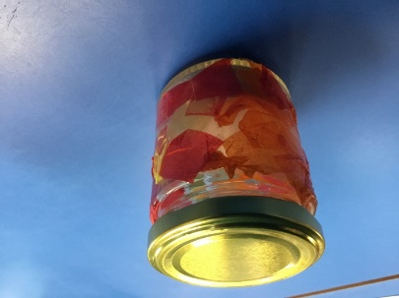

Bird feeder £2.00

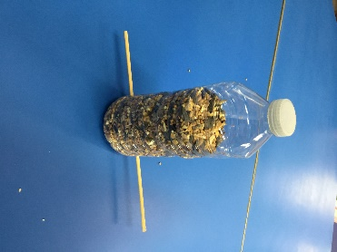

£4.00 for both items

