Dear Y4 Parents and Carers,

We are very pleased to have welcomed your children back to school. They are all excited to be back and ready to learn.

Below is information which we hope will be helpful to you:

PE
Our PE days are Tuesdays and Wednesdays. PE kits should be in school on these days. PE will be outside where possible and appropriate.

Outdoor learning
There is no such thing as bad weather, only inappropriate clothing! At The Ellis we are working hard to develop the outdoor environment and opportunities to learn outside and in Y4 we will be using our outdoor classroom and wider school environment as much as possible. This means that your child will need appropriate footwear and coats every day. Indoor pumps will be needed in school to protect our classrooms from the inevitable mud!

Reading Books
Your child may have already brought home a reading book to share with you at home, or they may have a book that they are reading at home. Please record in their reading diary when they have read to an adult or maybe an older sibling. We ask that reading diaries are in your child’s book bag every day so that we can fill them in when they have taken part in reading in school. If reading diaries are filled then we will send home a second diary free of charge, however if it is lost then we ask that a new one is bought from the office at the cost of £1. Your child is welcome to change their book any day of the week when they have completed it but it is their responsibility to ensure books are changed regularly. Children should aim to read at home at least 3 times per week and dojos will be awarded for reading.

Spelling books
The children are once again receiving spelling books. They will write in their new spellings on a Friday and bring their book home to practise. Please support your child in learning their spellings. They will be regularly assessed in their spellings on a Friday. Their spelling books need to be in school every Friday.

Home Learning
Each half term, children are expected to complete a home learning project linked to our topic. I have attached a sheet of a few ideas linked to our topic but feel free to create your own ideas! We are always intrigued to see what our superstars have been up to! Once they have completed their project or projects (as some children prefer to do a few shorter projects, whilst others like to complete one long one), please send them into school so we can share their learning with the class. (Photos or PowerPoints can be emailed to Mrs Fiddes and will be passed onto Year 4 staff to share). Please encourage your child to take pride in their home learning and aim for a quality piece that may have taken a few sessions to complete.

Online learning
Children are encouraged to be regularly practising spellings, time tables and areas of the curriculum online. As a school we have subscribed to websites to support the children with their learning. The children will be given their individual logins for TT Rockstars and Spelling Shed. Please support your child with their learning on these platforms. If logins have been misplaced I can issue new ones.

Topmarks maths is also a fantastic website for the children to be practising all areas of the maths curriculum using interactive games.

Our first topic is The Rotten Romans and below is an overview of the learning we will be doing this half term.
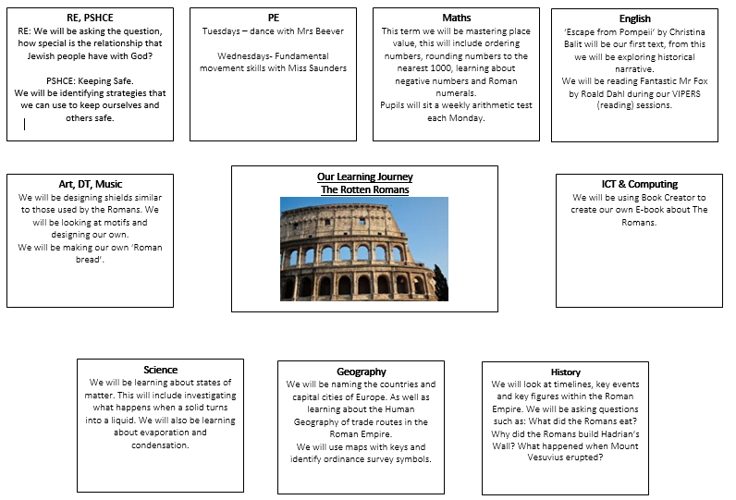

Home learning suggestions
Here are some learning activities that you can do with your children at home to support their learning in school.
- Make a 3D model of a Roman Villa and/or a Celtic round house from Britain.
- Get someone to pretend they were a Roman military leader or you could be this person. Conduct an interview. Write out the questions and answers.
- Make a 3D model of an item from Roman times
- Write a food diary for one day if you were member of a Roman household, see if you can try to do the same for a British person during the same period.
- Find a Roman recipe. Create this recipe and take a photo to show your creation. (Write the recipe to go with your photo in case others would like to have a go)
- Design a job advert for someone to work as a servant in a Roman villa
- Write your own Roman poem.
- Create a maths work sheet for Roman children, making sure you use Roman numerals in your calculations.
- Design a Roman maze using reflective symmetry.
- Mint your own Roman coins

You can choose which of these activities you would like to do. You do not need to do all of them! We also know that you and your children have lots of original and creative ideas of your own. We love to see these too!
Please encourage your child to bring their learning into school to share.

If you have any questions, queries or worries then please get in touch via the phone or email.
Thank you for your continued support.
Best wishes,
The Y4 Team
(Miss Saunders, Miss Turton and Mr Webster)

