Hello and welcome Y1 Parents and Carers,

I hope you are all well and raring to go. I know we are very excited. To ease the transition into Year 1 I have included some information about the routines and expectations for the year. Year One is a fantastic year to get to know the routines of the school. Once the children have adapted to the changes it is very easy for them to progress through school as many routines are the same.
PE
Our PE days this year are Monday and Tuesday. PE kits should be in school on these days. PE on Monday is outside so the children are welcome to bring tracksuit bottoms or leggings to keep warm. Could earrings please be removed on these days. We are not allowed to take them out for the children so if they cannot remove them themselves they will have to miss the lesson. Please ensure they have a purse or wallet etc to put them into for safe keeping.

Covid 19
Children will be encouraged to wash their hands throughout the day. Hand gel will also be used when children return from break times. Tables and equipment will be wiped down at the end of the day. The children can now bring water bottles from home. Please note that we will be keeping our room well ventilated even during the cold months so please make sure they have a red jumper or cardigan on.

Reading Books
Your child will be bringing a coloured book band book home by the end of this week. These will be based on information that has been passed up from the previous teacher. These books should be read at home (comments regarding progress and enjoyment can be recorded in their reading diaries) and returned when completed. The children can swap their coloured banded books every day if they wish but it will be their responsibility to do this. We will aim to oversee this but it is not possible to do this for them. Comments made in the reading diaries will be monitored on a weekly basis.

The children will also receive a Read, Write inc books every week as soon as the children have been assessed. These books will be swapped every Monday by myself. Please can you ensure your child reads a minimum of twice a week. We monitor this in school. Children receive dojos for regular reading. If reading diaries are filled then we will send home a second diary free of charge, however if it is lost then we ask that a new one is bought from the office at the cost of £1. Please can you ensure your child’s Red Book Bags are returned daily.

Spelling books
Spellings will be written into the children’s spelling books on a Monday and they will bring these home to practise. Please support your child in learning their spellings by asking them to complete the table in their spelling book or by using Spelling Shed. The children have been given their logins for this website in the front of their spelling diaries. The children will be tested on their spellings on the following Friday. Dojos will be given as a reward for their hard work.

Dojos
Children are awarded dojos for good work, behaviour, politeness etc. These are recorded in school. When a child reaches multiples of 50 they will be sent to the Head Teacher for a reward. If a child receives 3 or more dojos in a day their names will be placed on the silver star of our traffic light behaviour system and receive an extra reward from our treats draw.

Home Learning
As I am sure you are aware, children are also expected to complete a home learning project linked to our topic. I have attached a sheet of a few ideas linked to our topic but feel free to create your own ideas! We are always intrigued to see what our superstars have been up to! Once they have completed their project or projects (as some children prefer to do a few shorter projects, whilst others like to complete one long one), please send them into school so we can share their learning with the class. (Photos or PowerPoints can be emailed to Mrs Fiddes and will be passed onto class staff to share). Please encourage your child to take pride in their home learning and aim for a quality piece that may have taken a few sessions to complete.

Autumn 1st
Our new topic will be ‘Field to Fork’. Please see below to find an overview of the topic.
RE  The Christian Creation story | English  Traditional tales | Geography  Farming | Art  sketching
PSHE  Relationships |  |  | Outdoor Learning
Maths  Numbers to ten. ordering, one more and less, comparing etc | Field to Fork  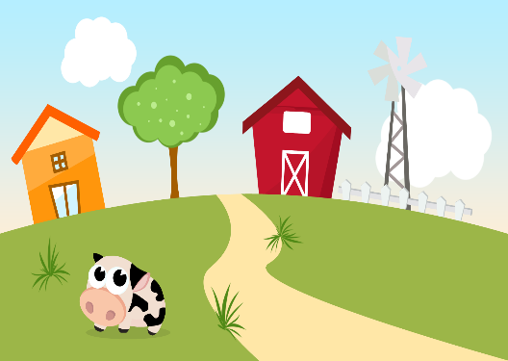 |  | DT  -
PE  Fundamental skills | Music  Charanga | Computing  Scratch | Science  Our Body

Home learning project suggestions
Here are some learning activities that you can do with your children at home to support their learning in school.
Powerpoint of the journey of food
Drawing fruit and vegetables
Making soup
Researching farm animals
Harvest celebrations
Researching where food comes from
Building farm equipment ie Lego

You can choose which of these activities you would like to do. You do not need to do all of them! We also know that you and your children have lots of original and creative ideas of your own. We love to see these too!
Please encourage your child to bring their learning into school to share.
If you have any questions, queries or worries then please get in touch via Mrs Fiddes in the office.
Thank you for your continued support.
Kind regards,
Mrs Broadbent and the Y1 Team.

