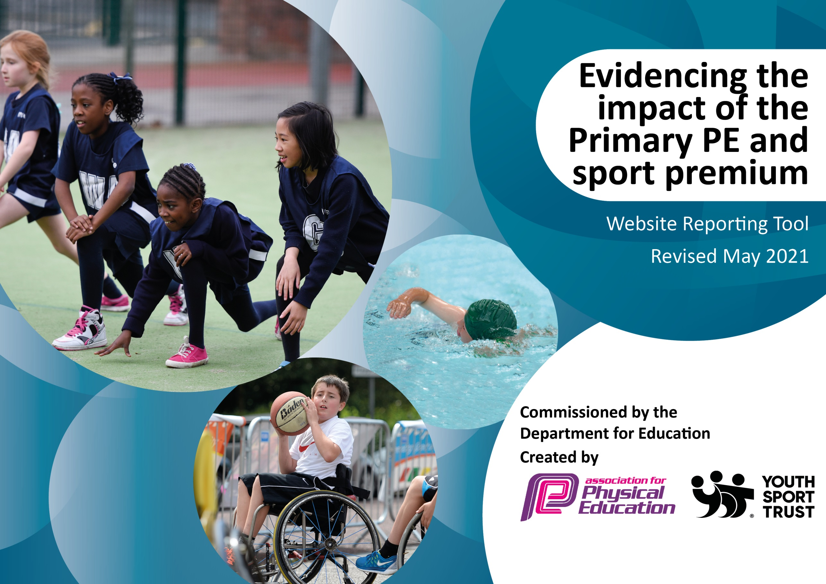

It is important that your grant is used effectively and based on school need. The Education Inspection Framework (Ofsted 2019 p64) makes clear there will be a focus on ‘whether leaders and those responsible for governors all understand their respective roles and perform these in a way that enhances the effectiveness of the school’.

Under the Quality of Education criteria (p41) inspectors consider the extent to which schools can articulate their curriculum (INTENT), construct their curriculum (IMPLEMENTATION) and demonstrate the outcomes which result (IMPACT).

To assist schools with common transferable language this template has been developed to utilise the same three headings which should make your plans easily transferable between working documents.

Schools must use the funding to make additional and sustainable improvements to the quality of Physical Education, School Sport and Physical Activity (PESSPA) they offer. This means that you should use the Primary PE and sport premium to:

- Develop or add to the PESSPA activities that your school already offer
- Build capacity and capability within the school to ensure that improvements made now will benefit pupils joining the school in future years
- The Primary PE and sport premium should not be used to fund capital spend projects; the school’s budget should fund these.
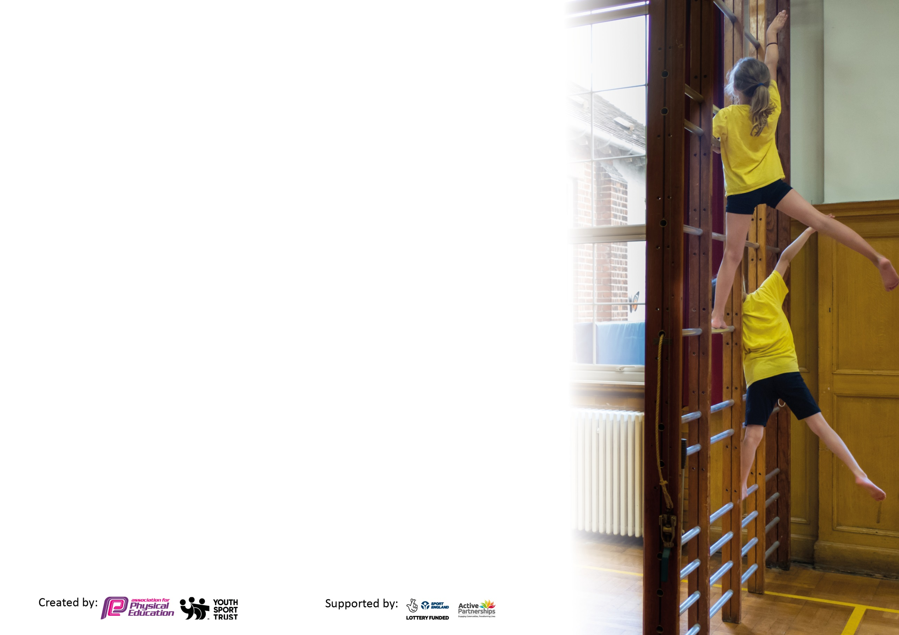
Please visit gov.uk for the revised DfE guidance including the 5 key indicators across which schools should demonstrate an improvement. This document will help you to review your provision and to report your spend. DfE encourages schools to use this template as an effective way of meeting the reporting requirements of the Primary PE and sport premium.

We recommend you start by reflecting on the impact of current provision and reviewing the previous spend.

Schools are required to publish details of how they spend this funding, including any under-spend from 2019/2020, as well as on the impact it has on pupils’ PE and sport participation and attainment by the end of the summer term or by 31st July 2021 at the latest.

We recommend regularly updating the table and publishing it on your website throughout the year. This evidences your ongoing self-evaluation of how you are using the funding to secure maximum, sustainable impact. Final copy must be posted on your website by the end of the academic year and no later than the 31st July 2021. To see an example of how to complete the table please click HERE.

Please note: Although there has been considerable disruption in 2020 it is important that you publish details on your website of how you spend the funding - this is a legal requirement.
Support for review and reflection - considering the 5 key indicators from DfE, what development needs are a priority for your setting and your pupils now and why? Use the space below to reflect on previous spend and key achievements and areas for development.

N.B. In this section you should refer to any adjustments you might have made due to Covid-19 and how these will influence further improvement.
Key achievements to date until July 2020: | Areas for further improvement and baseline evidence of need:
The school has enjoyed sporting success previously including County Cricket Championships.  The school has provided extensive varied additional after-school sports provision.  The school has been historically competitive locally and regionally in a range of sports.  Gold School Games Award for numerous years  No child misses out on after school sports provision because of cost | School needs to focus on the development of high quality CPD to support a sustainable Physical Education curriculum.  Further focus on the development of children’s understanding of healthy lifestyles and emotional and mental wellbeing will continue to be a focus in the year ahead  Embed a new scheme of learning and assessment throughout key stages  Focus on wellbeing and learning outside  Development of active lunch and break times – Refresher training of adult playground leaders for new and existing SMSA staff

Did you carry forward an underspend from 2019-20 academic year into the current academic year? YES/NO * Delete as applicable
Total amount carried forward from 2019/2020 £4593.00
+ Total amount for this academic year 2020/2021 £17741.00
= Total to be spent by 31st July 2021 £22334.00

Meeting national curriculum requirements for swimming and water safety.

N.B Complete this section to your best ability. For example you might have practised safe self-rescue techniques on dry land which you can transfer to the pool when school swimming restarts.
Due to exceptional circumstances priority should be given to ensuring that pupils can perform safe self rescue even
if they do not fully meet the first two requirements of the NC programme of study.
What percentage of your current Year 6 cohort swim competently, confidently and proficiently over a distance of at least 25 metres?  N.B. Even though your pupils may swim in another year please report on their attainment on leaving primary school at the end of the summer term 2021.  Please see note above. | 60%
What percentage of your current Year 6 cohort use a range of strokes effectively [for example, front crawl, backstroke and breaststroke]?  Please see note above. | 60%
What percentage of your current Year 6 cohort perform safe self-rescue in different water-based situations? | 60%
Schools can choose to use the Primary PE and sport premium to provide additional provision for swimming but this must be for activity over and above the national curriculum requirements. Have you used it in this way? | No

Action Plan and Budget Tracking
Capture your intended annual spend against the 5 key indicators. Clarify the success criteria and evidence of impact that you intend to measure to evaluate for pupils today and for the future.

Academic Year: 2020/21 | Total fund allocated: £22334  Total spent: £15838.50  Amount carried forward to 21-22: £6495 | Date Updated: 16.7.21
Key indicator 1: The engagement of all pupils in regular physical activity – Chief Medical Officers guidelines recommend that primary school pupils undertake at least 30 minutes of physical activity a day in school |  |  |  | Percentage of total allocation:
 |  |  |  | %
Intent | Implementation |  | Impact
Your school focus should be clear what you want the pupils to know and be able to do and about  what they need to learn and to  consolidate through practice: | Make sure your actions to achieve are linked to your intentions: | Funding allocated: | Evidence of impact: what do pupils now know and what can they now do? What has changed?: | Sustainability and suggested next steps:
-Educate children in the value and benefits of a healthy active lifestyle.  - Ensure our high quality PE and school sport offer develops competent and confident movers with the aim of inspiring lifelong participation in physical activity.  - Use active lessons to increase physical activity levels and learning. | - Through PE lessons and sport, ensure our children understand the role of movement in the development of their own physical literacy, fitness and well-being.  - Develop the PE curriculum to ensure lessons are progressive and build on previous skills taught  - Build links with local community sports clubs through our SGO.  - Develop action plan  - Purchase Resources  - Relaunch whole school initiative  - Train sports leaders  - Lead assemblies on importance of physical activity  - Encourage use of initiatives such as the ‘Daily Mile’ in ALL year groups at least once per week  -WOW Walk To School Challenge  -All Children from FS1 to Y6 took part in a Race for Life raising over £1000  Developing Children’s SMSC | £445.50 | - Positive attitudes to health and well-being  - Pupil concentration, commitment, self-esteem improved  - Positive behaviour and a sense of fair play (children in UKS2 organising their own competitions and refereeing.)  - Pupils activity at lunch and break increased  - Children taking part in daily additional activities such as ‘The Daily Mile’ regularly, outdoor learning  - children across the school more active on a daily basis and enjoy being active | - Monitor physical activity levels to ensure we meet the government guidelines of at least 30 minutes a day for each child in school time.
Key indicator 2: The profile of PESSPA being raised across the school as a tool for whole school improvement |  |  |  | Percentage of total allocation:
 |  |  |  | %
Intent | Implementation |  | Impact
Your school focus should be clear what you want the pupils to know and be able to do and about  what they need to learn and to  consolidate through practice: | Make sure your actions to achieve are linked to your intentions: | Funding allocated: | Evidence of impact: what do pupils now know and what can they now do? What has changed?: | Sustainability and suggested next steps:
- Use PE and sport to enable the development of life skills that are transferred to other curriculum areas, wider school and beyond.  - Use PE and sport to develop the whole person including thinking, social and personal skills?  - Use PE teaching to aid fine and gross motor skill development?  - Use sporting role models used to engage and raise achievement?  - Ensure PE and school sport is visible in the school (assemblies, notice boards,  school website, local press, pupil reward, social media and recognition of pupils)  - High quality PE lessons delivered during curriculum time.  - School staff better equipped/ more confident to teach PE in school  - Monitoring use of schemes and whole school PE coverage  -Developed our range of outdoor activities offered  -Forest school developed giving children a chance to experience OAA activities  Outdoor Equipment Developed:  Climbing Frame & Slide in Lower Key Stage 2 accessible all year  Trim trail in upper Key Stage 2 made more accessible all year | - SMSC – Our vision for PE and school sport is developed to reflect contribution to SMSC.  - Employment of sports coaches  - Continue to develop and use whole school plans and assessment.  - New Scheme (PE Passport) purchased to use throughout school in all key stages including FS  -Additional equipment purchased to support the teaching of specific skills or sports (Tri golf equipment, specific batting tees for cricket)  - All stars cricket and Chance to shine cricket coaches taught in school to give children specific teaching and upskill staff  -Forest school award 2 members of staff trained and lessons taught to all key stages | £599.00  £1994.00  £3378 (Slide actual cost was £5500 but school received £2122 from crowd funding)  Climbing frame was won in a competition by Creative Play. | - Children more confident climbing/swinging  - improved dexterity  - physical strength developed  - problem-solving developed  - Promoting a healthy lifestyle  - Learning independence, risk-taking and survival  - Developing logical and creative thinking  - Strengthening social skills | - Identify the positive impact that PE and school sport has on academic achievement, behaviour and safety, attendance, health and wellbeing and SMSC.  Review School development plan, Whole school policies/PE policy  - School staff better equipped/more confident to teach PE in school  - Monitoring use of schemes and whole school PE coverage

Key indicator 3: Increased confidence, knowledge and skills of all staff in teaching PE and sport |  |  |  | Percentage of total allocation:
 |  |  |  | %
Intent | Implementation |  | Impact
Your school focus should be clear | Make sure your actions to | Funding | Evidence of impact: what do | Sustainability and suggested
what you want the pupils to know | achieve are linked to your | allocated: | pupils now know and what | next steps:
and be able to do and about | intentions: |  | can they now do? What has
what they need to learn and to |  |  | changed?:
consolidate through practice:
- Raise the quality of learning and teaching in PE and school sport by providing support to deliver broad, balanced and inclusive high quality PE and school sport provision (within and beyond the curriculum) to raise pupils’ attainment.  - To encourage coaches employed to deliver the PE curriculum, to increasingly involve teaching staff supporting lessons - to increase their confidence in delivery of the subject.  - 1:1 lesson observations to monitor staff effectiveness and confidence  - Questionnaire to monitor pupil and staff attitudes towards progression in PE | -Use specialist coaches and providers for staff training to increase the knowledge and confidence of staff in delivering PE.  - Purchase quality assured resources to support teachers and support staff.  - PE lead/sports coaches used to help upskill teachers through modelling lessons, team teaching, help with planning and observations. Classes rotated to ensure all teachers benefit from coaches expertise | Sport leader TLR 0.5FTE £1975, 6 days management cover time £1170, Lunchtime sport leader salary £3000 |  | - Review staff confidence and competence in delivering high quality PE and school sport and allocate staff to upcoming CPD opportunities  - Further 1:1 lesson observations to monitor staff effectiveness and confidence
Key indicator 4: Broader experience of a range of sports and activities offered to all pupils |  |  |  | Percentage of total allocation:
 |  |  |  | %
Intent | Implementation |  | Impact
Your school focus should be clear | Make sure your actions to | Funding | Evidence of impact: what do | Sustainability and suggested
what you want the pupils to know | achieve are linked to your | allocated: | pupils now know and what | next steps:
and be able to do and about | intentions: |  | can they now do? What has
what they need to learn and to |  |  | changed?:
consolidate through practice:
- Provide opportunities to take part in a diverse range of school sport through extra-curricular clubs, competitions and events.  - Continue to offer additional extra- curricular opportunities for all pupils to take part in physical activity and sport  - Providing additional links to  Community Sports Clubs  - Children participate in festivals/ tournaments held through PSP.  - Increase opportunities for KS1 children  Continue to develop relationships with community coaches so a broad and wide range of activities can be offered to all age groups. | - Provide opportunities for children with SEND, the least confident and the least active to attend exciting, varied and a new range of activities through the school sport partnership.  - Employ sports coaches to provide age and stage appropriate extra-curricular sporting opportunities and to improve sports skills in children through increased opportunities in school  - To keep the website up-to-date with range of clubs currently on offer (changeable throughout the year)  - Children to attend the extra-curricular clubs.  - School to enter children into sporting festivals/ competitions.  - Links made with coaches and outside clubs – tennis/ cricket /rugby/football/hockey  - - Equipment continues to provide opportunities during break and lunchtimes. | £2250.00  Team Activ  £240.00  £787.00 |  | - Carefully select outside providers and ensure they understand our vision for school sport and that the opportunities they offer contribute to that vision.  - Further increase opportunities for KS1 children – in and out of school

Key indicator 5: Increased participation in competitive sport |  |  |  | Percentage of total allocation:
 |  |  |  | %
Intent | Implementation |  | Impact
Your school focus should be clear | Make sure your actions to | Funding | Evidence of impact: what do | Sustainability and suggested
what you want the pupils to know | achieve are linked to your | allocated: | pupils now know and what | next steps:
and be able to do and about | intentions: |  | can they now do? What has
what they need to learn and to |  |  | changed?:
consolidate through practice:
- Provide opportunities for all children to challenge themselves through both intra and inter school sport where the children's motivation, competence and confidence are at the centre of the competition and the focus is on the process rather than the outcome.  - Increased participation in School Games competitions.  - Providing opportunities for children with SEND, the least active and the least confident to attend competitions and events.  - Enter external events to give pupils the opportunity to compete against other schools  - Investigate further use of virtual inter house competitions/ children leading own events | - Engage more staff/ parents/ volunteers and young leaders to support attendance at competitions.  - Use external coaches to run competitions to increase pupils’ participation.  - Identify a set number of competitions/events to provide transport to.  - Ensure pupils get opportunity to take part in local competitive leagues, tournaments and festivals.  - Regular (termly), intra-house sports competitions for pupils across different sports.  - To develop links with external agencies in the community to ensure more pupils participate in community clubs outside of school |  |  | - Review attendance data and identify children for appropriate opportunities.  - Continue to attend events half termly meetings to help shape the offer to ensure it is appropriate for our pupils and of the highest quality.  - Further widen opportunities for pupils to take part in competitive sporting events  - Investigate further use of virtual inter house competitions/ children leading own events

Signed off by
Head Teacher:
Date: | 16.7.21
Subject Leader: | N Cook/ R Jaques
Date:
Governor:
Date:

