Dear Y3 Parents and Carers,

We hope you have had a lovely, relaxing holiday and enjoyed the sunshine. What a year it has been! We have really enjoyed teaching your children this year and we hope they enjoy their last half term in Year 3.



Below is information which we hope will be helpful to you (please note that there have been some timetable changes)-

PE

Our PE days are **Monday** and **Friday**. PE kits should be in school on these days but may not be used as we will limit changing in school. PE will be outside where possible and appropriate.

Outdoor learning

We will continue to work outdoor during our topic so please can you ensure that your child has the appropriate clothing in school and on hot days, a hat and sun cream.

Reading Books

Your child will continue to bring reading books home with them. Please record in their reading diary when they have read to an adult or maybe an older sibling. We ask that reading diaries are in your child’s book bag every day so that we can fill them in when they have taken part in reading in school. If reading diaries are filled then we will send home a second diary free of charge, however if it is lost then we ask that a new one is bought from the office at the cost of £1. Your child is welcome to change their book any day of the week when they have completed it but it is their responsibility to ensure books are changed regularly. Children should aim to read at home at least 3 times per week and raffle tickets will be awarded for reading. If your child is not reading regularly, then they may be asked to read during a break time at school and a letter requesting support from parents will be sent home.

Spelling books

The children are once again receiving spelling books. They will write in their new spellings on a **Monday** and bring their book home to practise. Please support your child in learning their spellings by asking them to complete the table in their spelling book and by using Spelling Shed. They will be regularly assessed in their spellings.

Home Learning

Each half term, children are also expected to complete a home learning project linked to our topic. We are always intrigued to see what our superstars have been up to! Once they have completed their project or projects (as some children prefer to do a few shorter projects, whilst others like to complete one long one), please send them into school so we can share their learning with the class. (Photos or PowerPoints can be emailed to Mrs Fiddes and will be passed onto class staff to share). Please encourage your child to take pride in their home learning and aim for a quality piece that may have taken a few sessions to complete.

Online learning

Thank you for embracing our new online learning platform **Seesaw.** We continue to learn more about the positives, possibilities and problems of the system but are really proud of the way our online learners have continued to engage and try hard at home. If your child is not able to attend school due to self-isolating or a bubble closure then Seesaw will continue to be the way we will deliver the curriculum online. If you ever have any difficulties with this then please contact school as we want to help all our children to continue to learn.

Children are encouraged to be regularly practising spellings, time tables and areas of the curriculum online. As a school we have subscribed to websites to support the children with their learning. The children have been given their individual logins for **TT Rockstars** and **Spelling Shed**. Please support your child with their learning on these platforms (**ideally they should access both sites at least twice a week**). Topmarks is also a very good interactive learning site for English and Maths and doesn’t require logins.

You can find the Fantastic Fletchers on Twitter **@TheEllisY3**

**Summer Term**

Our new topic will be **Around the British Isles.** We will be exploring the topic over both half terms of the Summer Term. Please see below to find an overview of the topic.

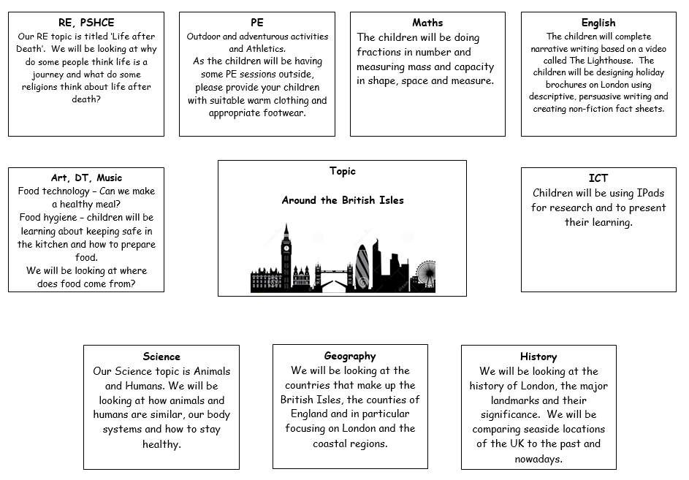

Home learning project suggestions

Here are some learning activities that you can do with your children at home to support their learning in school.

* Look outside to see the different human and physical features that you can see. Draw and label them.
* Think about England and compare it to another country. What are the similarities? How is it different?
* Research London. What can you find out about it? Can you create a factsheet or a PowerPoint about it?
* Draw or paint a seaside scene.
* Write an adventure story about someone who goes to the seaside. What might happen to them?
* Write recount of a holiday that you have been on and what you did whilst you were there.
* Look on a map of England. Can you find different cities? Can you find London?

You can choose which of these activities you would like to do. You do not need to do all of them! We also know that you and your children have lots of original and creative ideas of your own. We love to see these too! Please encourage your child to bring their learning into school to share or to post their projects on Seesaw.

If you have any questions, queries or worries then please get in touch via the phone or email. Thank you for your continued support.

Best wishes,

The Y3 Team