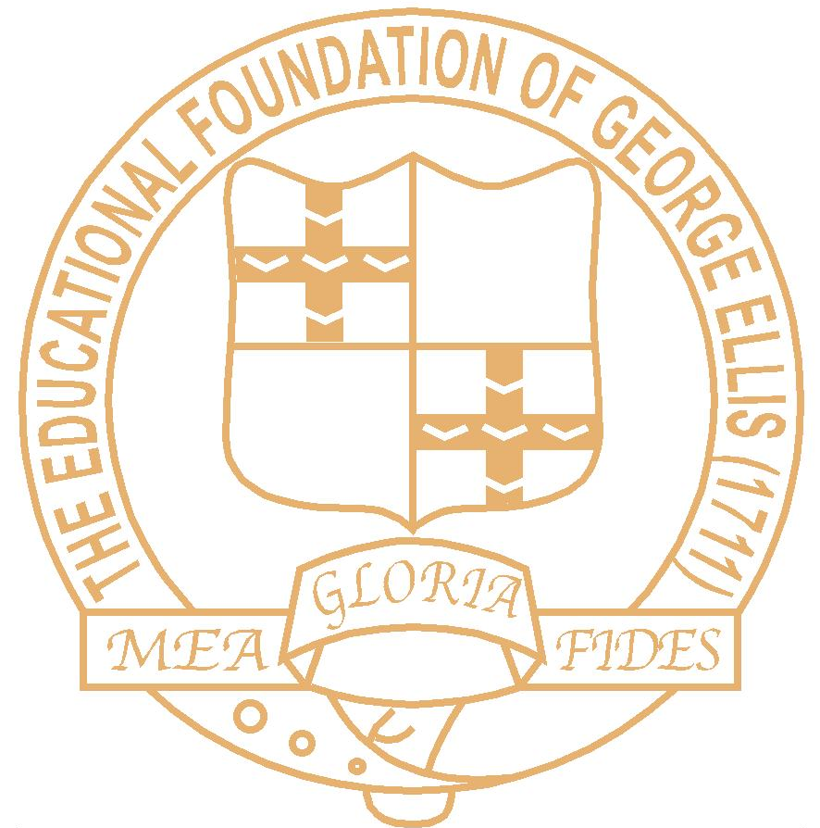
THE ELLIS CHURCH OF ENGLAND PRIMARY SCHOOL
SCHOOL STREET, HEMINGFIELD
BARNSLEY S73 0PS

Headteacher: Mrs R Hurding
www.theellisschool.org.uk

Telephone: 01226 753383

Dear Parent/Carer

Operation Encompass

Our school has been given the opportunity to take part in a project that will run jointly between schools and South Yorkshire Police. This project is known as Operation Encompass.

Operation Encompass is the notification to schools that a child (under 18) has been exposed to, or involved in, any domestic incident. This will ordinarily be done by the start of the next school day.

Operation Encompass will ensure that a specifically trained member of the school staff, known as a Designated Safeguarding Lead (DSL), is informed. The DSL can then use the information, in confidence, to ensure the wellbeing of the child. The school may be able to make provisions or adjustments to assist the young person and their family.

Our school is keen to offer the best support possible to all of our young people and we believe this will be extremely beneficial for all those involved.

Yours sincerely



Rachel Hurding
Headteacher
Designated Safeguarding Lead

