Vocabulary |  |  |  |  | Linked Geography
British Empire | Lands that Britain controlled all over the world (for example, India). | Reformer | A person who makes changes in order to improve things. |  | 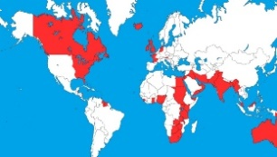  Examine the British Empire and what benefits it had to trade. Consider the impact of different climates on food growth.  Record on maps how the Empire changed over time.
Coronation | The formal service of a making a person king or queen of a country. | Slum | Poorest, most overcrowded and uncared for part of a town or city.
Factory Acts | Laws passed by government to protect people working in dangerous factories (particularly women and children). | Upper class | Wealthy people, often estate owners, who had a lot of money and servants.
Industrialized | Where heavy mechanised or factory industries, like mining and cloth making, have been widely developed. | Workhouse | Places set up by the government where poor people with no money could go and be given a bed, food and work. Many had very harsh rules
Paupers | Very poor people who have no way of feeding or supporting themselves. | Working class | The bottom of the Victorian class system. A working class man could be anyone from a skilled mechanic earning £90 a year to a servant earning £10 per year.
Influential Person |  |  | Timeline |  |  | Interesting facts
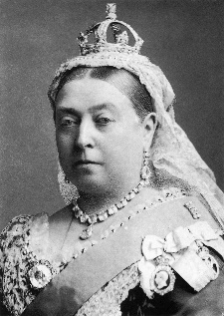  The Victorian period is named after Queen Victoria who reigned over Britain and a world Empire from her coronation in 1837 to her death in 1901 – 64 years. Life in Victorian England was very different to today. It was a time of great wealth and poverty, as well as invention and scientific discovery. |  |  | 1837 – Queen Victoria crowned (aged 18 years). 1840 – Queen marries her cousin, Prince Albert.  1844 – Factory act states children could start work from age 8 but had to have 2 hours schooling daily.  1847 – Factory act states women and children under 18 could only work 10 hours or less daily.  1851 – Great Exhibition. 1861 – Prince Albert dies.  1863 – First underground railway opens in London.  1867 – All factory workers limited to 10 hours work daily.  1870 – Dr Barnardo opens first home for boys.  1871 – First FA cup for football.  1877 – Queen declared ‘Empress of India’.  1880 – Children 5-13 required to attend school (but had to pay).  1882 – First electric power station in London.  1891 – Education made free and compulsory for children 5-13.  1897 – Queen Victoria Diamond Jubilee (50 years on the throne).  1901 – Queen Victoria dies. |  |  | 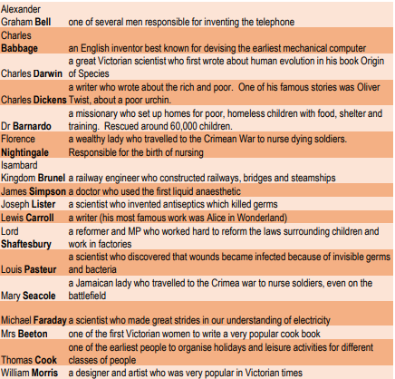  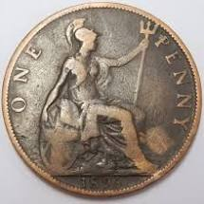  The first public toilets were used at the Great Exhibition. They cost one penny to use hence the term ‘spend a penny?
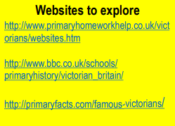
Art  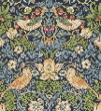  I know that William Morris was an influential designer during the Victorian period.  I can create repeating patterns in a variety of media.  I can use paint to create a cameo. |  |  |  | DT  I know how suspension bridges work and can create a replica.

