Vocabulary |  |  |  |  |  | Linked Geography
Period | An era or length of time. |  | Compulsory | A rule that is required by law |  | Local land uses changed significantly through the decades. More housing was needed and this impacted on local infrastructures.  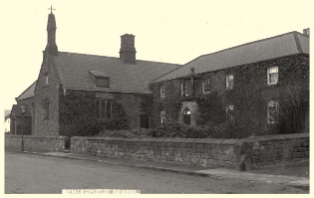
Decade | A period of ten years. |  | Infrastructure | The basic physical and organizational structures and facilities (e.g. buildings, roads, and power supplies) needed for the operation of a society or enterprise
Significant | Meaningful or important. |  | Generation | All of the people born and living at about the same time, regarded collectively
Millennium | A period of 1000 years |  | Technology | Machinery and equipment developed from the application of scientific knowledge.
Nobel Peace Prize | A prize awarded for the promotion of peace |  | Brexit | The withdrawal of the United Kingdom from the European Union
Influential People |  | Key events |  | Interesting facts
Elvis Presley  Nelson Mandela  Frida Kahlo  Andy Warhol  Martin Luther King  Margaret Thatcher  The Beatles  Oasis  Barack Obama |  | 1969 Moon landing  1984 Miners strikes  1989 Berlin Wall pulled down  2000 New millennium  2001 September 11th attacks  2004 Facebook launched  2007 iPhones created  2012 London Olympics  2014 Malala wins Nobel Peace Prize |  | 1960s  - Martin Luther King, Jr. stands at the Lincoln Memorial and speaks to a crowd of 250,000 on August 28  - Mary Quant introduces the mini skirt and changes fashion  - England win the World cup in 1966 |  |  | 1990s  - Boy bands and girl bands topped the charts such as the Spice Girls and Take That  - Nelson Mandela was freed  - Tiger Woods was the youngest winner of the Masters  - Women were allowed to become Anglican priests
 |  |  |  | 1970s  - Beatles split  - Walt Disney World opens  - Apple computers are founded |  |  | 2000s  - New millennium brings fears of Y2K technology crash  - Afghanistan war starts after terror attacks  - 2004 boxing day tsunami from the Indian Ocean
 |  |  |  | 1980s  - Prince Charles married Lady Diana Spencer  - Front seatbelts became compulsory  - Digital mobile phones invented  - Miners strikes |  |  | 2010s  - Same sex marriage was legalised  - Kate Middleton married Prince William  - England’s athletes win gold at London 2012  - Brexit
Art  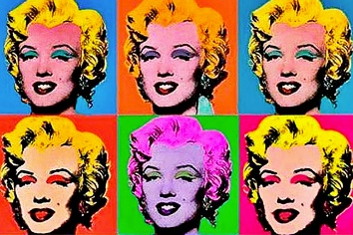  I can identify influential artists of the decades such as Andy Warhol and create art in their style.  I know about a range of art mediums and the benefits of using them. |  |  |  |  | DT

