Vocabulary |  |  |  |  | Linked Geography
Colonised | settle among and establish control over the indigenous people of an area. |  | Settlers | a person who moves with a group of others to live in a new country or area. | Countries of South America- Brazil, Argentina, Colombia, Peru.  I can identify different physical features of the Americas e.g. cities like New York, Great Lakes, Rainforests and Deserts.  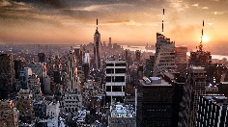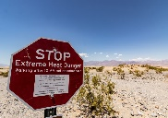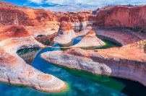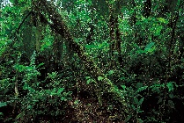
Empire | an extensive group of states or countries ruled over by a single monarch, an oligarchy, or a sovereign state. |  | Tonne | A measure of weight
Population | all the inhabitants of a particular place.
State | a nation or territory considered as an organized political community under one government.
Agriculture | practice of farming, including cultivation of the soil for the growing of crops and the rearing of animals to provide food, wool, and other products.
Human Geography
NORTH AMERICA |  |  |  | SOUTH AMERICA
Population Densities  The population density for North America is 20 people per km square however this is not spread evenly. |  | Colonialisation/languages  Throughout the 16th-17th centuries, European settlers (mainly from Britain, Spain and France) colonised different parts of North America. Many native North Americans became displaced by the colonisers. |  | Deforestation  The amazon rainforest has been rapidly destroyed over the past 50 years due to agriculture, illegal logging and human encroachment into the forest. |  | The Rio Carnival  The Rio Carnival is a festival held every year before lent. It is considered the largest carnival in the world with over 2 million people attending. It is filled with parades, dancers, floats and displays
Sports/Recreation  North America is relatively unique in that sports that originated in the region (basketball, baseball, American football) are more popular than global sports popular elsewhere e.g. rugby, football, cricket. |  | Cities and states  North America is a large country made up of 50 states. 48 on the mainland, plus Alaska and Hawaii. The USA is considered the richest and most powerful country in the world.  Manhattan is the business and entertainment centre of New York City, the largest city in the US. |  | Machu Picchu  The Inca Empire was the largest empire in pre-colonial South America  It was built in 1450 with dry stone walls. |  | Coffee Trade  The coffee plant is grown in abundance in South America and many countries from the continent are the biggest producers of coffee in the world. Brazil produces 2.2 million tonnes a year.
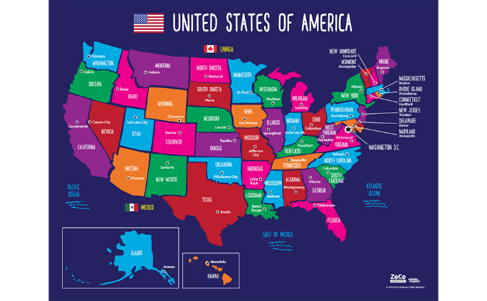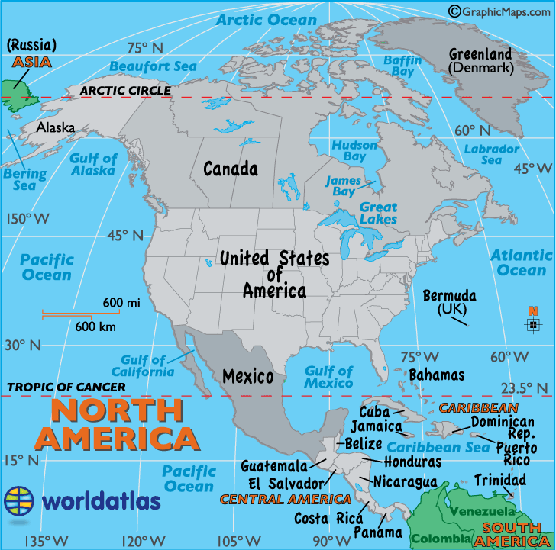 |  |  |  | Colonialisation/languages  Throughout the 16th-17th centuries, European settlers (mainly from Portugal and Spain but also the French, dutch and British) invaded and colonised South America. |  | 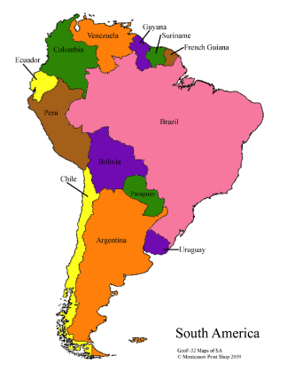
Art  I can draw animals native to the Americas using a range of skills.  I can create art in the style of Native Americans. |  |  |  | DT  I can design and make famous bridges from the Americas using a range of skills.  I know that Native americans created items such as dream catchers using a variety of weaving skills.

