Vocabulary |  |  |  |  | Linked Geography
Monarch | A leader of a country, e.g. a King or Queen. | Execution | Being put to death |  | 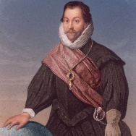  To know the countries Sir Frances Drake visited.  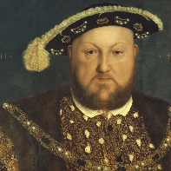  To know where Henry VIII visited and why.
Heir | The person next in line to throne who will take over when the current King or Queen dies. | Treason | To betray your country or monarch
Reign | The period of time that a monarch rules. | Beheading | A punishment which resulted in your head being chopped off with an axe.
Reformation | The act of changing (reforming) something. In this case the reformation of the church to remove the Pope’s control. | Gallows | A wooden structure where people were hung by a piece of rope around their neck.
Divorce | The legal end of a marriage. | Stocks | A block of wood with two holes for your hands and a hole for your head to go in. Local people threw rubbish and rotten food at the people in the stocks.
Timeline |  |  | Interesting facts
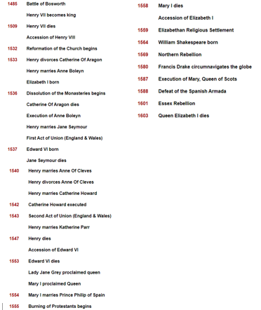 |  |  | 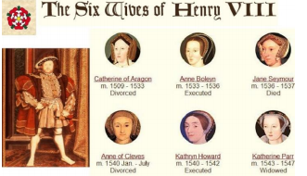 |  |  | 3. The Tudor rose was created when Henry VII brought an end to the Wars of the Roses. He joined the White Rose of York with the Red Rose of Lancaster to create the Tudor Rose.  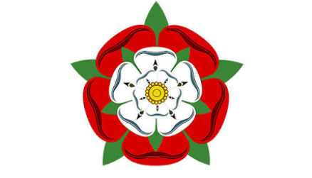
 |  |  | 1. There were six Tudor monarchs who ruled England from 1485 to 1603.  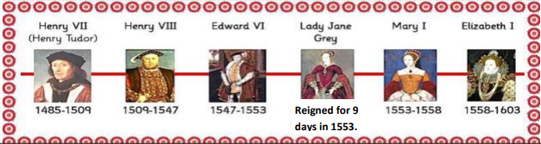 |  |  | 4. Religion was very important in Tudor times. Everyone had to go to church. If you didn’t attend the same church as the monarch you might get arrested, thrown into the Tower of London, or even executed.
 |  |  | 2. Tudor England had 2 of the strongest monarchs ever to sit on the English throne: Henry VIII & his daughter Elizabeth I. |  |  | 5. Henry VIII broke away from the Catholic church and created the Protestant Church of England so that he could divorce his first wife. He went on to have six wives, beheading two of them.
Art  I know about Tudor portraits and can recreate them in a variety of media |  |  |  | DT  I can use sewing skills to create a Tudor money pouch

