Vocabulary |  |  |  |  | Famous person
Architect | An architect is a person who designs buildings and prepares plans to give to a builder. Architects decide the size, shape, and what the building will be made from. Architects need to be good at math and drawing. They need imagination. | City | A city is a place where many people live closely together. City life has many benefits. Cities bring together a great variety of people from different backgrounds. They offer more jobs, more schools, and more kinds of activities than smaller towns and villages. |  | 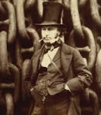  Isambard Kingdom Brunel was a Victorian engineer who was one of the main architects of Britain’s industrial revolution. He was famous for his pioneering work on both Britain’s railways and ships; building railways and designing bridges, tunnels, viaducts and passenger ships.
Skyscraper | A skyscraper is a very tall building with many stories, or floors. Early skyscrapers had 10 to 20 stories. Today, some skyscrapers have 100 stories or more. | Village | A village is a community made up of a small number of houses, usually in a country area. A village is bigger than a hamlet but smaller than a town or city. The number of inhabitants can range from a few hundred to a few thousand.
Construction | The process of building something or the name of a building. | Settlement | A place or region where people have settled to live.
Inhabitant | A person or animal that lives in a place | Home | The place a person or animal lives.
Rural | Relating to the countryside. | Urban | Relating to the town.
Houses through history |  |  | Interesting facts
I know about everyday lives of people in time studied  compare with our life today through the way they lived-houses  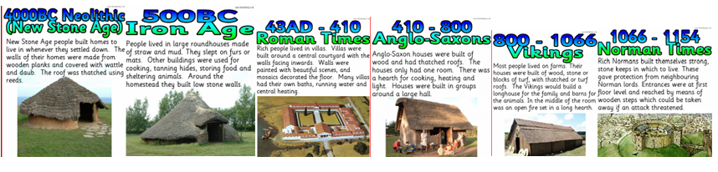 |  |  | The famous LEGO brick that we play with today is more than 50 years old. The bricks made way back in 1958 will still fit perfectly with those you play with today! |  |  | 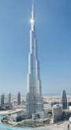  The Burj Khalifa is the world’s tallest building. This sky scraper is 828m tall and can be found in Dubai. It is 160 storeys high.
 |  |  | 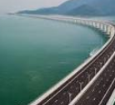  The Lake Pontchartrain Causeway is the world's longest continuous bridge over water. The world's longest bridge is the Danyang–Kunshan Grand Bridge in China, part of the Beijing-Shanghai High-Speed Railway. The bridge, which opened in June 2011, spans 102.4 miles (165 kilometres). |  |  | The largest city in the world by population is Tokyo, Japan, with a population of 38,001,000.
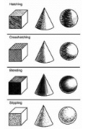  Art  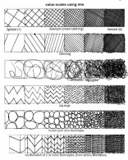  I can use pencils to sketch.  I can use shading and pattern to add texture to my drawings.  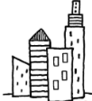  I can draw using perspective. |  |  |  | DT  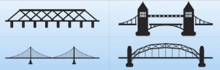  I know that there are different types of bridge.  I can find out about how different bridges are strengthened.  I can make my own model bidges.  I can evaluate the bridges I’ve investigated and made.

