Vocabulary |  |  |  | Linked Geography
Spinning top | Spinning top powered by pushing down on mechanism | Dolls House | Victorian toy. Early dollhouses were all handmade | 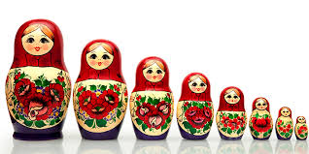  Matryoshka dolls are a set of wooden dolls of decreasing size placed one inside another. Thought to originate from Russia.  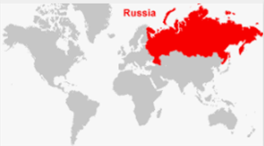
Punch and Judy | Punch and Judy is a traditional puppet show featuring Mr. Punch and his wife Judy. Usually found at the seaside. | Barbie  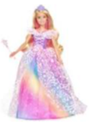 | Popular doll from the late 1970s and early 1980s.
Jack in a box | A pop up toy from Victorian Times. | Cabbage Patch kid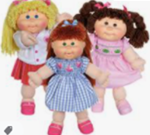 | Dolls from America. Each Cabbage Patch Kids doll was unique and claimed to be grown from the garden.
Lego | Plastic bricks from Denmark. | Rubik’s cube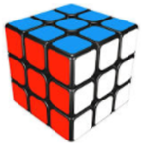 | Popular puzzle from the 1970.
Whip and top | Victorian toy. The whip is wound round the top and let loose by pulling sharply. | Chopper bike | Popular bike from the 1970s and early 1980s. Long handle bars and different sized wheels
Influential Person |  |  | Interesting facts
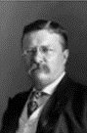 Theodore Roosevelt (American President-26th)  Did you know that the Teddy Bear was invented in honour of President Theodore Roosevelt? His refusal to shoot them gave the inspiration for the early Teddy bears. |  |  | Every civilisation at any time in history made toys for children to play with. |  | The way toys have changed over the centuries shows what materials people had to work with, such as stone, wood, clay, iron or plastic.
 |  |  | You can tell what era a toy came from by looking at what it was made from. |  | To find out what toys children played with in past times, you can visit a museum and look at the exhibits of old toys.
 |  |  | One of the oldest toys found in Britain is around 2,000 years old. |  | Just because a toy moves doesn’t mean it's modern – moving toys can have wheels and hinges instead of batteries.

