Vocabulary |  |  |  | Linked Geography
Solar system | The Solar System is the Sun and all the objects that orbit around it. | Astronaut | Is a person trained to travel in space | 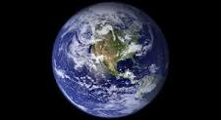  A lot can be learnt about the planet from space. Earth's crust and upper mantle are divided into massive plates that grind against each other in slow motion. As these plates collide, tear apart, or slide past each other, they give rise to our very active geology. Earthquakes rumble as these plates snag and slip past each other. Many volcanoes form as seafloor crust smashes into and slides beneath continental crust. When plates of continental crust collide, mountain ranges such as the Himalaya are pushed toward the skies.
Galaxy | A galaxy is a huge collection of gas, dust, and billions of stars and their solar systems | Planets | A mass which orbits a star
Satellite | A satellite is an object that moves around a larger object. | Moon | A mass which orbits a planet
Orbit | To travel around an object due to it’s gravitational pull | Vacuum | A place without gas or air.
Space | Space begins where the earth's atmosphere ends | Infinity | No end
Influential Person |  |  | Interesting facts
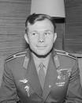  Yuri Gagarin was the first man in space. He was from Russia. Yuri was born on the 9th March 1934 and died on the 27th March 1968.  .  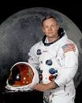  Neil Armstrong is an astronaut and teacher. He was born on August 5, 1930 in America. On July 20, 1969, Neil Armstrong made history by becoming the first man to walk on the moon.  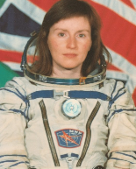  Helen Sharman became the first British astronaut and the first Western European woman in space on 18th May 1991. She was born in Sheffield on 30th May 1963 . |  |  | In space, there is no sound. There is no gas or air. It is a vacuum. |  | 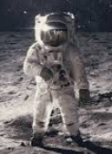  People who travel to space are called astronauts. Sometimes astronauts are in space for six months or even one year.
 |  |  | So far, there has never been life discovered on any other planet. |  | 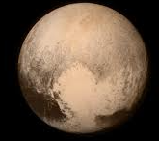  Pluto used to be called a planet but now is called a dwarf planet. This is because it doesn’t match the description of what scientists say a planet must be like.
 |  |  | 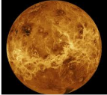  The hottest planet in our solar system is Venus. |  | 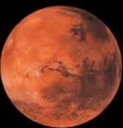  It would take nearly a year to travel to Mars.
 |  |  | 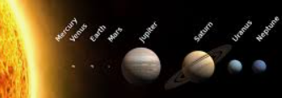  There are eight planets in our solar system: Mercury, Venus, Earth, Mars, Jupiter, Saturn, Uranus and Neptune. |  | 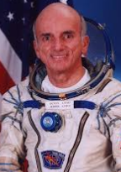  In 2001, a man called Dennis Tito paid millions of pounds to travel to space on holiday.
 |  |  | 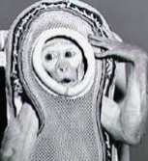  The first creature from Earth to go into space was a monkey called Albert. |  | 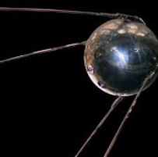  The Sputnik was the first rocket to be fired into space.

