Vocabulary |  |  |  | Linked Geography
Extinguish | Put out fire | Decade | Period of ten years | London is the capital city of England and it was here where the Great Fire of London began on Pudding Lane.  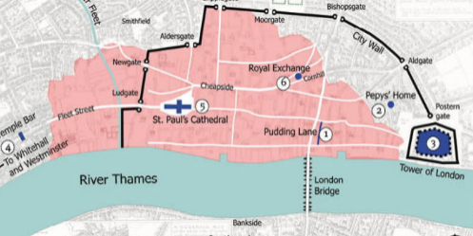  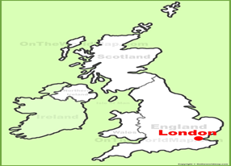
Explosion | To blow up | Drought | Long period of time without water
Ignite | Set on fire | Bakery | Place where they make bread and buns etc
Navy | Fleet of ships | Diary | Book where personal thoughts are kept
Parliament | Where important people meet in London to make rules
Influential Person |  |  | Interesting facts
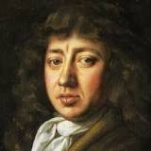  Samuel Pepys was in the navy of England and a Member of Parliament who is most famous for the diary he kept for a decade while still a young man. |  |  | The Great Fire of London happened between 2-5 September in 1666. |  | 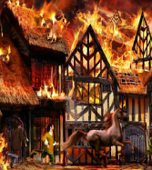  In 1666, lots of people had houses made from wood and straw which burned easily.
 |  |  | 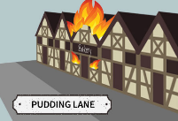  The fire began in a bakery in Pudding Lane. |  | One-third of London was destroyed and about 100,000 people were made homeless.
Time line  Jesus birth- Romans- Vikings- Tudors- Victorians- World Wars- Today  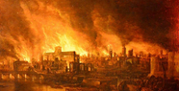 |  |  | The Great Fire of London is one of the most well-known disasters in London's history. It lasted just under five days. |  | 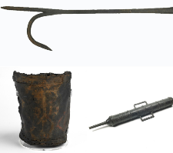  To fight fires during this time, people would have used leather buckets, metal hooks and water squirts.
 |  |  | 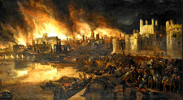  Before the fire began, there had been a drought in London that lasted for 10 months, so the city was very dry. |  | When London was rebuilt, there were lots of changes. They made London safer.

