Vocabulary |  | Linked Geography
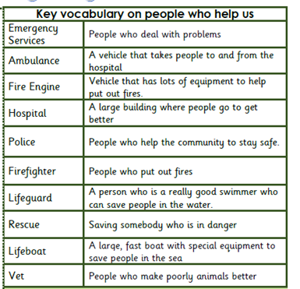 |  | 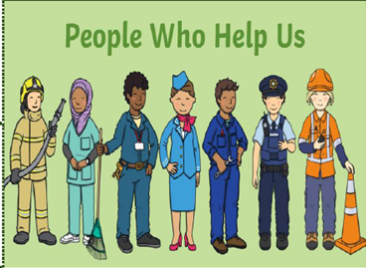
Influential Person | Interesting facts
Florence Nightingale  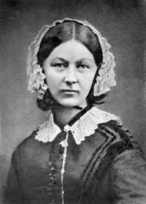 | Florence Nightingale was born to a wealthy family on the 12th May 1820 and she was named Florence after the place of her birth: Florence in Italy.  She lived in Derbyshire and Hampshire and she died in 1910. Florence Nightingale was a nurse and she saved the lives of many soldiers during the Crimean War (1854-56).  She became known as the Lady with the Lamp as she carried a lamp to check on her patients throughout the night. She met Queen Victoria in 1833 when she was awarded the Royal Red Cross medal. King Edward VII gave Florence a special award called the Order of Merit in 1907. She was the first women to receive this award and she changed the way that women were seen in the workplace.
Grace Darling  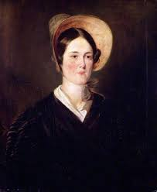 | Grace Darling is remembered for the rescue she undertook with her father in the Farne Islands in 1838.  The SS Forfarshire had broken up on rocks within sight of the lighthouse at Longstone, which was home to Grace and her parents.  Grace was determined to rescue the survivors immediately but was persuaded by her father to wait until morning and better light.  Grace and her father then set out through the stormy sea and collected some.  They rowed back to Longstone Lighthouse where Grace and her mother looked after the survivors while her father returned to the shipwreck to collect the last ones.  Grace soon found herself celebrated in print... even Queen Victoria wrote to her with a reward.

