Dear Y3 Parents and Carers,

We hope you have had a lovely, relaxing Easter holiday. It certainly feels more like Spring with the lighter days and hopefully nicer weather! It has been lovely to welcome your wonderful children back into school and they are already really enjoying our new VIP topic.

Below is information which we hope will be helpful to you (please note that there have been some timetable changes)-

PE
Our PE days are Monday and Friday. PE kits should be in school on these days but may not be used as we will limit changing in school. PE will be outside where possible and appropriate.

Outdoor learning
There is no such thing as bad weather, only inappropriate clothing! At The Ellis we are working hard to develop the outdoor environment and opportunities to learn outside, therefore in Y3 we will be using our wider school environment as much as possible. This means that your child will need appropriate footwear and coats every day. Indoor pumps will be needed in school to protect our classrooms from the inevitable mud!

Extra layers
Our windows will be remaining open in all weathers. Please provide your child with an extra layer that they can put on if they feel chilly in school.

Reading Books
Your child will have already brought home a reading book to share with you at home. Please record in their reading diary when they have read to an adult or maybe an older sibling. We ask that reading diaries are in your child’s book bag every day so that we can fill them in when they have taken part in reading in school. If reading diaries are filled then we will send home a second diary free of charge, however if it is lost then we ask that a new one is bought from the office at the cost of £1. Your child is welcome to change their book any day of the week when they have completed it but it is their responsibility to ensure books are changed regularly. Children should aim to read at home at least 3 times per week and raffle tickets will be awarded for reading. If your child is not reading regularly, then they may be asked to read during a break time at school and a letter requesting support from parents will be sent home.

Spelling books
The children are once again receiving spelling books. They will write in their new spellings on a Monday and bring their book home to practise. Please support your child in learning their spellings by asking them to complete the table in their spelling book and by using Spelling Shed. They will be regularly assessed in their spellings.

Home Learning
Each half term, children are also expected to complete a home learning project linked to our topic. We are always intrigued to see what our superstars have been up to! Once they have completed their project or projects (as some children prefer to do a few shorter projects, whilst others like to complete one long one), please send them into school so we can share their learning with the class. (Photos or PowerPoints can be emailed to Mrs Fiddes and will be passed onto class staff to share). Please encourage your child to take pride in their home learning and aim for a quality piece that may have taken a few sessions to complete.

Online learning
Thank you for embracing our new online learning platform Seesaw. We continue to learn more about the positives, possibilities and problems of the system but are really proud of the way our online learners have continued to engage and try hard at home. If your child is not able to attend school due to self-isolating or a bubble closure then Seesaw will continue to be the way we will deliver the curriculum online. If you ever have any difficulties with this then please contact school as we want to help all our children to continue to learn.

Children are encouraged to be regularly practising spellings, time tables and areas of the curriculum online. As a school we have subscribed to websites to support the children with their learning. The children have been given their individual logins for TT Rockstars and Spelling Shed. Please support your child with their learning on these platforms (ideally they should access both sites at least twice a week). Topmarks is also a very good interactive learning site for English and Maths and doesn’t require logins.

You can find the Fantastic Fletchers on Twitter @TheEllisY3

Summer Term
Our new topic will be Inspirational People. We will be exploring the topic over both half terms of the Summer Term. Please see below to find an overview of the topic.

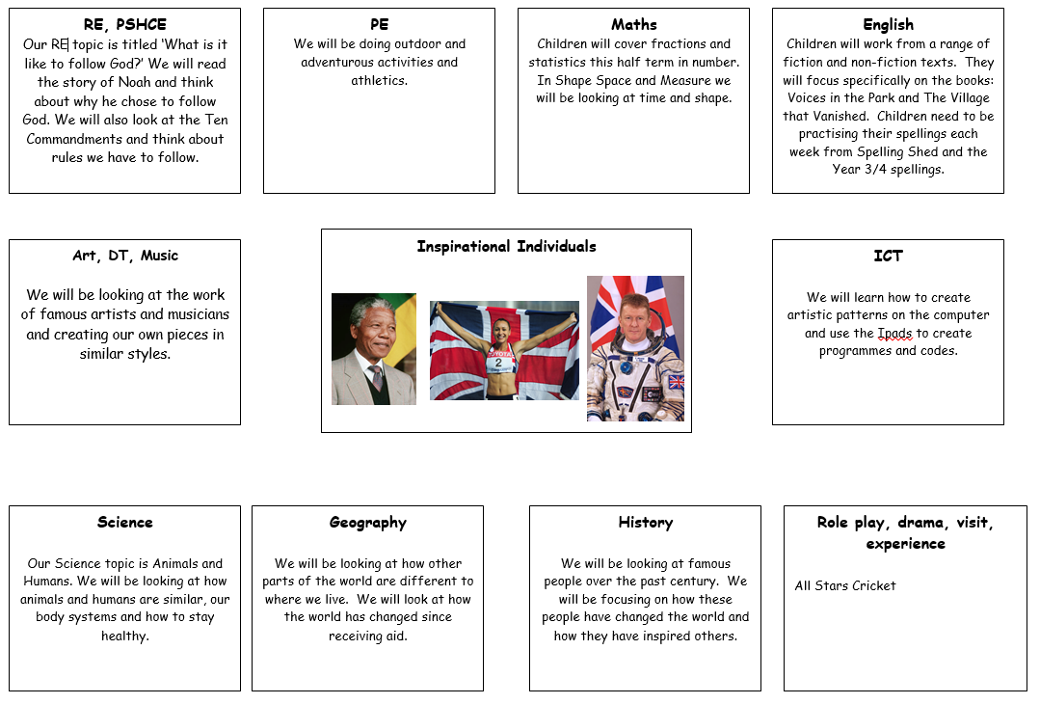

Home learning project suggestions
Here are some learning activities that you can do with your children at home to support their learning in school.

- Think about somebody that is inspirational to you. Why are they so inspirational? Write about who they are and why they are so inspirational.
- Imagine you could be an inspirational person for a day. Who would you choose to be and why?
- Write 10 questions that you would ask one of the inspirational people if you met them.
- Write a diary about a day in the life of an inspirational person.
- Write a story about someone who does something inspirational.
- Research one of the inspirational people that we have looked at in class or one that you know about. Can you write a fact file or create a PowerPoint about them?
- Draw a picture of somebody who is inspirational to you.
- Design a superhero who has got the power to change the world. What would they do and how? Draw and label a picture of them showing what their super power is.

You can choose which of these activities you would like to do. You do not need to do all of them! We also know that you and your children have lots of original and creative ideas of your own. We love to see these too! Please encourage your child to bring their learning into school to share or to post their projects on Seesaw.
If you have any questions, queries or worries then please get in touch via the phone or email. Thank you for your continued support.
Best wishes,
The Y3 Team

