Dear Y2 Parents and Carers,
Welcome back! I hope you have had a lovely Easter and managed to have plenty of time with your families. It has been wonderful to see the spring flowers starting to grow – let’s hope we continue to get some sunshine as it really helps to brighten up the days!
I would just like to say how quickly our home learners settled back in and how well our school learners adapted to a full class again at the end of last half term. I am proud of them all and thank you as parents for all you have done during the challenging times we have faced. You should be incredibly proud, not only of your children, but also yourselves.
Topic and Outdoor Learning
Our topic is ‘Into the Woods’ and science features heavily in it. We are so blessed to have a massive amount of outdoor space so we will be using the pond area, KS1 outdoor area, Forest School and Rainbow garden to teach the science objectives where possible allowing the children to learn through hands on experiences. Therefore, please ensure you child has a pair of wellies and a coat in school, (it might be worth checking what size their wellies are if they have not been changed since September!) Our Forest School days are Tuesday and Friday (the children know which group they are in).

PE
Our PE days are Wednesday and Thursday. Please ensure your child has a suitable pair of shoes or trainers in school on this day. PE will be outside where possible and appropriate. If your child is not able to take out their own earrings, please ensure these are removed on these days too. Thank you.
Extra layers
Our windows will be remaining open whatever. Please provide your child with an extra layer that they can put on if they feel chilly in school.

Reading Books
Your child will have already brought home a reading book to share with you at home. Please record in their reading diary when they have read to an adult or maybe an older sibling. We ask that reading diaries are in your child’s book bag every day so that we can see how they are getting on. If reading diaries are filled then we will send home a second diary free of charge, however if it is lost then we ask that a new one is bought from the office at the cost of £1. Children are welcome to change their coloured book whenever they are ready to. Children should aim to read at home at least 3 times per week and raffle tickets will be awarded for reading. If your child is not reading regularly, a letter requesting support from parents will be sent home.

Spelling books
Please also ensure their spelling book is in their book bag on a Friday so we can enter the new spellings. Please support your child in learning their spellings by asking them to complete the table in their spelling book and by using Spelling Shed. They will be regularly assessed in their spellings.

Children are encouraged to be regularly practising spellings, time tables and areas of the curriculum online. As a school we have subscribed to websites to support the children with their learning. The children have been given their individual logins for TT Rockstars and Spelling Shed. Please support your child with their learning on these platforms (ideally they should access both sites at least twice a week). Logins are stuck in the front of their reading diaries and spelling books.

Parent’s evening
An email has been sent out about how to book your slot for parent’s evening. Thank you to those who have already logged on (I hope it was self-explanatory). If you haven’t booked a slot yet, please do and if you are having any difficulties at all, contact Mrs Fiddes in the office who is a whizz at sorting these things out!
Jewellery Reminder
Can I also remind everyone of our school jewellery policy which is one pair of stud earrings and a watch only. Towards the end of last half term we started to get a lot of necklaces and bracelets / friendship bracelets creeping in! Not only is this potentially a health and safety issue when children are running about at playtime, it is also causing distractions during carpet time and learning time as some of the children were playing with them frequently. Thank you for your support in this matter.

May I also take this opportunity to say a HUGE thank you for your ongoing support this year. I genuinely can’t believe we only have one term left. I love teaching this class and intend to enjoy every minute of the summer term with them! They are a credit to all of you and have shown nothing but determination, resilience, positivity, maturity and perseverance – all at the tender age of 6 and 7. I am incredibly proud of each and every one of them and hope they are proud of themselves.

As always, if there is anything I can help you with, please do ask.

Kindest Regards
Mrs C Trotter

RE
This half term our key question in RE is ‘Does going to a mosque give Muslims a sense of belonging?’
During this unit we will look at what it means to belong and think about groups we belong to and then learn more about what a mosque is, what happens inside and how this makes Muslims feel.
PE
This half term, Mrs Beever will teach golf and Mrs Trotter will teach various bat and ball skills.

ART / DT
We will spend time looking at the two famous artists Van Gogh and Rousseau and create our own sunflower and animal pictures. We will also look at animal patterns and fur and use different media to create our own.
For DT, we will be exploring vehicles and creating our own safari vehicles using wheels and axles.

ENGLISH
The first part of the half term is centred on a beautiful non-fiction book called ‘One Day On Our Blue Planet (the Savannah). We will learn more about lions and other animals who live there and focus on different non-fiction pieces of writing. We will also be developing our vocabulary and descriptive writing by composing setting descriptions which capture the beauty of the African Savannah. Then we will look at some fiction books linked to animals and plants / gardens and we will end the half term planning, writing and editing our own story based on the scene where the house lifts up in the film ‘UP’ and floats away. I wonder where our Y2 children will decide their house will land….will it be in the Arctic, the desert, the rainforest or under the sea. I wonder what creatures they will meet and what they will get up to! I have no doubt, there will be lots of exciting stories!
MATHS
We will spend the first 3 weeks learning about fractions focusing on a quarter, a half and a third before we move onto two thirds and three quarters. We will also be learning that ½ and 2/4 are equivalent fractions before we end the unit counting in fractions and solving problems. Then we will move onto shape, space and measures and will learn to measure in cm and m. We will measure, order and compare different lengths and learn how many cm are in a m.

Children are encouraged to use TTRockstars to consolidate their learning at home.

GEOGRAPHY
We will be focusing on the use of globes, atlases, maps and plans this half term to learn about contrasting habitats around the world. We will be making our own plan for a garden to encourage wildlife and will learn how to use a key. We will then carry out fieldwork around the school grounds and will study aerial photographs.
ICT
As part of our research this half term, we will use the ipads to find out different information. We will be using the voice and video recorder to record our literacy work. We will also be looking at atlases, maps and plans online as well as google earth to look at aerial photographs.

SCIENCE
This whole topic is science-based and in virtually every subject we will be covering lots of science objectives.
We will learn about different animal groups and how to classify and sort them in different ways. We learn about how they adapt to their habitats and how these habitats provide for the basic needs of different kinds of animals and plants. We look at food chains, how they get the food they need and depend on each other. We also identify and name a variety of plants and animals in their habitats, including microhabitats. During the topic, we will observe and describe how seeds and bulbs grow into mature plants and find out and describe how plants need water, light and a suitable temperature to grow and stay healthy. There are lots of opportunities for hands on learning in our KS1 outdoor area, Forest School and Rainbow garden – so please ensure your child has wellies and a coat! Science like this is best by doing and observing it!

Into the Woods
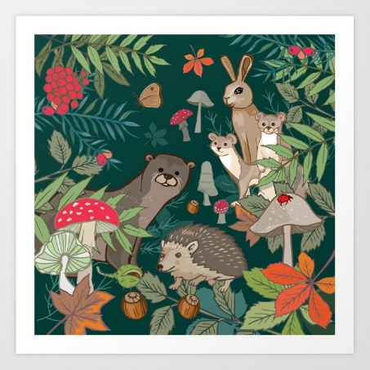

MUSIC
Our Charanga unit is called ‘Friendship’ and is one of Mrs Trotter’s favourite units! It is all about the importance of friendship and being there for each other – how fitting for this year! We will ensure we record the final version for you! It allows lots of chance to add actions and instruments.

Home learning project suggestions
Here are some learning activities that you can do with your children at home to support their learning in school.
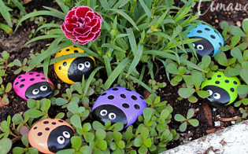
- Go for a walk in the local woods and identify different trees and flowers.

- Create a minibeast hotel in your garden and observe any insects which take up residence!
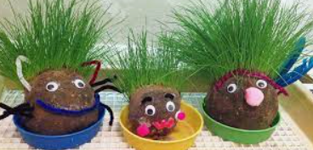
- Collect some stones and paint them like minibeasts.
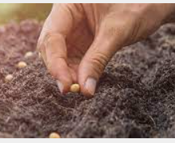
- Plant some seeds or flowers in the garden and watch them grow.
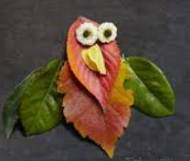
You could write a week by week diary entry about them!

- Create some funky cress heads!

- Make a bird feeder and watch the birds who visit!
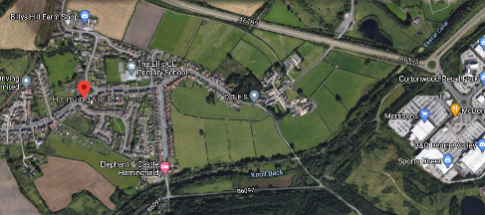
- Go out and draw some plants and leaves, do some bark rubbings, make some natural outdoor art work.

- Look on google Earth to find out about different habitats around the world – desert, arctic, rainforest, woodland.

- Create some Top Trump cards about different animals, trees or plants.

- Alphabet game – can you think of an animal which begins with each letter of the alphabet? What about the names of trees, plants or flowers!

You can choose which of these activities you would like to do. You do not need to do all of them! We also know that you and your children have lots of original and creative ideas of your own. We love to see these too! Please encourage your child to bring their learning into school to share or to post their projects on Seesaw.
Thank you for your continued support.
Best wishes,
The Y2 Team

