Dear Y5 Parents and Carers,

We are very proud of the way the children returned to school before Easter and continue to be impressed by their resilience. Thank you for working in partnership with school to support your children.

Over the Summer term Y5’s topic will be World War II. The children will be learning about some challenging content related to the war, so we ask that you be aware of the nature of the topic and encourage you to keep in touch if you or your child has any concerns related to the issues that might be explored during this topic.

History Workshop
To start the topic Y5 will take part in a virtual history workshop on the 14th of April with the company ‘Real History Alive’. Thank you to all those who have paid the voluntary contribution of £1.60 so that we can give the children this experience; your support is very much appreciated.

PE
Our PE days are Wednesday and Thursday. PE kits should be in school on these days but may not be used as we will limit changing in school. PE will be outside where possible and appropriate. The PE lessons on Thursdays will be swimming lessons at Hoyland Leisure Centre and children will need to come to school with a small bag with a towel and swimming costume on that day. There will not be time for showers so please do not send shampoo or shower gel.

Outdoor learning
There is no such thing as bad weather, only inappropriate clothing! At The Ellis we are working hard to develop the outdoor environment and opportunities to learn outside and in Y5 we will be using our outdoor classroom and wider school environment as much as possible. This means that your child will need appropriate footwear and coats every day. Indoor pumps will be needed in school to protect our classrooms from the inevitable mud! Y5 Forest school day will be Wednesdays.

Extra layers
Our windows will be remaining open whatever. Please provide your child with an extra layer that they can put on if they feel chilly in school.

Reading Books
Your child will have already brought home a reading book to share with you at home. Please record in their reading diary when they have read to an adult or maybe an older sibling. We ask that reading diaries are in your child’s book bag every day so that we can fill them in when they have taken part in reading in school. If reading diaries are filled then we will send home a second diary free of charge, however if it is lost then we ask that a new one is bought from the office at the cost of £1. Your child is welcome to change their book any day of the week when they have completed it but it is their responsibility to ensure books are changed regularly. Children should aim to read at home at least 3 times per week and raffle tickets will be awarded for reading. If your child is not reading regularly, then they may be asked to read during a break time at school and a letter requesting support from parents will be sent home.

Spelling books
The children are once again receiving spelling books. They will write in their new spellings on a Thursday and bring their book home to practise. Please support your child in learning their spellings by asking them to complete the table in their spelling book and by using Spelling Shed. They will be regularly assessed in their spellings. Their spelling books need to be in school every Thursday.

Home Learning
The CPG Maths and Reading books will be back in use after Easter and you will be sent an updated time table showing which pages should be done each week. Completing this learning at home is a valuable way for the children to secure their learning and use new skills. We would love for the children to also complete a home learning project too.

Online learning
Thank you for embracing our new online learning platform Seesaw. We continue to learn more about the positives, possibilities and problems of the system but are really proud of the way our online learners have continued to engage and try hard at home. If your child is not able to attend school due to self-isolating or a bubble closure then Seesaw will continue to be the way we will deliver the curriculum online. If you ever have any difficulties with this then please contact school as we want to help all our children to continue to learn.

Children are encouraged to be regularly practising spellings, time tables and areas of the curriculum online. As a school we have subscribed to websites to support the children with their learning. The children have been given their individual logins for TT Rockstars and Spelling Shed. Please support your child with their learning on these platforms (ideally they should access both sites at least twice a week). If logins have been misplaced I can issue new ones.

You can find the Creative Cowells on Twitter @TheEllisY5

Summer Term
Our new topic will be World War II. We will be exploring the topic over both half terms of the Summer Term. Please see below to find an overview of the topic.
RE  We will be exploring the question ‘What does it mean if God is loving and holy?’ and thinking about how Christians view and relate to God. | English  We will be exploring the moving picture book Rose Blanche. This is a book with challenging themes related to concentration camps and a child’s experience of war. It will inspire diary writing and a news script, as well as poetry.  We will be reading Letters for the Lighthouse in VIPERS. We will be developing our comprehension skills through answering questions about this novel. | History  This topic will be focused on WWII- This will include learning about the reasons for the war, the politics, life as a soldier and life on the home front. | PSHE  We will be learning about managing our emotions, Peer Pressure, Relationship and Puberty. We will be using a programme called 1decision to support this learning.
Art
We will be creating art inspired by Henry Moore’s Shelter sketches.

 |  | Geography  We will explore maps related to WWII. We will make maps and explore posiition and direction on a grid. | DT  We will be designing and constructing shelters. We will be cooking food using rationing recipes.
French
Mr Hamilton will be teaching Y5 French every Tuesday.
Music  We will be learning to sing a song about saying goodbye to loved ones as they leave to join the war effort and another about a soldier looking for a way to return home. | World War II  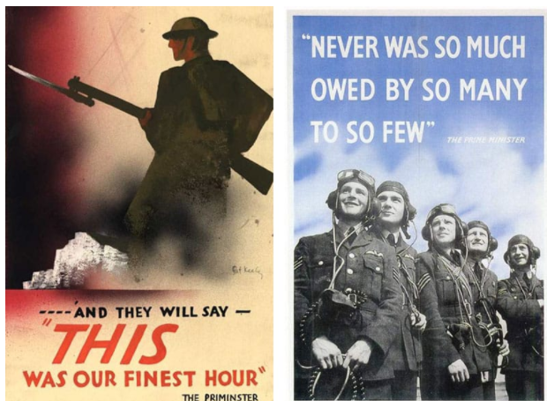 |  | Maths  We will be learning about fractions, decimals and percentages. We will also learn about angles and shape properties.  We will be developing our mathematical vocabulary and problem solving skills.
PE
Y5 will be having swimming lessons every Thursday.
We will have an outdoor PE lesson each Wednesday.

 | ARCHIE PROJECT  Y5 will be starting work on this Young Leaders project with Mr Hamilton. | Computing  We will be learning about codes, including the enigma code! | Science  We will be learning about human development and the human life cycle.

Home learning project suggestions
Here are some learning activities that you can do with your children at home to support their learning in school.
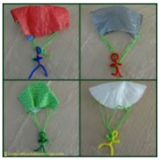
Design your own Parachute
Design and test a parachute to help a member of the RAF land safely. You could experiment with which materials make the best parachutes and record your findings on a chart.
1940s games
Research and play the games children would have played in the 1940s.
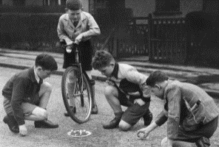
You could make a fact sheet or PowerPoint showing popular games and toys from the time.
Make a medal
Make a medal and write about the brave acts it would have been awarded for.
Tanks and planes
Find out about the machines of World War II. Can you create a labelled diagram of a tank or plane? Can you present facts about tanks and planes in an interesting way?
Rations
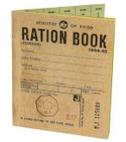
Create a ration book of your own. Find a war time recipe and have a go at making it. Write a dinner menu using ingredients that would have been available on rations.
Marvellous music
Write a morale boosting song.
Learn a war time song to perform to your family.
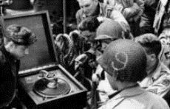
Research popular types of music and dance from the 1940s.
War time leaders
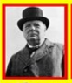
Research and present information about the WWII leaders.
Make do and mend
Make a new toy or piece of clothing from recycled material.
Maps
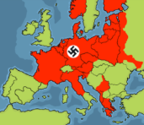
Make a map showing the countries involved in WWII. You could mark the countries occupied by the Nazis on your map.
You can choose which of these activities you would like to do. You do not need to do all of them! We also know that you and your children have lots of original and creative ideas of your own. We love to see these too! Please encourage your child to bring their learning into school to share or to post their projects on Seesaw.
If you have any questions, queries or worries then please get in touch via the phone or email. Thank you for your continued support.
Best wishes,
The Y5 Team

