Vocabulary |  |  |  |  | Linked Geography
Rainforest | A dense forest, normally found in  tropical areas with high rainfall.  They generate much of the world’s  oxygen. | Interdependent | When two or more people or things rely  on each other. |  | 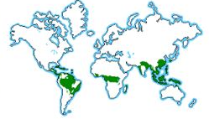  To know where rainforests can be found in the world.  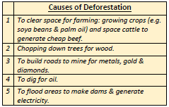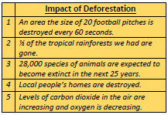
Continent | The world’s main continuous pieces  of land (Africa, Asia, Australasia,  Europe, North America, South  America, Antarctica). | Emergent Layer | Giant trees that enjoy the most sun but can also survive high winds.
Ecosystem | A community of plants and animals  that depend on each other to  survive. | Canopy | Dense layer of trees that overlap each other. Home to most of the animals in the rainforests.
Deforestation | The action of clearing a wide area  of trees | Understory | Relatively dark, open area below the canopy.
Habitat | The natural home or environment  of an animal, plant or organism | Undergrowth | Also known as the forest floor, mainly consisting of fallen leaves and fruit that decomposes and is used as food for trees.
Canopy Layers |  |  | Interesting facts
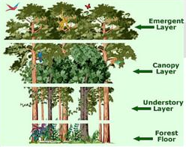 |  |  | Rainforests cover approximately 6% of the Earth’s  surface by contain more than ½ of the world’s  plants. About 90% of organisms are found in the  canopy. |  |  | Many things we have in our homes come from  rainforests including: chocolate, sugar, rubber,  bamboo and many medicines.
 |  |  | About 30 million species of plants and animals live  in tropical rainforests. |  |  | 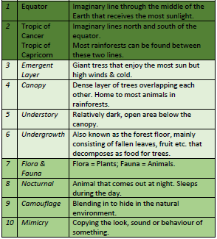
There are two types of rainforests – Tropical and Temperate. Tropical rainforests are generally
warmer than temperate ones.

Art  I can use collage skills to create a rainforest  I can develop my drawing skills  I can use a variety of techniques to draw different types of animal skin |  |  |  | DT  I can create pop out rainforest scenes  I know what materials I could construct a rainforest home from

