Vocabulary |  |  |  |  | Linked Geography
VIP | VIP stands for Very Important Person | The Olympic flag | The Olympic flag has a white background, with five interlaced rings in the centre: blue, yellow, black, green and red. This design is symbolic; it represents the five continents of the world, united by Olympism, while the six colours are those that appear on all the national flags of the world at the present time |  | Use a map to plot the locations of Olympics Games throughout history. Use this example as inspiration.  Find out the location of the next Olympics and plan a trip there. How will you get there? How long will the journey be?  Create a travel guide based on the location of the next Olympic Games.  Plot the route of the Olympic torch as it travels to the location of the Games.  Choose a country that is taking part in the Olympics and write a report about it. If each child chose a different country, these could be combined into a larger guide
Olympian | An Olympian is a competitor in the Olympic Games. The importance of being an Olympian will vary from athlete to athlete. Olympians are allowed to write OLY after their name | Olympics | The modern Olympic Games or Olympics are leading international sporting events featuring summer and winter sports competitions in which thousands of athletes from around the world participate in a variety of competitions
Significant | Meaningful or important. | Olympic Torch | The Olympic flame is a symbol used in the Olympic movement. It is also a symbol of continuity between ancient and modern games. Several months before the Olympic Games, the Olympic flame is lit at Olympia, Greece
VIP | Values in Practice (ViP) programme emphasises the need to put learning into action and the truth that no decision is value-free. Students explore issues to equip them with the skills and knowledge that they need to make good decisions now and in the future. | Ancient Olympics | The ancient Olympic Games were originally a festival, or celebration, of and for Zeus; events such as a footrace, a javelin contest, and wrestling matches were added later. The Olympic Games were a series of athletic competitions among representatives of city-states and one of the Panhellenic Games of ancient Greece
Olympic Rings | five interlaced rings in the centre: blue, yellow, black, green and red. This design is symbolic; it represents the five continents of the world, united by Olympism | Summer Olympics | The Summer Olympic Games (or the Games of the Olympiad,) first held in 1896, is a major international multi-sport event normally held once every four years.
Influential Person |  |  | Interesting facts
In ancient Greek religion and mythology, the twelve Olympians are the major deities of the Greek pantheon, commonly considered to be Zeus, Hera, Poseidon, Demeter, Athena, Apollo, Artemis, Ares, Hephaestus, Aphrodite, Hermes, and either Hestia or Dionysus. |  |  | PSHCE: look at friendships, how friendships are formed and maintained, and the qualities of a good friend. The lessons will then move on to disputes and bullying and will address strategies for coping with each of these. |  |  | The Olympic flame is a symbol used in the Olympic movement. It is also a symbol of continuity between ancient and modern games. Several months before the Olympic Games, the Olympic flame is lit at Olympia, Greece 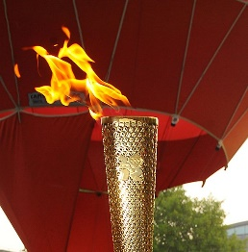
 |  |  | Steve Redgrave is the only British athlete to win gold at five consecutive Games.  - Chris Hoy - six.  - Jason Kenny - six.  - Bradley Wiggins - five.  - Steve Redgrave - five.  - Ben Ainslie - four.  - Mo Farah - four.  - Laura Kenny - four.  - Matthew Pinsent - four. |  |  | An Olympic medal is awarded to successful competitors at one of the Olympic Games. There are three classes of medal: gold, awarded to the winner; silver, awarded to the runner-up; and bronze, awarded to the third place. The granting of awards is laid out in detail in the Olympic protocols.  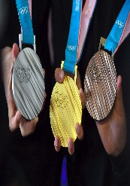
Time line  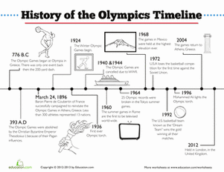 |  |  | The Olympic wreath has long been a sign of victory, a token of success that stems from the ancient Greek tradition and was later adopted by the Romans to signify martial victory. In the modern Olympics the wreath is used as a decorative symbol in the games and on the victory medals |  |  | Olympic Sports:  Olympic sports are contested in the Summer Olympic Games and Winter Olympic Games. The 2016 Summer Olympics included 28 sports,
ART:  Olympic Rings  Olympic Torch  Olympic Wreath  Handprint Olympic Medal |  |  |  | DT  Design a diet suitable for an olympian (varies depending on Sport)  Design a sports kit for an olympic team (varies depending on Sport)  Investigate the design of footwear for different sports which athletes need grippy shoes and which need slippy shoes? Using a Newton meter and a variety of sports shoes children can find out which shoes create the most friction when pulled across the floor. How could you make them lighter, grip better, or keep athletes feet cool in hot South America? Challenge them to design a special shoe that will enable athletes to jump higher or run faster

