Vocabulary |  |  |  |  | Linked Geography
Period | An era or length of time. | Archaeologists | Archaeology is the study of human history and pre-history, and is undertaken by studying sites and artefacts. In 1922, an archaeologist and Egyptologist named Howard Carter discovered the hidden tomb of King Tutankhamun. |  | Identify continent of Africa & find Egypt.  Name the capital city of Egypt.  Human Geography of trade routes in the Egyptian Empire.  Maps with Keys and identifying ordinance survey symbols.  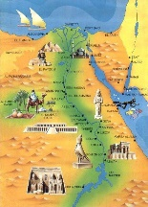  An introduction to farming.
Decade / Century | A period of ten years.  A period of 100 years | Rosetta Stone | The Rosetta Stone is a granodiorite stele discovered in 1799 which is inscribed with three ... drew on many other texts to develop an Ancient Egyptian grammar and a hieroglyphic dictionary which were published after his death in 1832.
Country | Egypt | Papyrus | Papyrus is a material similar to thick paper that was used in ancient times as a writing surface. It was made from the pith of the papyrus plant, Cyperus papyrus, a wetland sedge
Continent | Africa | Scarab Beetle | The scarab (kheper) beetle was one of the most popular amulets in ancient Egypt because the insect was a symbol of the sun god Re.
Hieroglyphics | Ancient Egyptians used a writing system called Hieroglyphics. The system of hieroglyphics uses over 700 symbols and pictures to represent sounds. The writing can be read from top to bottom or across the page from right to left, or from left to right. The direction the characters (often birds) are facing gives the reader a clue as to which direction they should read. If a bird is facing to the left, the writing must be read from the left. The word Hieroglyph comes from two Greek words; hieros meaning holy and glyphe meaning writing. The word ‘hieroglyph’ is a noun and refers to the individual characters whereas the word ‘hieroglyphics’ is an adjective which describes the alphabet. We know many things about how the Ancient Egyptians lived because people have managed to translate hieroglyphics. | Cartouche | a carved tablet or drawing representing a scroll with rolled-up ends, used ornamentally or bearing an inscription.
Influential Person |  |  | Interesting facts
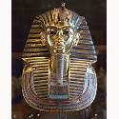King Tutankhamun  Occupation: last of his royal family to rule during the end of the 18th dynasty  Born: 1334 BC  Died: 1325 BC  Best known for: Being the boy King |  |  | The River Nile the longest river in the world, the Nile, runs through Egypt. Without the Nile River, all of Egypt would be desert. Only about an 2.5cm of rain falls throughout Egypt each year. But each summer, the Nile river rises because of rains at its source, far to the south in Ethiopia. When this happens, floods cover the river’s valleys, leaving sediments needed for trees, plants and crops to grow. |  |  | Mummies Unwrapped, the bandages of an Ancient Egyptian mummy could stretch for 1.6km. Yikes!  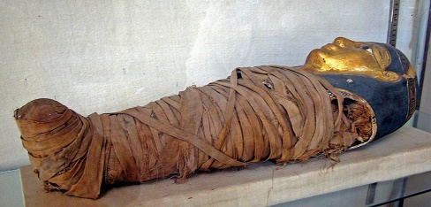
 |  |  | Egyptian Gods  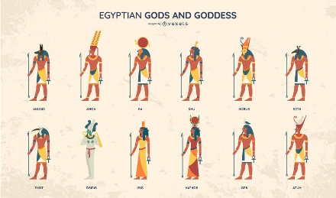  Ancient Egyptian deities are the gods and goddesses worshipped in ancient Egypt. The beliefs and rituals surrounding these gods formed the core of ancient Egyptian religion, which emerged sometime in prehistory. |  |  | Cats were considered to be a sacred animal by the Ancient Egyptians. It’s thought that most families kept a cat as a pet, which they believed would bring the household good luck!  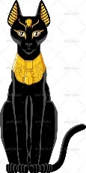
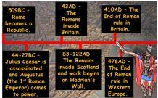  Time line |  |  | Pyramids The Pyramid of Khufu at Giza is the largest Egyptian pyramid. This incredible structure weighs as much as 16 Empire State buildings!  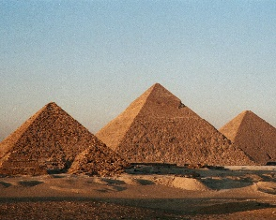 |  |  | Sphinx  A sphinx is a mythical creature with the head of a human and the body of a lion. In ancient Egypt, the sphinx was a spiritual guardian and most often depicted as a male with a pharaoh headdress—as is the Great Sphinx—and figures of the creatures were often included in tomb and temple complexes  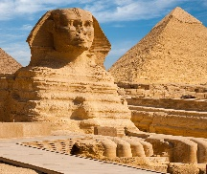
Art  I know that archeologists have found clay pots from the Egyptiasn era.  I know that the motifs often showed Egyptian men and women or food.  I can sketch my own motif design.  I can use clay to make a pot.  I can paint my motif design.  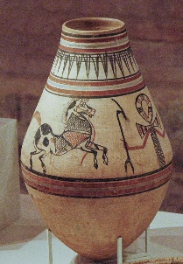 |  |  |  | DT  I know the types of food Egptian ate.  I know that  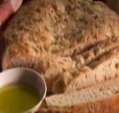  I know that the food Egptians ate grew seasonally and was effected by the climate in which they live  I can design and make papyrus  