Vocabulary |  |  |  |  | Linked History
Physical features | Natural features of land, for example mountains and rivers. | Land mark | A building or natural feature that is easily recognised. Big Ben and Ben Nevis are both UK landmarks. |  | Holidays in the past  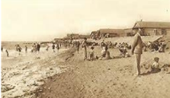  The word holiday comes from the words ‘holy day’ because a long  time ago holidays were based around religious festivals.  A long time ago, only rich people went to the seaside because there were no planes, trains or cars to get anyone there. They had to use horse and carriages which were very expensive. Rich people started visiting the seaside about 200 years ago. Seaside holidays became possible for many people about 150 years ago when steam trains were invented. In the past, before planes were invented, if people went on holiday they would stay within the UK, often heading to the beach resorts e.g. Blackpool, Southport, Bournemouth.  What is the same and different between holidays past and present?
Human features | Features that are built or developed by humans, for example bridges, buildings or sea defences. | Tourist | A person who is visiting a place for pleasure and interest, especially when they are on holiday.
Climate | The general weather conditions of a place. | Continent | A very large area of land that consists of many countries. Europe is a continent.
Capital city | The city wear the government of a country sits. The capital city of England is London. | Ocean | one of the five very large areas of salt water on the Earth's surface
Population | The people that live in a place. | Sea | Alarge area of salty water that is part of an ocean.
Water cycle |  |  | Interesting facts
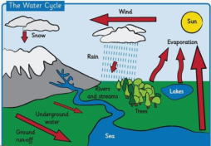  Water, over time, will return to the sea. A 'Water Cycle' is the journey water takes, from land to the sky and back again. The cycle consists of evaporation, condensation, precipitation and collection. |  |  | 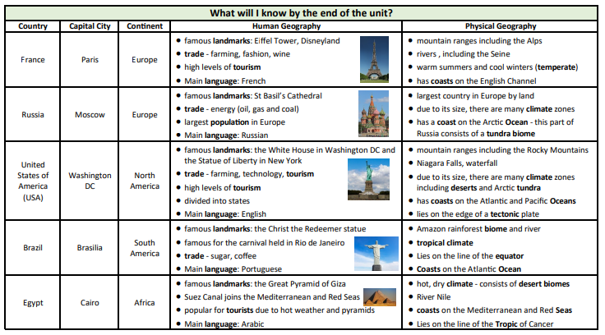
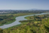
The River Nile is the world's longest river, stretching an incredible 4,130 miles (6,650 km).

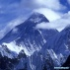
The highest mountain in the world is Mount Everest which is part of the Himalayan Mountains.

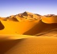
The largest is the Sahara Desert, a subtropical desert in northern Africa. It covers a surface area of about 3.5 million square miles.
Art  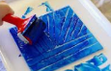  I can say what I like or do not like about art.  I can design a block print.  I can make a print block.  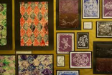  I can make pieces of at using my block print. |  |  |  | 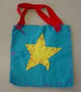  DT  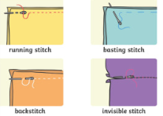  I can sew using different stitches.  I can design a bag.  I can make and evaluate my bag.

