Vocabulary |  |  |  |  | Linked Geography
Period | An era or length of time. | Invasion | Entering a country by force with large numbers of soldiers in order to take possession of it. |  | Name the countries and capital cities of Europe. Human Geography of trade routes in the Roman Empire.  Maps with Keys and identifying ordinance survey symbols.  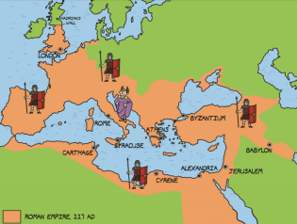  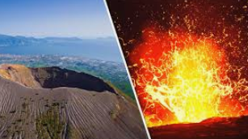  An introduction to volcanoes- linked to Escape from Pompeii and Rocks in Science.
Decade | A period of ten years. | Conquest | The act or process of getting or gaining something, especially by force.
Significant | Meaningful or important. | Empire | A group of countries ruled by a single authority.
Shape | To influence or have an effect on something. | Resistance | The action of opposing or fighting against something that you disagree with.
Version | Something different in a certain ways from another form of the same thing, for example an account of an event from a particular person’s point of view. | Romanisation | To make something, including writing, Roman in character.
Influential Person |  |  | Interesting facts
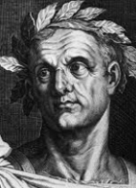  Julius Caesar  Occupation: Roman general and dictator  Born: July 100 BC in Rome, Italy  Died: 15 March 44 BC in Rome, Italy  Best known for: Being the dictator of Rome and putting an end to the Roman Republic |  |  | 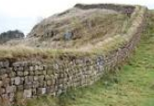  Hadrian’s wall was built by the Romans to separate the Roman’s and the tribes in Scotland. It still stands today. |  |  | 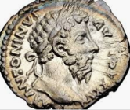  Romans introduced currency to Britain. Julius Caesar was the first person to have his face printed on a Roman coin.
 |  |  | 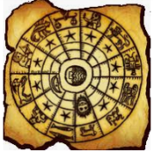  The calendar we use today was started by Julius Caesar. The names of our months are taken from the names of the Roman gods. |  |  | 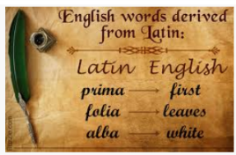  The Romans brought the Latin language to Britain. We still use lots of words with Latin roots.
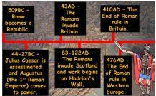  Time line |  |  | 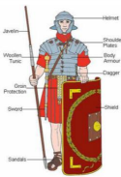  The Roman army was a highly organised force.Find out what it was like to be a Romans soldier. |  |  | 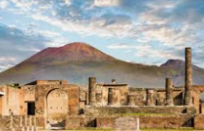  When Mount Vesuvius erupted in AD 79 the city of Pompeii was frozen in time.
Art  I know that archeologists have found clay pots from the Roman era.  I know that the motifs often showed Roman men andwomen or food.  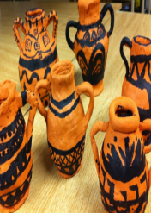  I can sketch my own motif design.  I can use clay to make a pot.  I can paint my motif design. |  |  |  | 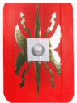  DT  I know the types of food Romans ate.  I know that Roman bread is similar to modern bread.  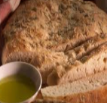  I know that the food Romans ate grew seasonally and was effected by the climate in which they live  I can design a shield that is similar to those used by the Romans.  I know how to strengthen, stiffen and reinforce my cardboard shield to make it stronger.

