Vocabulary |  |  |  |  | Linked Geography
Afterlife | The place where ancient Egyptians believed they would go when they died. | Akhet | The season of the year when the Nile river flooded. A very important time of year in the desert! |  | 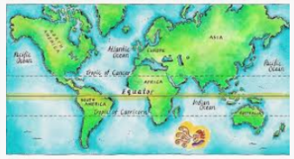  To know where the Equator is and its importance.  To know the position and difference between the North and South Hemispheres.  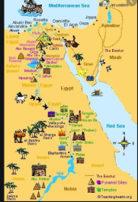  To know the position and significance of the Tropics of Cancer and Capricorn.  To know the position and main geographical landmarks of Egypt.
Decade | A period of ten years. | Dynasty | A period of rule when a series of Pharaohs all came from the same family.
Significant | Meaningful or important. | Pharaoh | The supreme ruler of all of Ancient Egypt.
Shape | To influence or have an effect on something. | Sarcophagus | A large stone box that held a mummy’s coffin. Often richly decorated for Pharaohs.
Version | Something different in a certain ways from another form of the same thing, for example an account of an event from a particular person’s point of view. | Mummification | The process of preserving a body after death in preparation for the afterlife.
Influential Persons |  |  | Interesting facts
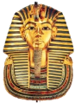  Tutankhamun- The youngest Pharaoh, famed for his burial tomb in the Valley of the Kings (mask, left).  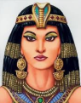  Cleopatra VII- Often considered the last Pharaoh of Egypt. Kept power by making alliances with famous Romans such as Mark Antony & Julius Caesar. |  |  | 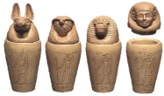  Canopic jars were special jars that held the organs of a mummy including the lungs, intestines, liver and stomach. |  |  | 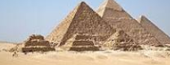  Pyramids were tombs built for the Pharaohs. They were built by hand by workers who
 |  |  | 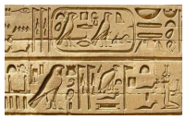  Hieroglyphics were a type of Egyptian writing that used a combination of pictures and symbols. |  |  | 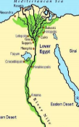  Area near the River Nile that flooded was known as the Black Land. Areas further away were known as the Red Land. They relied on the Nile’s flood to grow crops and farm.
Time line  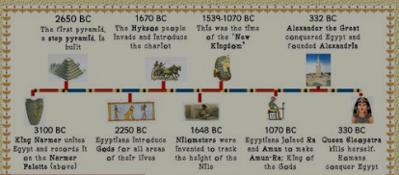 |  |  | 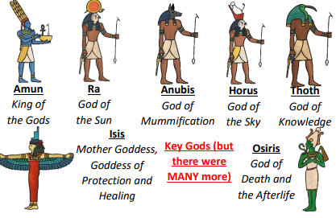 |  |  | 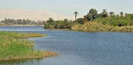  The Nile is the longest river in the world. The Nile River has been an important source of food, transportation, and water for the continent of Africa for thousands of years. Without the rich soil and clean waters that the river brought to the dry desert, Ancient Egypt would not have survived, and this extremely important civilization would have never happened.
Art  I know that archeologists have artifacts in the pyramids.  I can explore sktching and shading.  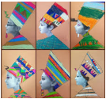  I can draw faces.  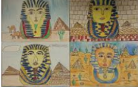  I can make decisions about colour and pattern. |  |  |  | 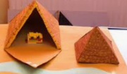  DT  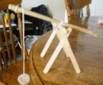  I know that pulleys and pivots can be used to lift and move blocks.  I can make different moving mechanisms.  I can make and strengthen structures.

