Vocabulary |  |  |  | Linked Geography
Diwali | Hindu period of fasting. | Advent | Lead up to Christmas in the Christian religion. | 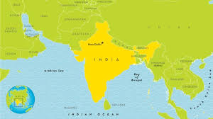  The capital city of India is New Delhi. The river Ganges is the largest river in India.  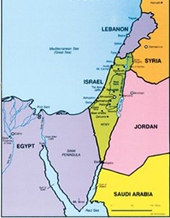  The Holy land is where Jesus was born over 2000 years ago. It is considered a sacred place where people visit.
Hindu | A person whose religion is Hinduism. | Nativity | The story of Jesus’ birth.
Hinduism | Hinduism is over 4,000 years old, making it one of the world's oldest religions. | Christian | A person whose religion is Christianity.
Ganesh | Ganesha or (Ganesh) is the elephant-headed god in Hinduism. He is the son of Shiva and Parvati. | Christianity | Christianity is the belief in the teachings of Jesus Christ, who Christians believe to be the Son of God.
Brahman | The Hindu God who takes three forms. | Christmas | Celebrated by Christians. It marks the birth of Jesus.
Influential Person |  |  | Interesting facts
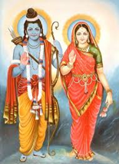  Rama and Sita is one of the main stories from Hinduism. It is about Rama rescuing Sita from a demon King Ravana with the help of Hanuman and his monkey army. |  |  | 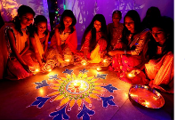  Diwali usually lasts five days and is one of the most popular festivals of Hinduism. |  | Christianity is the world’s biggest religion. Christians believe in one God that created heaven, earth and the universe.
 |  |  | Diwali celebrates good triumphing over evil. |  | Christians light one candle on an advent wreath each Sunday before Christmas (for 4 weeks).
 |  |  | 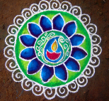  People draw rangoli patterns on the floor by the door to their homes to welcome the gods and bring good luck. |  | Christmas takes place on the 25th December each year and it is the time when Christians remember Jesus’ birth.
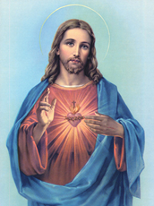  Jesus is the founder of the Christian religion. He is believed to be the Son of God and the Saviour of the World. |  |  | Diwali is the Hindu festival of lights. It is usually celebrated in November. The word Diwali means “row of lights”. |  | 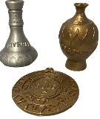  Christians celebrate Christmas by giving gifts to remind us of the presents given to Jesus by the Wise Men: Frankincense, Gold and Myrrh.
 |  |  | 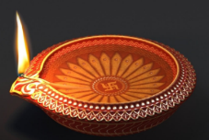  During the festival, people decorate their homes with lights and oil lamps called diyas. |  | Christians believe that Jesus was the Son of God, sent down to earth to save people by dying on the cross and taking the punishment for their sins.

