Vocabulary |  |  |  | Linked Geography
tourism | An industry linked to travel | pier | A bridge that goes into the sea | In the UK early tourists believed that the sea air and bathing in seawater was good for a person's health and coastal towns such as Brighton became popular. Coastal areas are often cooler than places inland. So, on hot days people go to the beach to cool off and swim in the sea. Many people enjoy relaxing on a beach.
coastal | Near the sea | bathing | Relaxing in the sea
excursions | Days out/trips | Bank holidays | Days off with pay
holiday | time taken off from work | century | 100 years
package | All costs included | annual | Once a year
Influential Person |  |  | Interesting facts
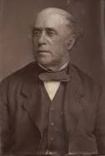  Thomas Cook was an English businessman. He is best known for founding the first ever travel agency. In the 1840s Thomas Cook began arranging excursions by train in Britain. In the 1860s Cook arranged package tours abroad. Thomas Cook organized for workers and their families. |  |  | At the end of the 18th century wealthy people began to spend time at the seaside |  | In the late 19th century the modern seaside holiday began with seaside rock, piers, donkey rides and Punch and Judy shows.
 |  |  | In 1871 the Bank Holiday Act gave workers a few paid holidays each year. |  | The first holiday camp in Britain opened in 1906.
 |  |  | People began to spend their paid days off at the seaside |  | Holiday camps reached their heyday in the 1950s and early 1960s.
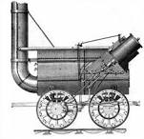  George Stephenson was the first person to invent the steam engine. His invention changed the world with the development of steam trains and railways systems. |  |  | In many seaside towns, promenades were also built. |  | By the 1950s two weeks holiday were common and by the 1980s most people had at least 4 weeks annual holiday.
 |  |  | In the 1840s the spread of railways made travel much faster and more comfortable. 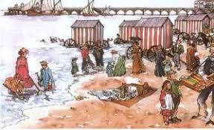 |  | as air travel became cheaper foreign holidays became possible for more and more people

