Vocabulary |  |  |  | Linked Geography
habitats | Place where animals and plants live together | Pollution | Damage to the environment (usually man-made) | An ecosystem is where a community of living organisms, such as plants and animals, live together with non-living aspects of their environment. Each living organisms relies on each other in order to live and are interdependent.  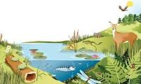
Food chains | Plants and animals rely on each other for food | Life cycles | How animals grow and change
prey | Eaten by a predator | organisms | Living things
predator | Live on prey | interdependent | Depend on each other
Mini beasts | Small insects | Botanist | Studies of small animal and plant life
Influential Person |  |  | Interesting Facts
David Bellamy  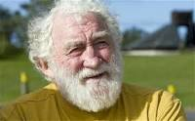  Sir David Bellamy was famous in the 1980s for his love of the natural world. He studied eco-systems and habitats in the UK. Not only was he a famous botanist he also became a TV presenter, author and environmental campaigner. |  |  | A ladybird might eat more than 5,000 insects in its lifetime! |  | A bee’s wings beat 190 times a second, that’s 11,400 times a minute.
 |  |  | Fruit flies were the first living creatures to be sent into space. |  | The stag beetle is the largest species of insect to be found in the UK.
 |  |  | Dragonflies have been on earth for 300 million years! |  | Caterpillars have 12 eyes!
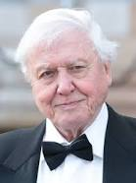  Sir David Attenborough is a famous for his work in the natural world. He is famous for his documentaries on the animal world and his global campaign to raise awareness of the damage of pollution to the planet. |  |  | One dung beetle can drag 1,141 times its weight – that’s like a human pulling six double-decker buses! |  | There are 36 species of dragonfly found in the UK.
 |  |  | A single honeybee colony can produce around 100kg of honey each year – that’s 220 jars! |  | Mosquitos are attracted to smelly feet!

