Vocabulary |  |  |  | Linked Geography
cocoa | Powder made from grinding cocao seeds | paste | Thick liquid | Chocolate comes from cocoa beans, which grew on trees in Central America and South America starting probably about 100 million years ago.  It was the Maya Indians, an ancient people whose descendants still live in Central America, who first discovered the delights of cocoa as long ago as 600 AD.  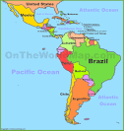
condensed | Made thicker | ground | To put pressure on something to make it powdery
invented | First made something | descendant | Born from family in the past
founder | The first person to discover or invent something | discovered | To find something or realise something
roasted | Heated until brown | ancient | From the past
Influential Person |  |  | Interesting facts
The first milk chocolate was made in 1875, by Henri Nestle. He invented the first-ever milk chocolate, using high quality condensed Swiss milk from his own factory and his never-ending knowledge about milk!  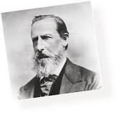 |  |  | Chocolate has been used in some form for at least 3,000 years. |  | Cocoa is roasted and ground to make a liquid or paste.
 |  |  | Chocolate is made from cocoa beans. |  | In celebration of its 100th birthday, Thorntons created the world’s largest chocolate bar
 |  |  | Chocolate often contains more sugar than cocoa. |  | Originally, cocoa (now known as chocolate) was used as a medicine for drinking.
The Cadbury Company made the first chocolate bar in 1842. John Cadbury was the founder of Cadbury World, the chocolate business based in Birmingham.  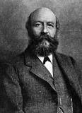 |  |  | People eat about 5 kg of chocolate per year. |  | The first cocoa drink was bitter and needed sweetening.
 |  |  | Chocolate Easter eggs were first made in Europe in the early 19th century |  | It is traditional to give chocolates on Valentine’s Day.

