Vocabulary |  |  |  | Linked Geography
Alliance | Where countries join forces or work together to achieve a certain goal. | Treaty | A written agreement between two or more countries. | The Alliance System  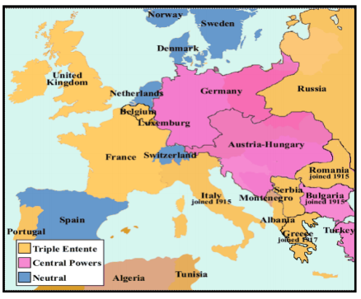  Many countries had made alliances with one other. They agreed to protect each other. If one was attacked, the others would defend them. The war was fought between:  • The Triple Alliance: Germany, Austria-Hungary and their allies.  • The Triple Entente: Great Britain, France and Russia.
Armistice | A formal agreement of warring parties to stop fighting. | Trench | Long ditches dug into the ground where soldiers lived.
Conscription | The requirement by law to join the armed forces. | Conscientious objector | A person who for reasons of conscience objects to complying with a particular requirement, especially serving in the armed forces.
Front Line | The area where the armies are engaged in fighting. | No Man’s Land | The area of land between two enemy trench systems.
Influential Person |  |  | Timeline |  | Interesting facts
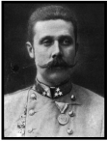  The assasination of Archduke Franz Ferdinand (Archduke of Austria) was one of the factors that sparked the outbreak of the Great War. |  |  | June 1914: Assassination of Franz Ferdinand August 1914: Germany invades Belgium. Britain declares war on Germany  August 1914: Battle of Mons  October 1914: Battle of Ypres  December 1914: Christmas truce  April 1915: Gas attack on Ypres  April 1915: Allied landings at Gallipoli  February 1916: Britain introduces conscription  July 1916: Battle of the Somme begins  July 1917: The United States declares war on Germany  March 1918: Start of German Spring Offensive November 1918: Armistice  June 1919: Treaty of Versailles signed |  | New technologies:  There were major developments in technology during World War One. New weapons and machines changed the way war was fought forever. Britain used tanks in battle for the first time in September 1916. Aeroplanes were recent inventions. As aircraft technology developed, planes became more important. Battleships– conflicts which took place on the sea were known as naval battles. Artillery field guns fired shells that exploded when they hit something. Machine guns fired up to 600 bullets a minute and were extremely dangerous
 |  |  |  |  | Remembrance Day: Every year on 11 November, people in the UK stop for a short moment of reflection. Poppies, which grew on the barren fields of World War One, are used to remember soldiers who died.
The Treaty of Versailles  World War One ended at 11am on 11 November, 1918—this became known as Armistice Day. The leaders of the USA, Great Britain and France met in Versailles to decide what should happen next. The agreement was called the Treaty of Versailles. Terms of the treaty included: • Germany had to accept total blame for starting the war. • They could not join the new League of Nations • Some places Germany used to own were taken from them. • Germany were banned from having an army of more than 100,000 men and from having any submarines or an air force. • The country had to pay 132 billion gold marks to repair the damages of war. They became poor because of this. |  |  |  |  | Trench Warfare:  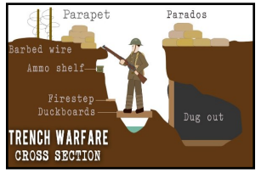  Many battles were fought using trench warfare. Long ditches were dug in the ground. Soldiers lived in the trenches and sometimes climbed out to attack. A famous example of trench war was the Battle of the Somme which started in July 1916.

