Dear Parents/ Carers,
We have been busy making Easter gifts in F2.
If you would like to buy your child’s gifts please see the description and price below.
Send all money into F2 in an envelope with your child’s name on stating which gift(s) you would like.
All money raised from these gifts will be used to buy equipment for the outdoor environment.
Flower Pot £2 Trinket Box £1

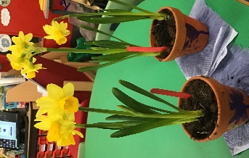

£3 for both gifts

Thank you

Mr Grayhurst and Mrs Beevers

