Downloading the App  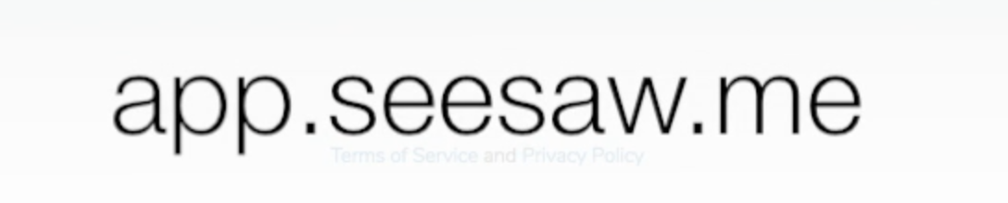 | To get started download the Seesaw Class app on your device or go to app.seesaw.me to get started. App updates may occasionally be required.
Logging in  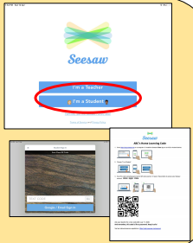 | When logging in you will need to select ‘I’m a student’ and use your text code or scan your QR code to get in.  Your teacher should have provided you with a log in sheet. If you do not have your log in details then please contact school and we will get them to you.
Learning assigned by your teacher  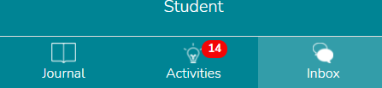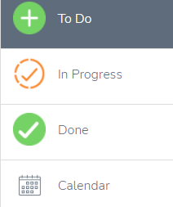 | You will be able to see activities that your teacher wants you to do by clicking on the 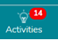 tab. This will take you to a list of activities that have been set.  They will be organised in four ways -  The work that is yet to be done will be in the ‘To do category’, any work that has been started or done and then sent back for review will be in the ‘In progress’ folder. The calendar view will show you work set for a specific day. The done folder is where you can view completed work and feedback from teachers.
Lesson activities | Lessons will be shared in a variety of ways - there might be videos, Power Points, links to other resources or voice recordings. You will need to read the instructions or click on the picture at the side of the activity. If a PowerPoint, video, text or voice recording has been added then you will need to click on the picture and either the arrow or the link icon to view this part of the lesson.  This arrow 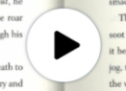 will play videos or voice recordings.  Arrows like this 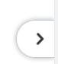 mean there is another page to look at.  If you see this chain icon 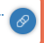 it means that you need to follow a link to another resource.
Completing tasks  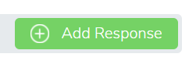 | When you have looked at the lesson and worked through the instructions from your teacher then you will be ready to do some work. There are lots of ways to do this- to get started click on .
Tools  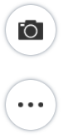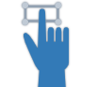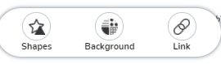 | Once you’ve clicked on ‘Add response’ you can use these tools to do work.  creates a text box that can be typed into. This tool allows you to resize and move text boxes.  The microphone tool allows children to respond to questions or challenges verbally.  The camera tool means you can add a photo- remember children can work on paper and then share a photo with us.  The three dots lead to these tools -  shapes can be added, the background can be changed and you can share links to other websites (we don’t expect these tools to be needed often).
More tools  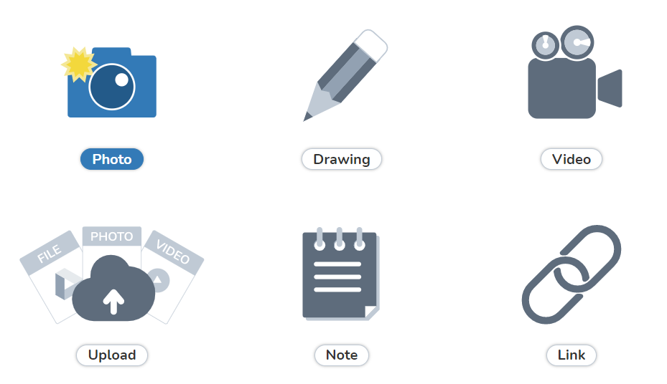 | For tasks without a template shared by the teacher you will be taken to these tools to choose from when you click on ‘add response’.  Allows photos.  Takes you to the same tools as above.  Is a filming tool so a short video can be shared.  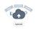Allows PDFs or pictures to be uploaded from the device (if your work is in a word document or PowerPoint these can be shared by saving as a PDF and uploading this way).  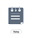Takes you to a note page where you can type a message or piece of work.  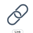Allows you to share a link to another website.
Printing tasks  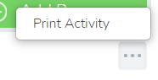 | Some parents have asked how to print tasks. For tasks where the teacher has uploaded a template or worksheet then this can be printed by going to the three dots at the bottom of the task and a tab saying ‘print activity’ will appear.
Asking for help | If you need help from a teacher or are unsure about a particular task then you can click on ‘Add response’ and use one of the tools to ask for help. Your teacher will then be able to add pointers or help and then send the work back to you. Work that is sent back can be found in the ‘In progress’ folder and a message will show in the Inbox 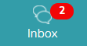 to show you a response has been made.
Journal  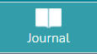 | The journal tab will show all work that has been completed and approved by your teacher.  Messages from staff will be at the bottom of pieces of work and you can type messages back by clicking on the comment button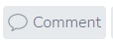. Teachers will also mark some work by using the drawing tools and you can see this by clicking on the picture of the work.
Sharing work or messages- not responding to a task  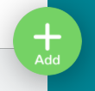 | If you want to share something that is not a direct response to a task or send a message on Seesaw then you can do this by clicking on the big green plus at the top of the screen.
The inbox  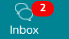 | If your teacher has sent a message or responded to you then a red circle will show on the inbox and this will take you to a notifications page. Messages can be accessed through one tab and notifications of activity by the teacher on the other.  The notifications will include the marking of work so please do review them - you can look more closely by clicking on each one. If a notification says a piece of work has been sent back for review then this is learning to refer back to and possibly improve with your teacher’s help.

