Dear Parents/ Carers,

We have been busy making Christmas gifts in Nursery.

If you would like to buy your child’s gifts please see the description and price below.

Please send all money into Nursery in an envelope with your child’s name on stating which gift(s) you would like to purchase.

All money raised from these gifts will be used to buy equipment for the outdoor environment.

Thank you

Mrs. T. Pollard

**Decorated Teapot with Gift (individual teabag & biscuit) £2.00**

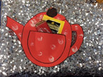

**Christmas Tree Decoration £2.00**

