Dear Parents/ Carers,
We have been busy making Christmas gifts in Foundation 2.
If you would like to buy your child’s gifts please see the description and price below.
Please send all money into class in an envelope with your child’s name on stating which gift(s) you would like to purchase.
All money raised from these gifts will be used to buy equipment for the outdoor environment. Thank you.

Double sided Snow Globe £2.50
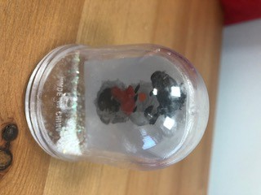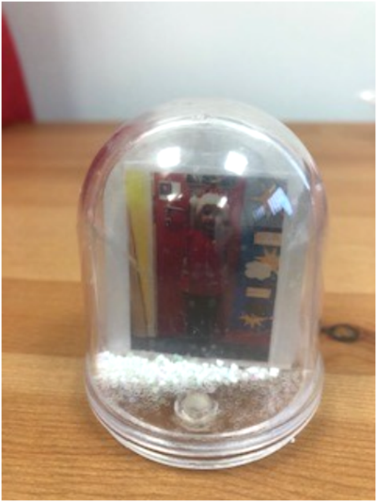

Christmas Tree Decoration £1.50
