Developing children’s language and understanding through stories
Reading stories is an essential experience for young children, helping them to develop a wide range of important skills.
- Improves listening skills
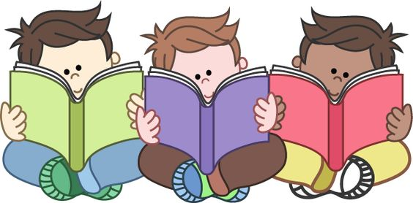
- Promotes conversation
- Builds vocabulary
- Develops memory
- Imagination
- Prediction
- Awareness of story structure
- Helps children make sense of the world around them

What will my child be learning while sharing and talking about a story?
(Objectives taken from our Early Years curriculum)
- Repeat words or phrases from familiar stories.
- Join in with repeated refrains and anticipate key events and phrases in rhymes and stories.
- Listen to stories with increasing attention and recall.
- Describe main story settings, events and principal characters.
- Use talk to connect ideas, explain what is happening and anticipate what might happen next.
- Begin to be aware of the way stories are structured.
- Use vocabulary and forms of speech that are increasingly influenced by their experience of books.
- Use language to imagine and recreate roles and experiences
- Listen with enjoyment and respond to stories, songs and other music, rhymes and poems and make up their own stories, songs, rhymes and poems.
- Show an understanding of the elements of stories, such as main character, sequence of events, and openings, and how information can be found in non-fiction texts to answer questions about where, who, why and how.
- Retell narratives in the correct sequence, drawing on the language patterns of stories.
- Listen with enjoyment to stories, songs, rhymes and poems, sustain attentive listening and respond with relevant comments, questions and actions.
Please read with your child today!

